support@twitter.com, partner@twitter.com, lawenforcement@twitter.com
records@facebook.com, support@facebook.com, helpdesk@fb.com

Caso 60-2021: Twitter & Facebook (Jack Dorsey & Mark Zuckerberg)

Cargos:
- Censura y Violación a la Libertad de Expresión
- Violación a los Derechos Políticos

LISTA DE EVIDENCIAS

Evidencia 1: Censura contra el Presidente Trump
Tribunal Budista de Derechos Humanos: Durante 2020 la red social Twitter catalogó varias veces como mentiras a las expresiones del Presidente de USA, Donald Trump, sobre que en la elección presidencial hubo fraude. Luego, en enero de 2021 Twitter dio un ultimátum al Presidente Trump, censurando 3 manifestaciones públicas de Trump en las que él criticaba a la empresa por ser oponerse a la libertad de expresión. Pocos días después, la plataforma Twitter anunció la suspensión permanente de la cuenta del Presidente Trump por incitación a la violencia. A pesar de que Trump nunca hizo un llamado a la violencia que ocurrió en el Parlamento Norteamericano, ciertamente mantuvo su derecho político a considerar que la elección presidencial fue fraudulenta, lo cual fue argumentado en numerosas ocasiones ante la justicia. Por ejemplo, en un mensaje censurado por Twitter el Presidente Trump simplemente critica la falta de libertad de expresión en Twitter, y en otro mensaje Trump afirmó que los 75 millones de seguidores que él tiene en Twitter son grandes patriotas estadounidenses, que tendrán una voz gigante en el futuro y no se les faltará el respeto o tratará injustamente, todo lo cual fue interpretado por Twitter como una “incitación a la violencia”. Sin embargo, en una declaración en la Casa Blanca el mismo Presidente Trump efectivamente condenó la violencia realizada por los activistas que habían invadido el Capitolio. La plataforma Twitter exime de cualquier violación a las normas de la empresa a toda manifestación de cualquier líder o presidente, lo cual claramente no se aplicó con el Presidente Trump. Esta misma censura luego fue imitada por las empresas Facebook, Instagram, Snapchat, Pinterest y Reddit, a pesar de que en en mayo de 2020 Zuckerberg había criticado a las censuras de Twitter contra el Presidente Trump alegando que Facebook y las redes sociales no deberían ser el árbitro de la Verdad de todo lo que las personas dicen en Internet. No obstante, meses después Facebook censuró y acusó a Trump de socavar la transición pacífica y legal e incitar a la insurrección violenta contra un gobierno elegido democráticamente. Incluso, sorprendentemente la prestigiosa CNN ha censurado al Presidente Trump cortando la transmisión de un discurso presidencial bajo los motivos de que “no eran Verdad” las palabras del Presidente. Finalmente, la Sociedad Interamericana de Prensa (SIP) aclaró que el bloqueo indefinido en las redes sociales a las expresiones de una persona pública como el Presidente Trump significa censura previa, tal y como lo señala la Declaración de Salta sobre Principios de Libertad de Expresión de la Era Digital, pues se infieren delitos o faltas que todavía no ocurrieron.
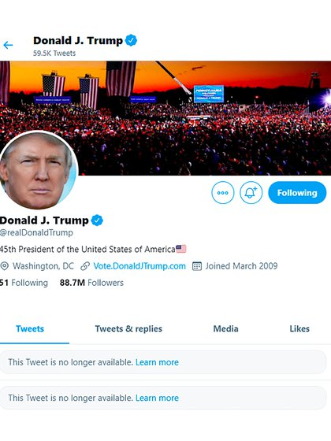
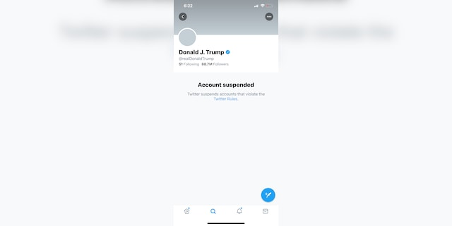
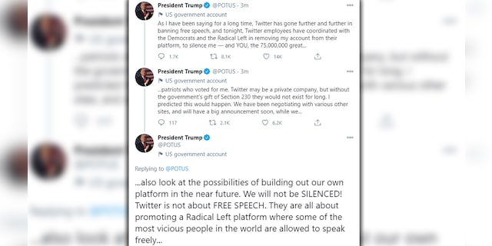
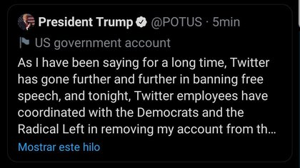
Twitter: "The use of the words 'American Patriots' to describe some of his supporters is also being interpreted as support for those committing violent acts at the US Capitol,"
Facebook CEO Mark Zuckerberg: "We believe the risks of allowing the President to continue to use our service during this period are simply too great," "Therefore, we are extending the block we have placed on his Facebook and Instagram accounts indefinitely and for at least the next two weeks until the peaceful transition of power is complete."
White House Deputy Press Secretary Judd Deere: "It is indisputable that nobody has been more successful at using digital media than President Trump to communicate directly with the American people, but it’s incredibly ironic, yet not surprising, that when the President spoke to the country at a critical time Big Tech chose to censor and block him from doing so," "Big Tech is out of control."
Nikki Haley – former US Ambassador to the UN: "Silencing people, not to mention the President of the US, is what happens in China not our country,"
Dr Ben Carson - US Secretary of Housing and Urban Development: "Silencing a significant number of voters and erasing history is no way to unite us; it only further divides. Big tech and social media platforms want to act like media organisations but don't want to be held accountable with the rest of media. Speech should be free whether you agree or not," "United States is not China", "You want to ban @realDonaldTrump, fine you're a private company, but @Twitter deleting the President's account which highlights this admin & its history is wrong. @Facebook & @instagram banning all images from the Capitol riot is a dangerous precedent to set. We aren't in China"
President's son, Donald Trump Jr: " Free-speech no longer exists in America. It died with big tech and what's left is only there for a chosen few. This is absolute insanity!," "Mao (Zedong) would be proud"
Rep. Matt Gaetz: "Big tech tyranny is playing out before our very eyes."
Rep. Jim Jordan, R-Ohio: "What happened on Wednesday at the U.S. Capitol is as wrong as wrong can be," "But canceling conservative speech will not promote ‘unity and healing.’"
Kate Ruane, senior legislative counsel at the American Civil Liberties Union (ACLU): “We understand the desire to permanently suspend Trump now, but it should concern everyone when companies like Facebook and Twitter wield the unchecked power to remove people from platforms that have become indispensable for the speech of billions— especially when political realities make those decisions easier”
Dennis Prager: “The whole point of America was freedom,” “The left is suppressing, oppressing the greatest feature of the United States.” “What threatens the country? A foolish, stupid, wrongheaded, vile attack on the Capitol, which reopened for business within hours, versus the ongoing suppression of free speech? It’s not symmetrical.” “There’s no comparison,” “The disgusting events of January 6 do not threaten this country nearly as much as the suppression of free speech does,” “The left suppresses liberty everywhere it takes power—there is no exception,” “And it is happening, incredibly, in the country of the Statue of Liberty and the Liberty Bell, for which they have contempt,” “There was no exception in the last 100 years to the left taking power and not suppressing free speech,” “they’re using January 6 as the excuse to do so”
James Neilson: Once upon a time, progressives, or “liberals” as North Americans call them, agreed that censorship was bad. They would have been appalled by the notion that the richest men on Earth were entitled to prevent the sitting US president, however obnoxious many thought him, from communicating with his followers. But times have changed and plenty who see themselves as progressives are fully in favour of silencing anyone who does not share their viewpoints and are therefore congratulating Twitter, FaceBook and company for moving against Trump. No doubt the Silicon Valley oligarchs hope that, as a quid pro quo, the Democrats will forget about applying antitrust legislation to them so they can continue raking in huge amounts of money. (…) By banning Donald Trump from Twitter and FaceBook, calling what happened an “insurrection” and the perpetrators “domestic terrorists,” the thoroughly politicised Big Tech billionaires, plus most Democrats and those Republicans who broke ranks, all egged on by much of the “mainstream media,” told the world that it was okay to treat anyone who still supported the outgoing president as either a criminal or a mentally challenged nutcase who, like Trump himself, deserved to be turned into a non-person and permanently banished from cyberspace. Trump was booted out of the contemporary version of the public square of which Mark Zuckerberg and the rest are gatekeepers for allegedly “inciting insurrection.” Did he? Though he evidently fired up his supporters by telling them to “fight like hell” for what they believe in and stage a protest outside the Capitol, he did not ask them to storm the building and, when they went inside, quickly let them know he was in favour of the police and against violence. His Big Tech accusers know this, which is why they say they decided to blacklist him because they think that in the current context anything he says could be construed as incitement to violence.
The Epoch Times: “(We) cannot independently verify the claims made by Twitter in its determination. The Epoch Times has reached out to Twitter asking whether it had any evidence that Trump’s statements were directly linked to any violence. Twitter did not immediately respond.”

Evidencia 2: Crítica del Presidente Trump a la violencia
White House press secretary Kayleigh McEnany: “We condemn (the violence), the president and this administration, in the strongest possible terms,” “It is unacceptable and those that broke the law should be prosecuted to the fullest extent of the law.” “a group of violent rioters undermining the legitimate first amendment rights of the many thousands who came to peacefully have their voices heard in our nation’s capital.” “Those who violently besieged our capitol are the opposite of everything that this administration stands for,” “The core value of our administration is the idea that all citizens have the right to live in safety peace and freedom.”
President Trump: “Like all Americans, I am outraged by the violence, lawlessness, and mayhem. I immediately deployed the National Guard and federal law enforcement to secure the building and expel the intruders” “America is and must always be a nation of law and order. The demonstrators who infiltrated the Capitol have defiled the seat of American democracy.”“To those who engaged in acts of violence and destruction, you do not represent our country. And to those who broke the law, you will pay.”
President Donald Trump: “In light of reports of more demonstrations, I urge that there must be NO violence, NO lawbreaking, and NO vandalism of any kind,” “That is not what I stand for and it is not what America stands for. I call on ALL Americans to help ease tensions and calm tempers. Thank You.”
Republican National Committee Chairwoman Ronna McDaniel: “violence has no place in our politics. Period.” “I wholly condemned last week’s senseless acts of violence, and I strongly reiterate the calls to remain peaceful in the weeks ahead,” “Those who partook in the assault on our nation’s Capitol and those who continue to threaten violence should be found, held accountable, and prosecuted to the fullest extent of the law.” “Let me be clear: Anyone who has malicious intent is not welcome in Washington, D.C. or in any other state capitol. The peaceful transition of power is one of our nation’s founding principles and is necessary for our country to move forward.” “now is the time to come together as one nation, united in the peaceful pursuit of our common democratic purpose.”
Trump attorney Jenna Ellis: “it is possible (and correct) to support election integrity, the Constitution, and free speech and also condemn violence,” “We are a nation under the rule of law.” “Some on the right are trying to build a false narrative that support for the Constitution is condemning election integrity,”
President Donald Trump: “Over the course of the past year, made so difficult because of COVID-19, we have seen political violence spiral out of control. We have seen too many riots, too many mobs, too many acts of intimidation and destruction. It must stop,” “Whether you are on the right or on the left, a Democrat or a Republican, there is never a justification for violence. No excuses, no exceptions. America is a nation of laws. Those who engaged in the attacks last week will be brought to justice.” “Now I am asking everyone who has ever believed in our agenda to be thinking of ways to ease tensions, calm tempers, and help to promote peace in our country,” “There has been reporting that additional demonstrations are being planned in the coming days, both here in Washington and across the country.” “I have been briefed by the U.S. Secret Service on the potential threats. Every American deserves to have their voices heard in a respectful and peaceful way. That is your First Amendment right. But I must emphasize that there must be no violence, no law-breaking, and no vandalism of any kind.” “The incursion of the U.S. Capitol struck at the very heart of our republic. It angered and appalled millions of Americans across the political spectrum,” “I want to be very clear, I unequivocally condemn the violence that we saw last week. Violence and vandalism have absolutely no place in our country and no place in our movement. Making America Great Again has always been about defending the rule of law, supporting the men and women of law enforcement, and upholding our nation’s most sacred traditions and values.” “Mob violence goes against everything I believe in and everything our movement stands for. No true supporter of mine could ever endorse political violence. No true supporter of mine could ever disrespect law enforcement or our great American flag. No true supporter of mine could ever threaten or harass our fellow Americans. If you do any of these things, you are not supporting our movement, you’re attacking it, and you are attacking our country. We cannot tolerate it.”

Evidencia 3: Asesinato Extrajudicial a la Veterana de la Fuerza Aérea Ashli Babbitt
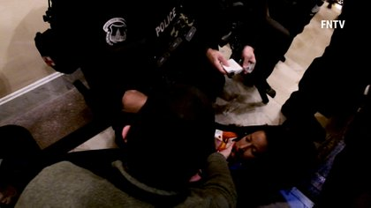
Tribunal Budista de Derechos Humanos: Durante las protestas de manifestantes contra el fraude electoral de la última elección presidencial estadounidense se produjeron algunos muertos. Uno de ellos fue el asesinato extrajudicial de Ashli Babbitt, Veterana de la Fuerza Aérea de USA, quien fue asesinada por la policía tras intentar entrar por una ventana interna del Capitolio. Babbitt fue una oficial de seguridad de alto nivel de la Fuerza Aérea y también una activista libertaria. El Fiscal federal de Columbia abrió una investigación por uso excesivo de la fuerza. Sin embargo, Twitter y Facebook no sólo no criticaron a la policia por el asesinato extrajudicial de esta activista sino que incluso censuraron al Presidente Trump.

Evidencia 4: Críticas de Políticos Internacionales contra la Censura
Tribunal Budista de Derechos Humanos: El Presidente de México, López Obrador, criticó la censura realizada por Twitter y Facebook, considerando que se trata de un mal presagio para el futuro que las empresas silencien y censuren a la libertad de expresión. Incluso, el Presidente López Obrador consideró que podría estar creándose un Poder Mediático Mundial, un Tribunal de censura como la Santa Inquisición para manejar la opinión pública. Incluso el Presidente López Obrador consideró que las normas de Facebook no están por encima de la libertad, del derecho a la información o del papel de las autoridades legales. Al mismo tiempo, otros políticos internacionales criticaron la censura realizada por Twitter y Facebook. Por ejemplo, el Ministro francés de finanzas Bruno Le Maire también condenó la censura realizada por estos gigantes tecnológicos, considerando que son parte de una oligarquía digital que amenaza a la democracia. Al mismo tiempo, Jean-Luc Mélenchon, líder de Francia Insumisa, manifestó que el comportamiento de Trump no puede servir como pretexto para que Google, Apple, Facebook y Amazon se arroguen el poder de controlar el debate público.
Steffen Siebert, German Chancellor Angela Merkel spokesperson: “(freedom of opinion is an essential right of elementary significance) This fundamental right can be intervened in, but according to the law and within the framework defined by legislators—not according to a decision by the management of social media platforms,” “Seen from this angle, the chancellor considers it problematic that the accounts of the U.S. president have now been permanently blocked”
Clement Beaune, junior minister for European Union affairs: “This should be decided by citizens, not by a CEO,” “There needs to be public regulation of big online platforms.”
Manfred Weber, leader of the European People’s Party: “We cannot leave it to American Big Tech to decide how we can or cannot discuss online. Today’s mechanisms destroy the compromise searching and consensus-building that are crucial in free and democratic societies. We need a stricter regulatory approach”
Jonas Gahr Støre - Norway’s left-wing Labor Party leader: “This is a line where freedom of expression is also at stake,” “If Twitter starts with this sort of thing, it means that they have to go around the world and look at other people completely astray, and shut them out.”
Australian Prime Minister Michael McCormack: “There’s been a lot of people who have said and done a lot of things on Twitter previously that haven’t received that sort of condemnation or indeed censorship. I’m not one who believes in that sort of censorship.”
Treasurer Josh Frydenberg: “Those decisions were taken by commercial companies, but personally, I felt uncomfortable with what Twitter did,” “I may not agree with what you say, but I defend the right to say it”
Senator Alex Antic, Fellow Liberal Party: “Our democratic process is founded on our ability to share ideas freely and to be exposed to challenging and opposing viewpoints. It is crucial to the integrity of that process that Big Tech companies do not censor one side of the debate,”
Alexey Navalny, Russian opposition leader: “Don’t tell me he was banned for violating Twitter rules. I get death threats here every day for many years, and Twitter doesn’t ban anyone.” “This precedent will be exploited by the enemies of freedom of speech around the world. In Russia as well. Every time when they need to silence someone, they will say: ‘this is just common practice, even Trump got blocked on Twitter'”

