Caso 19: Ronald Lloyd Spencer & “The Church of Shambhala Vajradhara Maitreya Sangha”

Presentado por la Fiscal Maestra Yan Maitri-Shi

HONORABLE JURADO DEL COMITÉ INTERNACIONAL DE ETICA BUDISTA (CIEB) y TRIBUNAL BUDISTA DE DERECHOS HUMANOS (TBDH)
Tras la Legitimación y Validación de las Pruebas, Evidencias y Cargos por parte del Maestro Budista Maitreya, Presidente y Guía Espiritual del CIEB-TBDH, se aborda el caso frente al acusado, Ronald Lloyd Spencer & “The Church of Shambhala Vajradhara Maitreya Sangha”. Esta investigación fue iniciada por el Comité Internacional de Ética Budista a partir de la denuncia realizada por Maitreya Buddhist University.
A continuación se enumeran los Cargos por los cuales el Comité Internacional de Ética Budista está acusando a Ronald Lloyd Spencer & “The Church of Shambhala Vajradhara Maitreya Sangha”:
- FRAUDE ESPIRITUAL
- FALSO BUDISMO
Por lo tanto, se detallan una serie de EVIDENCIAS que fundamentan los Cargos aludidos para que los miembros del Jurado decidan acerca de la posible “Responsabilidad”, “Inocencia” o “Insania” del acusado. Dichas evidencias son provenientes de medios gráficos y audiovisuales que han sido reunidos, ordenados y confirmados en su orden y contexto como Medios Probatorios para efecto de conocer, establecer, dictaminar y determinar la Responsabilidad del Acusado por la comisión de los Cargos anteriormente mencionados.
El Procedimiento establecido en los Estatutos del COMITÉ INTERNACIONAL DE ETICA BUDISTA & TRIBUNAL BUDISTA DE DERECHOS HUMANOS da la ostentación a ambos Órganos de gozar de independencia y libertad de la regulación y control estatal y nacional, además de poseer la legalidad y actuación como Pueblo Budista para hacer valer sus costumbres, tradiciones, prácticas, procedimientos, juicios y derechos, así como el actuar en pos del desarrollo de la Espiritualidad y la Ética Budista, así como de la defensa de los Derechos Humanos Internacionales. Este procedimiento tiene la particularidad, singularidad y distinción de tener: “Jurisdicción Especial del Derecho Tribal” y ”Jurisdicción Universal del Derecho Internacional”, teniendo así el Carácter, la validez Jurídica, las Facultades Legales, la infraestructura, la Capacidad y Formación necesaria para ser Actor, Administrador y Ejecutor de Justicia en este rubro y ejercicio, determinando la “Responsabilidad” del Acusado por medio de un Juicio Ético que tiene como Propósito la Verdad, la Reconciliación y el Aprendizaje.-

DETALLE DE LAS EVIDENCIAS

Comité Internacional de Ética Budista: En Estados Unidos existen miles de sectas. Una de ellas es liderada por Ronald Lloyd Spencer, quien alega ser la reencarnación de Siddharta Gautama y Jesús de Nazaret. Él ha creado una secta religiosa supuestamente budista, aunque absolutamente ninguna de sus enseñanzas es budista. De hecho, en realidad, Ronald Lloyd Spencer enseña esoterismo y vende productos de geomancia y curación parapsicológica, utilizando de manera fraudulenta e ilegítima la imagen del Budismo. A través de este FRAUDE ESPIRITUAL Ronald Lloyd Spencer ha recaudado cientos de miles de dólares, alegando falsamente que ese dinero será utilizado para la reconstrucción de templos en el Tíbet y otros países, por lo que se aprovecha de personas ignorantes que desconocen sobre Espiritualidad Budista tanto en Estados Unidos como en Asia, a quienes ha estafado sistemáticamente utilizando el nombre de “Maitreya the Christ”, lo cual constituye un daño y ofensa enorme a la cultura milenaria del Budismo.

Evidencia 1: Disfrazados de Monjes Budistas crean un templo de Esoterismo, alegando falsos antecedentes budistas
GLENDA ANDERSON (THE PRESS DEMOCRAT): “The Church of Shambhala Vajradhara Maitreya Sangha Monastery sits atop a mountain overlooking Clear Lake like a mirage hinting of exotic mythical temples. (…) Each structure includes underground levels that are connected by passage ways, a rabbit warren structure that helps conserve energy. Spiral stairways link the above- and below-ground levels. The design of the monastery near Kelseyville is intended to enhance spirituality and the environment, said Lama Daniel, a former London lawyer who gave up his worldly ways to become an American Buddhist monk. The monastery incorporates green living and building technologies with sacred geometric patterns that stimulate healing of the soul, he said. (…) The monastery is on 160 acres purchased in 2006 for about $375,000, according to Lake County documents. The finished product is expected to cost $1.5 million to $2 million. Construction began in 2008 and has yet to be completed but the complex already is home to a small population of nuns and monks as well a handful of yaks and llamas. Upon completion, it will be open to the public for spiritual healings and retreats. The monastery is the brainchild of an American-born (…) Ronald Lloyd Spencer (…) in a written statement said Tibetan masters came to his home when he was 9 years old to tell him he was Buddha Maitreya, the reincarnation of Buddha. He said his parents rejected the Tibetan masters' news and he did not pursue his calling until he turned 30. According to the organization, (Mr Spencer) founded the Buddhist Association of North America, built several monasteries, including in Tibet, and meditation centers in India, Nepal, China, London, Sedona, Arizona, Napa and Santa Rosa. The meditation centers focus on Soul Therapy, a trademarked system using sacred design and geomancy. They utilize crystals, magnets and wire in geometric designs to assist in the soul healing. Healing tools are suspended over beds in private meditation rooms in the domes and in the pyramid building, where (…) etheric weavers hang in a chapel-like room with speakers emitting the calming voice of (Mr Spencer). (…) A variety of etheric weavers and pendants in geometric shapes can be purchased online. The money from the devices, which start at about $80 (…) has given more than $3.7 million to support the renewal and restoration of Tibetan Buddhist monasteries and sacred sites in Nepal, India and Tibet, said.”
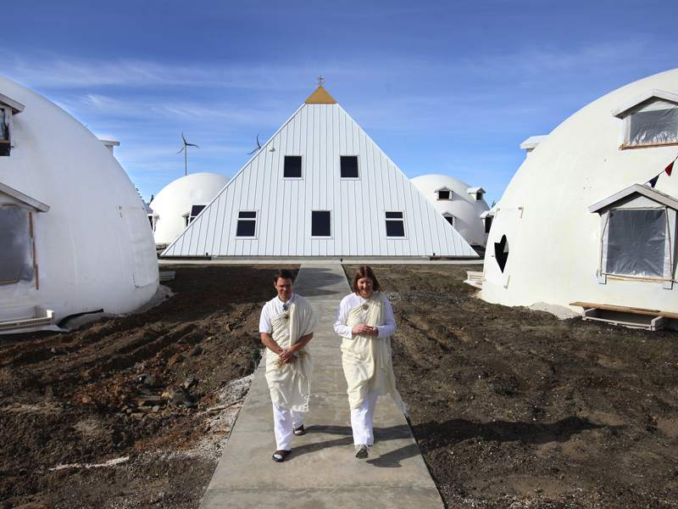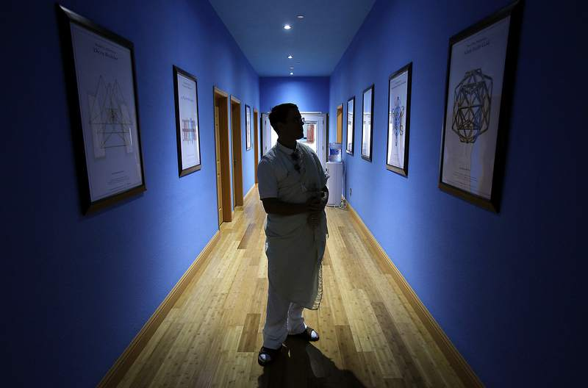
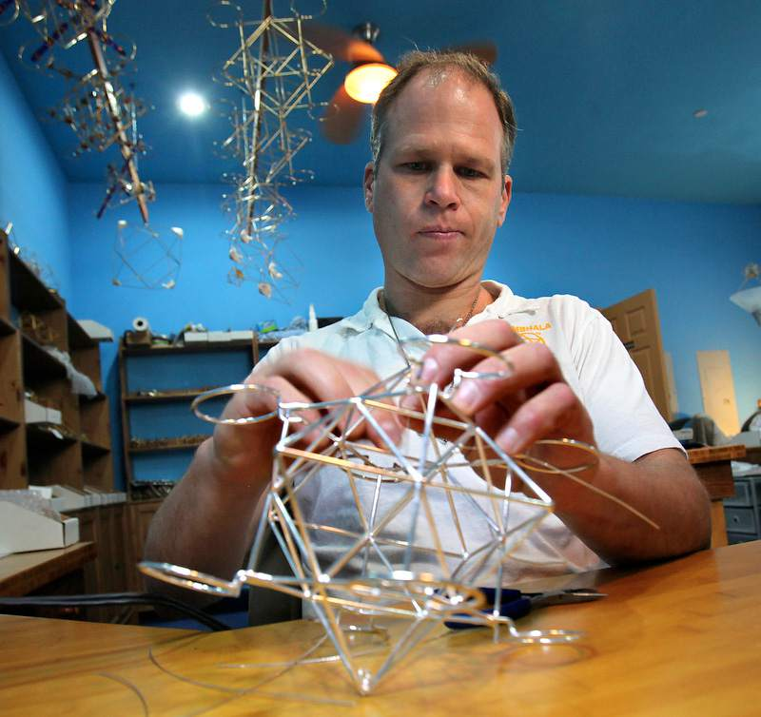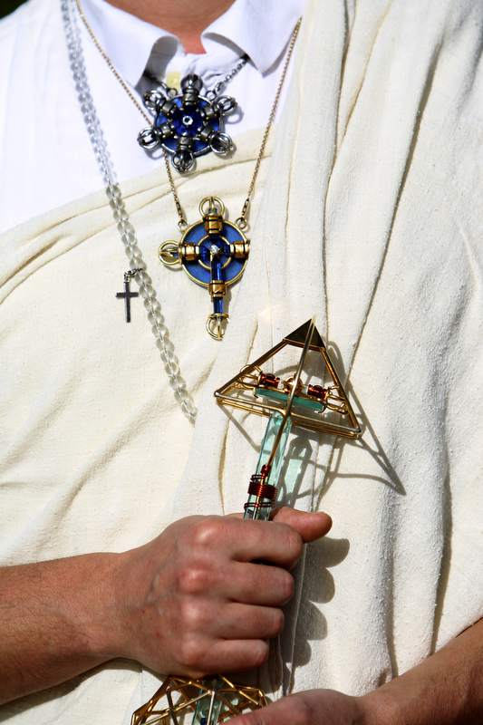
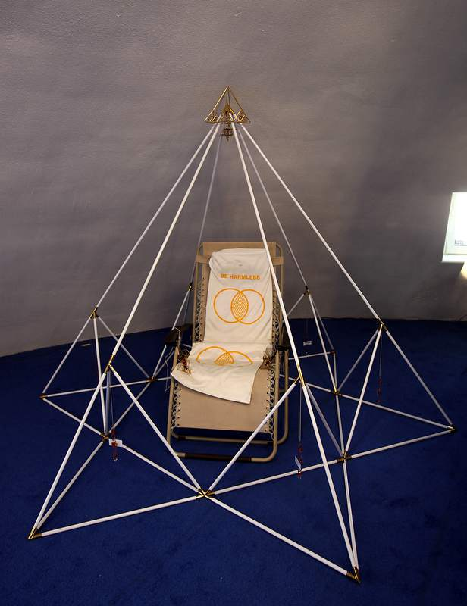
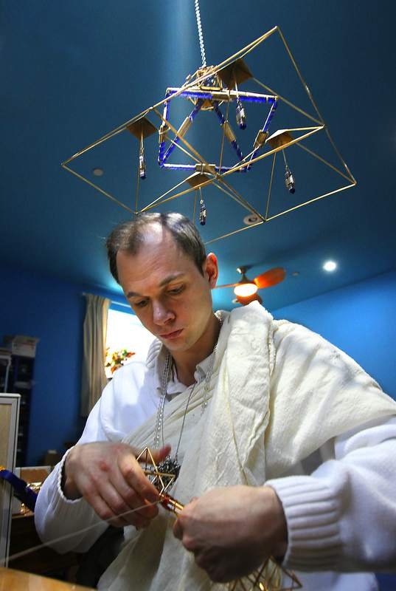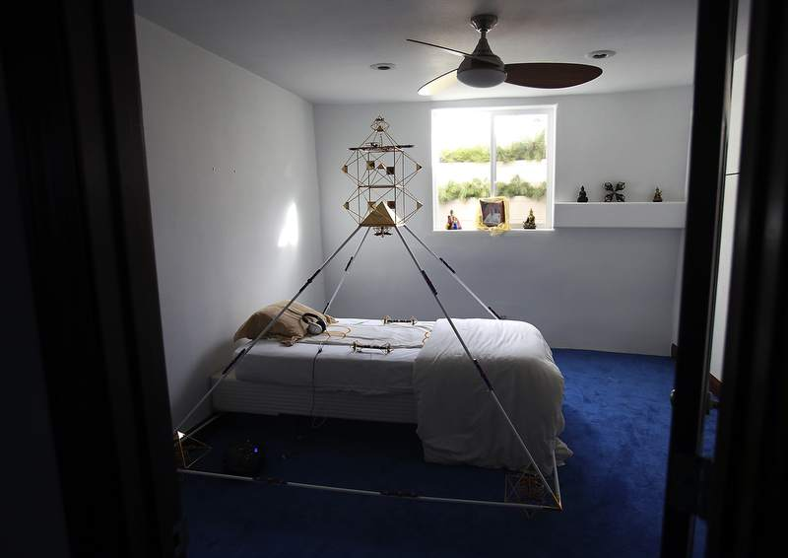

Evidencia 2: Engaño
Rick Ross: “A former truck driver who now runs a cult in California (…) announced on radio that he and the Dalai Lama of Tibet are working together. Ronald Lloyd Spencer (…) says that he and the Dalai Lama will soon be sitting on throne seats next to each other. Spencer runs therapy and retreat centers in Mt. Shasta, California and Omaha, Nebraska. He made these and other bizarre claims on his radio shows, which are broadcast in the Bay area of San Francisco on 1450 KFST FM, KNRY 1240 AM in Santa Cruz and in Omaha on KKAR Talk. (…)Mr. Spencer is a liar. A former secretary who served His Holiness the Dalai Lama and is now at Stanford University (…) Secretary Tenzin Geyche Tehton added that what Spencer says concerning the Dalai Lama is totally nonsense and simply rubbish. (…) It seems Mr. Spencer collects donations for lifesaving assistance, which may explain how he managed to arrange various photo ops to show supporters and to post at his website. (…) his sordid past includes theft, sexual abuse, fraud and brainwashing. One of his victims referred to him as little more than a con man. Spencer may say that donations help in the restoration of [Tibetan] monasteries, but you won't find a detailed and independently audited financial statement on his website, to demonstrate dollar-for-dollar how the money is spent. One former Spencer confidant observed, I pity the poor monasteries that cannot possibly have the slightest hint about how he is using them. Spencer also sells an array of pricey metaphysical contraptions and amulets, some supposedly designed for etheric healing. He claims, all profit from sales is donated to Tibetan monastery renovations and sponsorship of exiled Tibetans. Ron Spencer staffs his Soul Therapy and Shambhala Retreat Centers, largely with Americans he calls monks. These devotees manufacture the contraptions he hawks, but often receive little more than room and board. (…) an eclectic mix of New Age beliefs that includes everything from the Archangel Michael to the Lost Continent of Atlantis. Spencer even promotes theories about UFOs. However, these are certainly not doctrines His Holiness the Dalai Lama would recognize. (…) (Spencer) has been divorced, remarried and has children. (…) also has a history of recreational drug use and is a hemp enthusiast. Well, it's a free country and as they say (…). But it seems Spencer's sailing shouldn't be subsidized by trading on the respected name of the Dalai Lama of Tibet.”
Ratna Henry Chia: “(Ronald Lloyd Spencer), an American man born in 1951, declares that he is (…) the reappearance of Christ, the Buddha. (…) And his name and title are changed time to time: Archangel Michael, Tulku Karma Sonam Phuntsok Rinpoche, Babaji, Tulku Je Tsong Khapa Gyalwa Rinpoche, Lama Dorje Buddha Maitreya Jesus Archangel Michael and last but not the least the American Buddha. (…) An official email from the Office of His Holiness the Dalai Lama regarding (Spencer): Dear Ratna Henry Chia, Thank you for your email. I am to inform you that the person you mentioned in your email as being a tulku has never been endorsed or recognised by His Holiness the Dalai Lama. We had received quite a number of letters and emails recently and in the past regarding this. With best wishes, Tenzin Wangden Andrugtsang. (…) ”
CultNews.com (November 09, 2002): “Spencer claimed on his radio show, “that [the Dalai Lama of Tibet] will retire next July and in recognition of Buddha Maitreya…crown him…and hand over all…ashrams…as well as [his] spiritual seat to Spencer. This announcement was made on Spencer’s Shambhala Hour program, which is broadcast in the Bay area, Santa Cruz and Omaha, Nebraska.”

Evidencia 3: Maltrato a Monjes Budistas
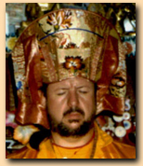
CultNews: “(Spencer) got mad when some monks he hosted from Tibet wouldn’t recognize that preposterous title. Ronald Lloyd Spencer’s Church of Shambala, which has been called a cult, sponsored seven monks to make the journey to America. However, it seems when the monks refused to recognize Spencer as the reincarnation of Buddha the church abruptly withdrew its support, their religious visas were revoked and a dozen immigration officers in riot gear showed up to arrest them… After the negative fallout from this it seems a legal settlement was struck between the would-be Buddha and the mistreated monks. According to a document dated March 9th and recently forwarded to CultNews that settlement not surprisingly includes what is commonly called a gag order. It states, In the interest of settlement of all differences, legal disputes, claims and causes of action, the parties, including their legal representatives, agree not to have any further contact with the media, which includes newspaper, television, radio and internet websites, or any other media form for the purpose of discussing any issue of the Monks and the Church of Shambala and the dispute regarding the visa revocation… (…) The Church of Shambala and the Monks recognize that there are differing accounts of the events leading up to the arrest of the Monks and thereafter but wish no further reporting on this matter… Well, it looks like the monks got a good lawyer and Ron Spencer wants everyone kept quiet. Daniel Honeywell, Spencer’s disciple and representative, said that the document he forwarded via email to CultNews was supposedly self-explanatory (…). Hopefully, what flows from all this is that the monks were well provided for and traveled back to their native land peacefully and in comfort. Though the matter might have been concluded better if Spencer and his church offered them a public apology. But despite the settlement, which essentially silences the monks on the matter, this self-proclaimed Buddha has been busted as an egotist and certainly less than hospitable host to say the least. CultNews thinks it will require virtually endless reincarnations according to Buddhism before someone like Ron Spencer ever reaches spiritual maturity.”

Evidencia 4: Estafa
Cult Education Institute (quoting an old friend of Ronald Lloyd Spencer): “My experience with Ron was actually quite a while ago, in Honolulu, Hawaii about 1983 to 1984. I lost all contact with him after that time period. I am writing this now because I just happened to run across one of his centers in Mt. Shasta, California, the Archangel Michael Soul Therapy Center. I met this very nice girl running the center who was totally ignorant of Ron's past history. In those days in Hawaii, he had not yet developed his Buddhism angle, although the roots of that were evident. He was then totally into exploiting the New Age trends of the time. Crystals and pyramids were all the rage, and Ron knew how to play with them. In my first introduction to the small group that had formed around him, a good friend encouraged me to meet and then continue with Ron. After my first meeting I was told that if I was to be in with the group I should buy a cheap shiny pyramid necklace pendant for $150.00. This demonstrated to me right away what Ron was and still is mainly interested in, money. I was a student at that time and did not have that kind of money to spare. Ron found out I had credit card though and it turned out he had to have a $1,000.00 stereo system for his magic. He assured me that if I purchased the stereo for him he would pay me back shortly. Ron also required precious stones for his ceremonies. He saw my mother's diamond engagement ring that I wore, and said he wanted to borrow it just for a certain ceremony and would give it right back. Weeks went by and I frequently asked him for the credit card payment and my mother's ring back, but there was always some excuse or another, but a not to worry, I would get them back soon. Meanwhile, Tai Situ Rinpoche, a truly distinguished Tibetan Buddhist teacher, was visiting Hawaii and gave several lectures at the University of Hawaii, which I was attending. Tai Situ Rinpoche made quite an impact in Hawaii at that time. Ron claimed that he was a very close friend of Tai Situ Rinpoche and announced this widely to promote himself. At that point I was beginning to suspect Ron's behavior and motives, and was strongly suspicious of this claim. I made a private appointment with Tai Situ Rinpoche the next day. I asked him if he knew Ron Spencer. He did not recognize the name (…). He had absolutely no relationship or any other contact with Ron of any kind (…). I was losing hope of ever getting my ring or money back. Meanwhile, bad things were happening to the sister of my friend who first introduced me to Ron. My friend (a girl), her sister, Ron, and Ron's wife and child were all sharing a house that my friend was paying for. My friend told me that her sister was having an emotional crisis. She did not know what was going on, but we found out later after Ron skipped town, that Ron was sneaking into her room after his wife went to bed and was having sex with her. He claimed that this was for her spiritual benefit and used crystals and other magic objects inserted into her body. One of the people in the small hardcore group that followed Ron around was an ex-prostitute. Although she had ended that life and moved on, Ron convinced her that her bad karma could only be healed if she gave him all her salary. This, the poor lady did with joy, informing us that only now were her sins being forgiven, by Ron. Others of this group also were supporting Ron financially. Perhaps he needed all he could get, because of the huge intake of drugs he seemed to require, mainly marijuana and LSD. I wonder if he still uses drugs to the extent he once did. I was emboldened by my interview with Tai Situ Rinpoche. I started to tell my friend of Ron's lies and theft. From me and from observing her sister's problems, my friend also became suspicious, even though she had been Ron's main financial benefactor. Shortly thereafter Ron left Hawaii very suddenly, with, of course, my ring and the unpaid bill. That was the last I heard of this con man until my Mt. Shasta visit. It was interesting going through Ron's Mt. Shasta center and looking at his website. I can readily identify the source and see the flow of all the nonsense he inflicts upon his poor victims. I personally love and learn from Buddhism and am especially outraged that Ron appears to be exploiting this profound wisdom now as his latest con. Even though his writings on the website are barely literate, there is some skill to all of his lies and distortions. It looks like he even has finally made it to the East to take photos with legitimate Tibetan Buddhists. I pity the poor monasteries that cannot possibly have the slightest hint about how he is using them and who he really is. Now he is supposedly the Buddha and Jesus.”
Guruphiliac: “(Ronald Lloyd Spencer) runs the Tibetan Foundation/Church of Shambhala [bold italics ours], which apparently has little to do with Tibet and a lot to do with Ron's appropriation of Tibetan Buddhism as a means toward his own economic benefit and ego-aggrandizement. (…) But before Ron was the second coming of Buddha and Christ, he was just another NewAge™ flimflam man living in Hawaii. (…) A money scammer (…) The real question is whether Ron is knowingly impersonating the Buddha or if he actually believes he is the Buddha. It's a very important distinction. In the former he is an out-and-out con man and criminal, in the latter he's merely another insane guru with enough ninnies around who believe in him to keep him going. (...) For the moment, we're going with the former.”

Evidencia 5: Lucro con Falsos productos metafísicos
Ratna Henry Chia: “(Spencer is selling) etheric healing tools! So bulky! I have never seen such things in Tibetan Buddhism. Very Expensive! Some of them costs more than USD300.00! No wonder Ron Spencer is so rich (…) Blue Syberian Agni Suryan Vajra – Price: USD655.00. Maitreya Christ Principle Ascension Vajra – Price: USD430.00. Christ Consciousness Vajra – Price: USD720.00. Deva Padmasambhava Ghanta – Price: USD345.00. Earth Angel Dharma Tetragramation Vajra – Price: USD460.00. Dharma Double Dorje *24K Gold Plated* – Price: USD440.00. The Earth Dharma Double Dorje – Price: USD720.00. Solar Cross *24K Gold Plated* – Price: USD740.00. Metatron Solar Cross – Price: USD800.00. Crystal Ascension Solar Cross – Price: USD900.00. Metatron half Mat System with Clear Crystal Etheric Weavers – Price: USD550.00. Metatronic Geometric Forms: Metatron Cube – Price: USD280.00. The Pyramid Meditation Solar Ascension System – Price: USD2500.00. Quartz Crystal Singing Bowls – Price: USD200.00. Shambhala Solar Forms: Shambhala Star – Price: USD565.00. A set of 10 Etheric Weavers for Healing the Etheric Field Awakening Buddha Nature – Price: USD972.00.””

Evidencia 6: Comportamiento sectario y Lavado de cerebro
Cult Education Institute (quoting a former follower of Spencer): “I heard about a certain Buddhist group that used metatronic tools and based their understanding of the soul and individual personality upon rays of light. Each ray was supposedly associated with certain distinct personalities. This appeared at first to be mystical and very cerebral--fitting within my previous studies and understanding of Kaballah. I met a so-called Buddhist monk, ordered their books and signed up for a darshan (i.e. one-week intensive seminar) in the mountains of Mount Shasta, California. (…) Everybody was asked to dress completely in white and bring a tape player. I traveled light--thinking that this was the guru I had been searching for. (…) We quickly lost our sense of connection with the outside. (…) The monks worked 18 or more hours every day without complaints. Everyone was honored and grateful to be a part of the ashram or Sangha House as it was called--supervised by (Spencer). (…) Later, I would come to understand that everything he criticized, concerning incorrect behavior and thinking--were actually things he was doing. How he labeled it as wrong within others, but got away with it himself--was a piece of his brainwashing. He wanted to separate us from everything but himself [see Milieu Control]. If we gave our individuality up and followed him we could remember our pure soul [see Demand for Purity] and find the many awesome answers we had all been looking for. How easy it seemed. Why not? We would be eating such wonderful, blessed food (from the same menu) and be with the reincarnation of Buddha and Jesus too. (…) Our money was spent for the darshan, tools and books. Everything was blessed and there were very beautiful crystals in the metatronic designs. All of (Spencer) designs were supposed to be telepathically sent to his monks (…). If something didn't seem right, went unexplained or was questioned, never mind--it was somehow related to the fact that we were processing and/or awaking old soul material [see Doctrine Over Person]. (…) I seemed to have answers for everything. Everything had a simple answer, but the answers were not mine. Actually, everything was not mine--I had become part of someone else. Someone else was giving directions now and I didn't have to worry. What a relief! My soul was being integrated. I kept in communication with the other participants and we planned our next darshan on (Spencer) birthday--we were invited, chosen and special. Now it was time for intense soul therapy. I bought a pyramid from the group, other tools and kept reading their books about the rays (Tapestry of the Gods) and played their music. Mind stilling, hypnotic, subliminally suggestive music with drumming, chanting and (Spencer)--continuously lecturing while the music played rhythmically in the background. He lectured about the rays and other beliefs. All the tapes and compact discs I purchased from the group were carefully put together by (Spencer). My friends and family were silent about what I had stepped into. If something had been said something to me--it probably would have fallen upon deaf ears. The people in my life listened politely. I told them about using the tools that seemed to posses some energy and the books that gave me the deeper understanding that I had always searched for. Of course (Spencer) was becoming ever more present in my consciousness. I began giving him more and more credit for the positive changes in around me. But why? After two more darshans that involved a close friend--we were invited to join the Sangha --an extended group that was closely aligned with a worldwide ashram. Our enlightenment and recapitulating then would occur at an even faster pace. The clothes were ordered, but before they arrived someone said, You might be part of a 'cult.' Whamo! Me in a cult? I tried to shake it off, but knew it was true and it blew my socks off. I had been betrayed, spiritually raped and I was mad. I had also brought a close friend into this. I now felt the embarrassment of sharing with friends and family the so-called tools and the pyramid at my office. Now I was apologizing for everything previously said. After making apologies I started to spread the news and contacted others involved. Looking back it is hard to believe that I entered such a trap under the influence of someone who now appears be a master con man. But before when people close to me said, You are acting strange--I just saw them as the lost ones [see Dispensing of Existence]. In the beginning I received so many calls from the ashram center either trying to sell me something, or arrange for another darshan. I should have known. The monks work long hours and risk injuring themselves and others by driving without sleep. I should have known. It should have been obvious too through the music (with Spencer droning voice offering his lessons), which played 24 hours a day--that we were being continuously programmed. We were not allowed to get away and there was no free time. (…) Doubts came and went, but the music always seemed to be pulling me back and I wanted to believe. I ignored all the warning signs because it was so comforting belonging to and being part of such a special group of like-minded seekers. I realize now that there was a widening gap of separation developing through my group experience, which was pulling me away from my personal roots and individual value system. This should have been my first clue. Anything that tends to pry you away from your family and values should at least be suspect. I had always been very trusting--especially regarding people who held positions of respect. Maybe this was naïve, but that was my early schooling. Sadly, it seems time for me move beyond those childhood ideals--gradually a balance is emerging. Ron Spencer appears to have an ugly background. Ron seems to be a common con man who exploits others. He has had several wives and left behind children. He may have been wanted once by the English authorities and is being watched more carefully here in the states. There have also been allegations of sexual abuse and exploitation between Ron and at least one former female follower. When I started looking into various allegations regarding Ronald Spencer he responded by claiming I had lost it was emotionally unfit and trying to manipulate others. He was playing his mind games again. Subsequently I was excommunicated and designated within his category of Dark Lodge [a negative term used by the group--see Loaded Language]. The supposed Dark Lodge can be a pretty lonely place, but it was heaven compared to where I was once headed for. Since being excommunicated I began to read a highly recommended book, Captive Hearts, Captive Minds by Tobias. After the first three chapters it became clear to me that I had been with a real Psychopath --someone without feelings, only out for their own gain, exploiting and power tripping over others. A very sick man. It made me sick to think that I had taken the bait and was so close to being reeled in. But that sickness was the first part of healing for me and I worked through it and probed that discomfort to better understand the experience and myself. Thankfully, there were others willing to help in that process. Many issues and relationships seem clearer to me now. Maybe it sometimes takes shaking things up a bit --to get the dust off and clarify things through a new perspective. Finally though, I concluded that [Ron Spencer] had ironically given me an opportunity to grow and realize the importance of self-introspection. I find myself actually thanking him for that. And I would rather be thankful than resentful, which seems like a more positive attitude for my recovery and healing. After all that I have experienced it seems to me--that when we feel lonely and isolated we should not go searching for something outside of ourselves. But look inside instead--for a deeper and more loving sense of who and what we are and hopefully a better understanding of our own individual self worth.”

Evidencia 7: Falsas Enseñanzas Budistas
En el siguiente video puede apreciarse cómo Ronald Spencer transmite enseñanzas que no son budistas, asociando su enseñanza con Dios y con la venta de productos esotéricos fraudulentos:
-Dharma - A Relationship with God https://www.youtube.com/watch?v=xOmmThZ12YE

-Soul Therapy® Meditation Pyramids https://www.youtube.com/watch?v=v4xJ6togTSg
-Estafas realizadas en Asia https://www.youtube.com/watch?v=v4xJ6togTSg

Evidencia 8: Falso Monasterio Budista
A continuación se detallan los falsos servicios que provee el supuesto Monasterio Budista de Ronald Spencer:
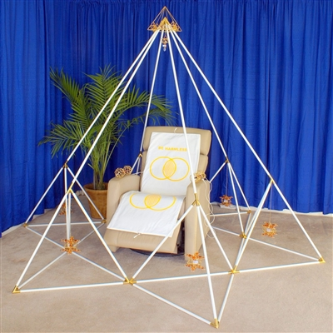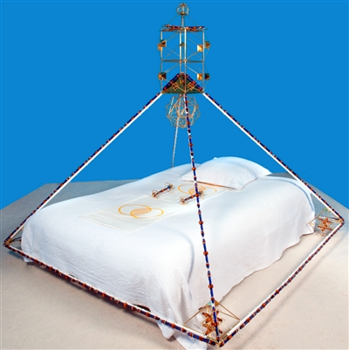
1 hour private Soul Therapy® meditation in Buddha Maitreya the Christ's Metatron Pyramid. Choose to do Soul Therapy either in person at the Buddha Maitreya the Christ & Tara's Shambhala Planetary Healing Monastery in Northern California or at The Buddha Maitreya Soul Therapy Centre in Glastonbury, UK or as a distance healing for yourself or a loved one. Offering $51.50
1 our private Soul Therapy® meditation in Buddha Maitreya the Christ's Full Crystal Shambhala Ascension Meditation Pyramid. Choose to do Soul Therapy either in person at the Shambhala Planetary Healing Monastery in Northern California or at Buddha Maitreya's Soul Therapy Centre in Glastonbury, UK or as a distance healing for yourself or a loved one. Offering $51.50
Brainwave Optimization® - Relax Your Brain. Optimize Your Life. http://www.shambhalahealingtools.com/Brainwave-Optimization-s/35127.htm
"The Church of Shambhala Vajradhara Maitreya Sangha Monastery is an ecological center, but the main reality of the monastery is the sacred design used in every aspect of the monastery: the phi ratio from the central pyramid, the pyramid being 51 degree, the 6 dome circles placed around the pyramid in a 6 pointed star, the 51 degree pyramids placed over each dome and the fact that all residential and retreat rooms have 51 degree pyramids facing north, all based on the sacred human form and its relationship to sacred forms that help the soul to awaken and transform lower mind and lower emotions to become more spiritually incarnated on the physical level for both the person and for the planet, as the sacred temples built all over the world are universally connected. This helps the United States in becoming healed as nation. This awakens the nations to Love and Healing to avert wars and the political support of these wars."

Evidencia 9: Profanación y uso fraudulento de los títulos “Buddha” y “Cristo”

En el siguiente link se aprecia cómo Ronald Spencer afirma ser la encarnación de Gautama y Jesús: http://www.buddhamaitreya.org/Buddha_Maitreya/About/
En el siguiente link se aprecia cómo Ronald Spencer ha creado una falsa biografía espiritual, en la cual afirma ser la única encarnación de Buddha y Cristo para intentar legitimar su fraude: “The combination of applied magnetics, crystal and sacred geomancy creates an energetic reality of transmission - a science developed by Buddha Maitreya the Christ called Metatronics. The natural healing of chakric energies that takes place, along with the integration of the etheric field makes a connected whole per- son with the revelation of higher mind. This energetic shift prepares each person to receive Buddha Maitreya the Christ’s transmission of the Soul.
His blessing dissolves past karma, helps people to heal and experience the love and connection through their etheric field (mind, body, emotions) to the Lord who is always present in every life and at every death. Buddha Maitreya the Christ walks the path of harmlessness in each life. He is known in previous lives as Buddha, Christ and Krishna and imparts that consciousness to every living being.”
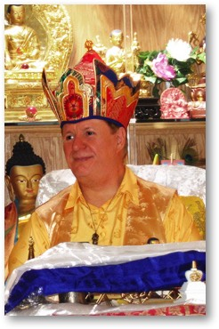

GLENDA ANDERSON (THE PRESS DEMOCRAT), A taste of nirvana in Lake County April 7, 2011 http://www.pressdemocrat.com/news/2295659-181/a-taste-of-nirvana-in?gallery=2356757&artslide=0
Rick Ross, California "cult" leader makes "baseless" claims about the Dalai Lama of Tibet. November 01, 2002 http://www.cultnews.com/archives/000281.html
http://chagchen.org/2006/07/03/more-on-the-maitreya-flake/
CultNews,“CULT” LEADER CLAIMS HE’S BEEN TAPPED AS THE NEXT DALAI LAMA OF TIBET. https://cultnews.com/2002/11/cult-leader-claims-hes-been-tapped-as-the-next-dalai-lama-of-tibet/
CultNews, “Buddha” busted, 2006-03-12 https://cultnews.com/2006/03/buddha-busted/
My Experience with Ron Spencer (aka "Buddha Maitreya") January 2002, https://culteducation.com/group/1149-shambhala-soul-therapy/19245-my-experience-with-ron-spencer-aka-buddha-maitreya.html
Buddha Baiting For Fun And Profit, Wednesday, February 15, 2006 http://guruphiliac.blogspot.com.ar/2006/02/buddha-baiting-for-fun-and-profit.html
http://chagchen.org/2006/07/03/more-on-the-maitreya-flake/
Whamo! Me in a cult? March 15, 2000 https://culteducation.com/group/1149-shambhala-soul-therapy/19244-whamo-me-in-a-cult.html
http://www.shambhalahealingtools.com/Buddha-Maitreya-Shambhala-Monastery-s/41665.htm
http://www.buddhamaitreya.org/Buddha_Maitreya/About/
http://www.buddhamaitreya.org/Buddha_Maitreya/Biography/Incarnations/#1

