Caso n° 08/2015:
AUSTRALIA

HONORABLE JURADO DEL COMITÉ INTERNACIONAL DE ETICA BUDISTA (CIEB) y TRIBUNAL BUDISTA DE DERECHOS HUMANOS (TBDH)
P R E S E N T E . –

En la presencia del Presidente y Guía Espiritual del CIEB-TBDH Maestro Budista Maitreya, y de la Secretaria Ejecutiva del CIEB-TBDH Maestra Yan Maitri-Shi, se aborda el caso denunciado por la World Association of Buddhism (WBA) frente AUSTRALIA por los Delitos de PERSECUCION, EXTERMINIO ANIMAL, ECOCIDIO, DEFORESTACION, CONTAMINACION MARITIMA y Los que resulten, siendo una clara y penosa violación y falta de respeto a la vida animal, vegetal y a las aguas de este país.-

Sekkha Dhamma, en cuanto Fiscal del CIEB y el TBDH, reconozco el arduo y organizado trabajo que se realizó para la amplia recopilación de Pruebas en este caso, de igual forma, agradezco la aportación de las mismas para el análisis que concierne a la Parte que represento. Dicho esto, con el debido respeto comparezco a exponer:
Recibido el listado de medios digitales que fueron reunidos, ordenados y a la vez confirmados en su orden y contexto como Pruebas por parte de la Secretaria Ejecutiva del CIEB y TBDH Maestra Yan Maitri-Shi, doy paso a la Cuarta Etapa del Procedimiento denominada: “VALORACION DE LAS PRUEBAS”, misma que se establece en el Acta Constitutiva del CIEB y TBDH para efecto de conocer, establecer, dictaminar y determinar la Responsabilidad por la comisión de los Delitos de PERSECUCION, EXTERMINIO Y GENOCIDIO ANIMAL, ECOCIDIO, DEFORESTACION, CONTAMINACION MARITIMA y Los que resulten como responsabilidad del gobierno de AUSTRALIA y el Ministro de Medioambiente Greg Hunt, incidiendo con ello en Violación de los Derechos de los Animales (gatos y demás especies animales afectadas) que pretende erradicar con tácticas depredadoras, crueles y atroces. Esta Acusación fue realizada por la WORLD ASSOCIATION OF BUDDHISM en el ámbito de la Ética Budista, acto que sigue a continuación:

VALORACION DE PRUEBAS
PRIMERA VALORACION.- Al ser la parte medular de esta parte procesal, es necesario señalar los Medios Probatorios ofrecidos por la Secretaria Ejecutiva del CIEB y TBDH Maestra Yan Maitri-Shi, y presentarlos formalmente al Jurado para su conocimiento, mismos que se componen de 12 Evidencias que validan la Acusación motivante del actual proceso, intituladas con una amplia gama de Delitos cometidos en contra de la Flora, Fauna (gatos salvajes y domésticos, así como otras especies animales que se afectan consecuentemente de la persecución salvaje y eliminación felina) y Aguas Australianas. Lo anterior, denunciado desde el campo de la Ética Budista. Estas Evidencias provienen de medios digitales audiovisuales de dominio público (medios de comunicación), mismos que se enlistan a continuación:

Evidencia 1: PERSECUCIÓN Y GENOCIDIO DE GATOS
Greg Hunt, ministro de Medio Ambiente de Australia dijo: "By 2020, I want to see two million feral cats culled, five new islands and 10 new mainland areas as safe havens, free of feral cats, and control measures applied across 10 million hectares," (https://news.vice.com/article/feline-massacre-australia-unveils-plan-to-kill-two-million-feral-cats)
French animal rights champion, former actress, Brigitte Bardot said in a letter to Australia’s Environment Minister Greg Hunt: "This animal genocide is inhumane and ridiculous, (…) Killing cats to protect other animals is outrageous, you will disperse harmful products, dangerous for all species, without distinction, and death by poisoning is a terrifying pain. In addition to being cruel, killing these cats is totally useless because the rest of them will keep breeding,(…) Your country is sullied by the blood of millions of innocent animals, so please don't add cats to this morbid record" (https://www.rt.com/news/310547-australia-cats-bardot-genocide/ )
Jonathan Pearlman, from The Telegraph UK, said: “Declaring a war on cats, the federal government said it planned to use poison baits and has created a phone app called Feral Cat Scan for the public to alert authorities about areas where large numbers of the predators have been spotted.” (http://www.telegraph.co.uk/news/worldnews/australiaandthepacific/australia/11743499/Australia-declares-war-on-feral-cats-with-plan-to-cull-two-million-by-2020.html)
Jonathan Pearlman, from The Telegraph UK, said: “The government is pushing for tighter regulation of cat ownership and measures to control the population such as desexing and microchipping. (…) Some experts said the government should consider requiring domestic cats to be kept indoors.” (http://www.telegraph.co.uk/news/worldnews/australiaandthepacific/australia/11743499/Australia-declares-war-on-feral-cats-with-plan-to-cull-two-million-by-2020.html)
Damien Licari, an ecologist with Lismore city council, said: “There's no doubt that cats and domestic cats have an impact on small mammals and birds in urban areas, (…) I choose not to own a cat and in times when I have owned cats, they've been entirely indoor cats. I would applaud any change in laws that would lock cats inside.” (http://www.telegraph.co.uk/news/worldnews/australiaandthepacific/australia/11743499/Austraia-declares-war-on-feral-cats-with-plan-to-cull-two-million-by-2020.html)
La Capital, de Argentina dijo: “Las autoridades han colocado cebos y trampas, señaló el responsable de especies amenazadas, Gregory Andrews, quien pidió también a los dueños de felinos que los castren y no los dejen salir. (…)Todos los estados y territorios de Australia han declarado a los gatos salvajes como "plaga" (…) desde que se anunció el proyecto han surgido 20 planes para erradicar a los felinos.” (http://www.lacapital.com.ar/informacion-gral/Australia-matara-a-dos-millones-de-gatos-para-proteger-especies-nativas-20150717-0153.html)
Vice News escribió: “Estos gatos, que están siendo clasificados como nocivos y peligrosos por los estados y territorios de Australia ya se han erradicado por completo en tres islas del país.” (https://www.vice.com/es_mx/read/australia-planea-exterminar-a-dos-millones-de-gatossalvajes)
Seamosmasanimales.com dijo: “Irónicamente, el gobierno ha hecho hincapié en que la erradicación de los gatos se llevará a cabo con humanidad. Aunque está claro que utilizar un veneno no es ético y menos un acto de humanidad sino un genocidio del modo más cruel.” (http://www.seamosmasanimales.com/2015/07/brigitte-bardot-repudia-australia-y-pide-detener-la-matanza-de-dos-millones-de-gatos.html).

Evidencia 2: EXTERMINIO
John R. Platt, from Scientific American: “Most recently 3,000 feral cats were shot during a 16-day period in Queensland to keep them away from a 29-square-kilometer (…)” (http://blogs.scientificamerican.com/extinction-countdown/feral-cats-killed-protect-bilbies/)
Jared Owens, from The Australian, wrote: “Environment Minister Greg Hunt has called for research into a virus to eradicate feral cats (…) Mr Hunt said the government endorsed a dedicated eradication program, the use of island arks that exclude invasive species, and a research into a safe and targeted form of biological control (…) Domestic cat owners would likely be required to immunise their pets against the disease.” (http://www.theaustralian.com.au/national-affairs/greg-hunt-calls-for-eradication-of-feral-cats-that-kill-75m-animals-a-night/story-fn59niix-1226939644027)

Evidencia 3: EXTERMINIO A OTRAS ESPECIES
John R. Platt, from Scientific American said: “Dingoes, which compete with cats and other predators for food, have been poisoned to protect agricultural sheep, but Griffith University researcher Jean-Marc Hero told The Australian last September that this approach gave cats and foxes a chance to fill the ecological gap the dingoes left behind.” (http://blogs.scientificamerican.com/extinction-countdown/feral-cats-killed-protect-bilbies/)
ABC News said: “Earlier this year officials said that close to 700 koalas had been killed off in south-eastern Australia because overpopulation led to the animals starving, while feral camels and wild horses have been culled in the outback to stop them destroying land.” (http://www.abc.net.au/news/2015-07-22/brigitte-bardot-condemns-greg-hunt-for-feral-cut-cull-plan/6640846)
Brigitte Bardot, from Brigitte Bardot Foundation, said: “The public image of Australia is disastrous: Kangaroo massacres, wild horses slaughters… Your country is far from being exemplary (…) Indeed, you are about to scatter harmful chemicals in the wild, potentially dangerous for all species without any distinction. (…) You expose these animals to a death under atrocious suffering. (…). Your country is sullied by the blood of millions of innocent animals, so please, don’t add cats to this morbid record!” (www.fondationbrigittebardot.fr) and (www.abc.net.au/news/2015-07-22/brigitte-bardot-condemns-greg-hunt-for-feral-cut-cull-plan/6640846)
The Conversation said: “If rabbits are culled from an area, but cats aren’t controlled at the same time, then cats might switch prey and eat more small native mammals.(…) Past experience tells us how these programs can go awry. For example, when feral cats were eradicated from Macquarie Island in 2000, rabbit numbers exploded because the cats had kept the rabbits in check. Rabbits caused severe damage to the island’s native vegetation before being eradicated (…) in 2014.” (http://theconversation.com/feral-feast-cats-kill-hundreds-of-australian-animals-35555)
Mike Seccombe, from Saturday Paper, wrote: “Hunt also approved the West Australian government’s controversial, and now abandoned, plan to catch and kill sharks to protect swimmers” (https://www.thesaturdaypaper.com.au/news/politics/2014/12/06/greg-hunts-hostile-attack-the-environment/14177844001333)

Evidencia 4: PETICIONES PARA DETENER LA MATANZA Y SUGERENCIAS DE SOLUCIONES RECONCILIADORAS PARA CONTROLAR LA POBLACIÓN DE LOS GATOS SALVAJES

Mini Kitty Commune (MKC), Australia asked: “Prime Minister Tony Abbott (…) Please stop planned killing of 2 million Australian cats. We don’t want a war on kittens! (…) The Australian Government plans to kill over 2 million cats, with a $3.6m fund established to wipe colony cats off the face of the earth. (…) This high risk initiative includes a website designed to dob in colony cats and a number of cat eradication programs including baiting, shooting, dogs, traps and nearly every method of killing known. (…) We have concerns that this massive war on cats is high risk and significantly dangerous to the community. We ask that the government stop this program to allow public review, put in place solid checks and balances to ensure that this program is not a free for all for cat hating people to dob in cats and destroy colonies of well managed animals. This includes; The huge risk to owned and unowned cats, with baiting programs that could easily go wrong; The risk of cruelty to animals, with trapping, savage dog attacks, shooting and other methods that harm animals; The illogical approach of a “dob in a colony” site, showcasing trapping methods and risking home grown grudges from cat hating people; A risk to all animals through the many methods of death that do not discriminate between cat, dog, possum, bird or any animal.(…) This program should not have snuck quietly into legislation, but been subject to public review and scrutiny. Please stop this program to allow full public review and assurance that millions of animals are not being unnecessarily killed for their only crime, of being a cat. (…) Yours (undersigned)” (http://mkc.org.au/learn/petitioncatwar)

Brigitte Bardot, from Fondation Brigitte Bardot wrote: “Dear Minister, The announcement made by your government regarding the culling of two million cats is appalling the whole international community. May I remind you that cats are, such as dogs, pets. (…) Killing two million cats of a population of 20 million is a scandal, a shame! (…) This animal genocide is inhumane and ridiculous; the 6 million dollars you plan to spend in destroying these animals would be much better spent in setting up a large-scale sterilization campaign. These campaigns have been proven very effective everywhere they have been experienced. My foundation works all over the world with the Australian veterinarians of Vets Beyond Borders to neuter successfully stray animals. (…) In addition to being cruel, killing these cats is absolutely useless since the rest of them will keep breeding. My Foundation works on this kind of issues for decades and I can assure you that no alternative is efficient but neutering. Sterilized cats will still defend their territory but will no breed anymore. (…) These are the reasons why I implore you, Minister, to dedicate 6 million dollars budget not to cull 2 million cats but to set up a vast sterilization campaign instead. (…) It is high time to stop these barbaric and pointless practices as they put the spotlight on your country the worst possible way. (…) Humane cruelty is limitless but changing one’s mind is a proof of intelligence and humanity. (…) I’m counting on you, don’t disappoint me. Brigitte Bardot.” (www.abc.net.au/news/2015-07-22/brigitte-bardot-condemns-greg-hunt-for-feral-cut-cull-plan/6640846)
Animalspetition.org: “Dear Australian Environment Minister Greg Hunt, (…) You recently announced a plan to kill 2 million feral cats in the country who it says are harming native species, despite the fact that animal rights groups say this won’t do much to help. You claim the cats will be killed humanely, but is there really a way to murder innocent animals who are just trying to survive? (…) I agree with Brigitte Bardot that Bardot the money set to murder innocent animals would be better used to sterilize them and decrease the population in that nonviolent way rather than your plan to shoot and poison the animals. (…) Considering feral cats stem from domesticated cats who became wild, sterilization seems much more fair. These animals didn’t ask to be abandoned from their homes and forced to survive in the wild. I urge you to not unnecessarily murder 2 million feral cats and instead consider more humane options. (…) Sincerely,” (http://animalpetitions.org/114862/dont-murder-feral-cats/)
Damián Di Leonardo, de Argentina: “Dirigido al ministro de medio ambiente de Australia el Sr. Greg Hunt y el embajador australiano en Argentina el Sr. Noel Campbell: (…) Hago el pedido de anular la decisión de exterminar a los felinos ya que atentan contra la ley mundial de protección animal aplicando el uso de veneno "Eradicat" y trampas terrestres o el intento de traer enemigos naturales que solamente encarecen sus propios bolsillos. La única manera que propongo es que con ese dinero se haga un programa de esterilización masiva para los gatos callejeros y una posible migración de estos a otras zonas que no alteren la convivencia con otros animales. (…) English version: (…) To the Minister of Environment Mr.Greg Hunt Australia and the Australian ambassador to Argentina Mr.Noel Campbell (…) I order to annul the decision to exterminate the cats because they threaten the world animal protection law applying the use of poison "Eradicat" and land cheating or attempting to bring expensive natural enemies that only their own pockets. The only way I propose is that with this money mass sterilization program for stray cats and a possible migration of these other areas that do not alter the coexistence with other animals do.” (https://www.change.org/p/greg-hunt-noel-campbell-anular-la-decisi%C3%B3n-de-exterminar-a-gatos-callejeros-por-supuesto-da%C3%B1o-ecol%C3%B3gico?recruiter=57117040&utm_source=share_petition&utm_medium=twitter&utm_campaign=share_twitter_responsive)
Arian Wallach, University fellow at Charles Darwing University and Daniel Ramp, Senior Lecturer at University of Technology, Sydney, wrote: “let’s embrace cats as part of Australia’s environment. We could even rename them Australian wildcats. (…) what may seem counterintuitive is that leaving cats alone can also benefit Australia’s threatened native species (…) Many cats do live among us, but most now exist in a completely wild state, including in the middle of the driest of deserts and the lushest of rainforests. Sterilisation can help reduce the number of house cats without a home, but it will not benefit wildlife away from cities. We need to move beyond thinking about cats as either wards or enemies. (…) Killing cats, even two million of them, can inadvertently increase cat numbers by enabling more cats to immigrate into vacant territories. Conversely, cat eradication can cause population booms of other species (such as rabbits and rats) and result in further harm.(…) Attempting to remove cats from Australian ecosystems will not be a clean and painless surgery (…)The number of cats and their influence on other wildlife are a function of ecological context. Major forces that influence the ability of prey to coexist with cats include vegetation cover and larger predators. Grazing and fire can reduce vegetation cover and make it harder for prey animals to escape. Significantly, larger predators, such as dingoes, are a major threat to cats. (…) Foxes have long been held as Australia’s primary environmental villain. They are also easier to kill, because they more readily scavenge. Meat baits laced with 1080 poison are used extensively in conservation programs. (…) This inhumane poison kills foxes and dingoes in untold numbers, and enables cats to breed up and move with impunity across the landscape. (…) For example, a major poison-baiting campaign did help recover endangered woylies for a time, but eventually the loss of foxes and dingoes caused cats to take over and the newly recovered population collapsed. (…) Cats have become an integral part of Australia’s wildlife and beauty. Many native species successfully coexist with cats, especially when we leave predators alone. (…) Australian wildcats probably provide the same ecological functions as they do in their native ranges, such as suppressing population irruptions of their prey. Killing cats achieves only one outcome with consistency: it produces dead cats. (…) Embracing cats is a paradigm shift. It means embracing the entirety of Australia’s modern ecosystems - native and feral - and letting go of the past. (…) It is time to accept these immigrants as Australian citizens.” (https://theconversation.com/lets-give-feral-cats-their-citizenship-45165)

Evidencia 5: MUERTES MASIVAS POR ENVENENAMIENTO Y RIESGO DE AFECTAR OTROS ECOSISTEMAS
VICE NEWS said: “The elimination of wild cats will involve the use of detector dogs, fencing, and shooting, as well as the use of a new poison bait called "Curiosity", which has been developed by the government and a private biotech company over several years. A toxic compound in the bait stops the flow of oxygen within the poisoned cat, and is described in the government's plan as the new humane feral cat bait. It will be placed inside pieces of meat that are molded to resemble sausages.” (https://news.vice.com/article/feline-massacre-australia-unveils-plan-to-kill-two-million-feral-cats)
People for the Ethical Treatment of Animals (PETA) said: “Having witnessed the painful deaths of countless feral cats, we cannot in good conscience advocate trapping, altering and releasing as a humane way to deal with overpopulation and homelessness, (…) Not only is shooting and poisoning cats cruel, culls have been shown to be unsuccessful in the long term,”(https://www.rt.com/news/310547-australia-cats-bardot-genocide/)
RT Question More: “a spokeswoman for PETA Australia told (…) that the use of poison in suburban areas puts domestic animals, such as cats and dogs, as well as carnivorous wildlife at risk.”(https://www.rt.com/news/310547-australia-cats-bardot-genocide/ )
John R. Platt, from Take Part said: “The 1080 poison, also known as sodium fluoroacetate (…) The Australian charity The World League for Protection of Animals calls it [poison] cruel and indiscriminate and says it can damage ecosystems in which it is applied” (http://www.takepart.com/article/2015/02/04/australias-new-plan-kill-feral-cats-and-save-endangered-marsupials)
Dr. Tony Buckmaster, of the Invasive Animals Cooperative Research Center at the University of Canberra, said: “In my view, it becomes a choice—deploy the bait and potentially risk the death of a few native animals, or don’t deploy the bait and guarantee the death of many, (…) it is simply not possible to guarantee that no nontarget animal will ever take a bait and die,” (http://www.takepart.com/article/2015/02/04/australias-new-plan-kill-feral-cats-and-save-endangered-marsupials)
Seamosmasanimales.com dijo: “La organización australiana de la Liga Mundial para Protección Animal llama a esta medida cruel e indiscriminada y dice que puede dañar los ecosistemas en los que se aplica.”
(http://www.seamosmasanimales.com/2015/07/australia-exterminara-dos-millones-de-gatos-domesticos-por-dano-ecologico.html)

Evidencia 6: ENGAÑO GUBERNAMENTAL
Greg Hunt, Environment Minister, said: “There are up to 20 million feral cats taking up to four native Australian animals a night. That is over 20 billion Australian native species being destroyed a year,” (http://www.abc.net.au/news/2014-11-13/greg-hunt-feral-cat-native-animals-fact-check/5858282)
ABC News said: “Fact Check asked Mr Hunt for the basis of his claim and his office said the figures were sourced from The Action Plan for Australian Mammals published in June 2014. (…) However, Fact Check contacted the authors, Professor John Woinarski from Charles Darwin University and consultant biologist Andrew Burbidge, who both say the plan provides no such statistic. (…) The Environment Department says feral cats are thought to threaten 81 vulnerable and endangered native animals - 35 bird species; 36 mammal species; 7 reptile species; and 3 amphibian species. (…) The number of native Australian animals killed by feral cats each night is also difficult to calculate, due to differences in the size of prey. The stomachs of dissected feral cats can contain one rabbit, or up to 50 frogs. (…) Mr Hunt's claim that feral cats are destroying over 20 billion native Australian animals each year is unverifiable.” (http://www.abc.net.au/news/2014-11-13/greg-hunt-feral-cat-native-animals-fact-check/5858282)
Professor Woinarski, from Charles Darwin University said: “The Action Plan for Australian Mammals does not give any estimate or data on the number of feral cats in Australia or on the number of individual animals killed by those cats,” (http://www.abc.net.au/news/2014-11-13/greg-hunt-feral-cat-native-animals-fact-check/5858282)
Dr. Burbidge, who chairs the West Australian Government's Threatened Species Scientific Committee, said: “The action plan highlights that feral cats are the current greatest threat to Australia's mammals. But... it does not attempt to provide an estimate of the number out there,” (http://www.abc.net.au/news/2014-11-13/greg-hunt-feral-cat-native-animals-fact-check/5858282)
Professor Dickman, from Sydney University said: “If it's difficult to put a number on the population, then it's difficult to put a number on animals they kill.” (http://www.abc.net.au/news/2014-11-13/greg-hunt-feral-cat-native-animals-fact-check/5858282)
Tim Doherty, PhD Candidate at Edith Cowan University said: “The assumption that cats eat five native animals each night may hold true in northern Australia where European rabbits are largely absent, but it won’t always stand up in the southern half of the continent where rabbits form a staple part of cats' diets in many areas. These are only estimates of course and they’re useful for engaging the wider community in the feral cat discussion. (…) A number of news reports also state that the recent Action Plan for Australian Mammals estimated that there are 15 million feral cats in Australia. I’ve read the main sections of this 1,000 page book, and I don’t believe this to be the case. It appears that these numbers are becoming conflated as they filter through various media reports. Nevertheless, these massive numbers are great for capturing the attention of the general public and raising awareness about feral cat impacts. But from a scientific point of view, it’s important to ask how reliable these estimates are. (…) I think it’s important that we think about this more closely, especially given Greg Hunt’s decade-long feral cat eradication plan. How can we eradicate feral cats if we don’t know how many there are? ”. (http://theconversation.com/to-eradicate-feral-cats-we-need-to-know-how-many-are-out-there-33014)
Lisa Chalk, from Animals Australia said: “It's worth noting that the primary and most significant threat to the continued existence of Australia's native species is the destruction of their habitat and food sources.” (http://www.abc.net.au/news/2015-07-22/brigitte-bardot-condemns-greg-hunt-for-feral-cut-cull-plan/6640846)
ABC News said: “Animals Australia said it was sceptical the Government's proposed measures would make a significant difference to the wild cat population.” (http://www.abc.net.au/news/2015-07-22/brigitte-bardot-condemns-greg-hunt-for-feral-cut-cull-plan/6640846)

Evidencia 7: MUERTES PERVERSAS E INHUMANAS
Ameena Schelling, from The Dodo For the Love of Animals, wrote: “Unfortunately, the cats face unpleasant deaths. Australia will use a variety of approaches to cull the cats — as well as non-native foxes — including poison traps and trained tracker dogs.” (https://www.thedodo.com/australia-kill-feral-cats-1253963938.html)
Brianne Hogan, from Ecorazzi, wrote: “The government funding of the five-year plan will largely go toward killing Australia’s feral cats, whether by baiting, shooting or poisoning, with promises that these killings will be carried out in a “humane and effective” manner. (…) Tyler Flockhart, a wildlife ecologist from University of Guelp (…) noted euthanasia of those cats that aren’t adopted out of shelters isn’t popular with the public (nor does it seem humane). (…) However, it seems that Australia doesn’t agree, or just doesn’t care. Nevertheless, it will be a devastating five years for the feral cats in Australia.” (http://www.ecorazzi.com/2015/07/22/australia-plans-to-kill-2-million-stray-cats-by-2020/)
Shane Bateman, a veterinarian and chair of the board of the Guelph Humane Society, said: “A good scientific look at history would tell us that that model just simply doesn’t work,” (http://www.ecorazzi.com/2015/07/22/australia-plans-to-kill-2-million-stray-cats-by-2020/)
Seamosmasanimales.com dijo: “Y si usted se pregunta ¿Por qué no esterilizan masivamente? Le podremos responder que tiene muy bajo costo pero el gran problema de siempre es el ser inhumano, que simplemente no quiere abaratar su mano de obra a favor de la vida animal. ¿Por qué no se utiliza al dingo? Los dingos podrían ser parte de una visión ecológica de cómo podemos reducir el impacto de los gatos. Lamentablemente no se ha tomado más opciones que la de exterminar de la forma más fácil (y costosa) e indiscriminada. Así de simple y cruel.” (http://www.seamosmasanimales.com/2015/07/australia-exterminara-dos-millones-de-gatos-domesticos-por-dano-ecologico.html)

Evidencia 8: ECOCIDIO; DEFORESTACIÓN; CONTAMINACIÓN EN LAS AGUAS Y OCÉANOS
Master Yan Maitri-Shi: [En las Imágenes 4; 5; 6 y 7 de la evidencia fotográfica, puede observarse algunas de las especies en peligro de extinción, las cuales se están viendo perjudicadas principalmente por la deforestación.]
Master Yan Maitri-Shi: [En la Imagen 1 se observa a un koala solitario que se encuentra en el medio de la zona deforestada]
Master Yan Maitri-Shi: [En la Imagen 8 puede verse marcada en rojo la gran superficie afectada por la deforestación.]
La Prensa Salud y Ciencia dijo: “la empresa de análisis y seguimiento de riesgos Maplecroft, (…) compiló un índice para 180 países (…) Australia está en décimo lugar [del listado de deforestación mundial] y está categorizada como de alto riesgo (…) Los países de extremo riesgo están perdiendo especies de plantas que ayudan a proporcionar beneficios como aire limpio de bosques, líneas divisorias de cuencas para ríos y mangles que protegen líneas costeras. (…) Los bosques absorben y encierran grandes cantidades de dióxido de carbono, ayudando a desacelerar el cambio climático. Sin embargo, la deforestación está interrumpiendo este ciclo y es responsable de por lo menos un 10% de la contaminación anual de gas invernadero de la humanidad.” (http://www.prensa.com/salud_y_ciencia/Nigeria-Indonesia-encabezan-deforestacion-mundo_0_3259174076.html)
La Nación Tecnología publicó: “La destrucción de los bosques en Australia es una amenaza medioambiental ampliamente infravalorada debido al elevado nivel de dióxido de carbono (CO2) que encierran, según un estudio (…) El informe de la Universidad Nacional australiana estima que la deforestación podría desprender en la atmósfera el triple de las emisiones de CO2 estimadas hasta ahora.(…) [El Profesor Brendan Mackey dijo que] En su opinión, la deforestación es responsable cada año del 17,5% de las emisiones de gases de efecto invernadero.” (http://www.nacion.com/tecnologia/Emisiones-CO2-deforestacion-Australia-estimado_0_992900742.html)
Universidad Nacional de Australia: "Si los bosques siguen siendo destruidos y deteriorados, el dióxido de carbono desprendido aumentará de forma significativa las concentraciones de gases de efecto invernadero en la atmósfera" (http://www.nacion.com/tecnologia/Emisiones-CO2-deforestacion-Australia-estimado_0_992900742.html)
El informador, de México publicó: [En el puesto número 7 se encuentra] “Australia: La potencia oceánica principalmente conformada por áreas en procesos de transformación, tiene un alto uso de fertilizantes y es la potencia que sufre más pérdida de bosques.” (http://www.informador.com.mx/tecnologia/2013/461379/6/los-diez-paises-mas-contaminados-del-planeta.htm)
James Tejada, estudiante, escribió: “La deforestación se ha convertido en una poderosa amenaza para la biodiversidad en Australia, donde 3.000 ecosistemas desaparecerán en poco tiempo, amenazando la vida de más de 1.000 especies animales y vegetales, según la estimación recogida en The Australian Terrestrial Biodiversity Assessment 2002. (…) La investigación constata que ninguna parte de Australia escapa a la amenaza de la deforestación. La transformación progresiva de la superficie forestal en zona de pastos para el ganado y la utilización comercial de los bosques constituyen la causa fundamental de la deforestación. (…) En los últimos años se han extinguido 22 especies de mamíferos, entre ellas los bandicoots y los wallabies.” (http://ladeforestacionenelplaneta.blogspot.com.ar/2008/11/la-deforestcion-afecta-australia.html)
Oliver Milman, from The Guardian, UK wrote: “Eastern Australia is one of the world’s 11 deforestation hotspots that together will account for 80% of global forest loss by 2030, a new report has warned. (…) Between 3m hectares and 6m hectares of rainforest and temperate forest, mainly stretching across New South Wales and Queensland, could be lost between 2010 and 2030 on current trends, according to the World Wildlife Fund’s Living Forests report. (…) About 70% of the eastern forests of Australia have already been cleared or disturbed, with just 18% of the area under any sort of protection, the WWF report states. Australia’s forestry loss has primarily been caused by land clearing for livestock, with unsustainable logging and mining also blamed for tree felling. (…) WWF said the watering down of environmental protections by the previous LNP government in Queensland led to a sharp rise in land clearing, with 275,000 ha torn down in the past financial year – a tripling of vegetation loss rates since 2010.” (http://www.theguardian.com/environment/2015/apr/27/east-australia-one-of-11-areas-account-for-80-of-world-forest-loss-by-2030)
Dermot O’Gorman, chief executive of WWF Australia said: “Maintaining forest protections is vital at state level. We’ve lost the large majority of the eastern Australian forest, which means the remaining forests are even more important to maintain. (…) If business as usual continues, we will see more Australian species disappear, as well as the continuing decline of our water, topsoil and local and regional climate.” (http://www.theguardian.com/environment/2015/apr/27/east-australia-one-of-11-areas-account-for-80-of-world-forest-loss-by-2030)
Frances Pike, from Independent Australia: “Forestry has changed. Industrialised logging is the new norm. Silviculture now is highly mechanized harvesting technology capable of intense rapid clearing. There was no announcement to the Australian public that selective logging by manual extraction was being replaced by machines that flatten forest understoreys. (…) A disastrous set of clear fell “experiments”, alongside the aerial application of herbicide and/or accompanying on ground “disincentives” to native animals (in the form of poisoned baits), is called “sustainable”. Systematically, industrialised logging modifies forest ecosystems. Deliberately or inadvertently, a process of “conversion” of forests into factories takes place. Australian deforestation is occurring at rate and of a scale never seen before. (…) Two thirds of Australia's loggable native forest is under Commonwealth-state Regional Forest Agreements (RFAs) — a mid to late 90’s attempt to control deforestation. The ecological basis was to be an offset system, the establishment of Comprehensive, Adequate and Representative (CAR) reserves. The process for establishing these was inadequate, unscientific, its legal status ambiguous. Yet the stated ecological intent is used by government and Industry to claim sustainability. Reports of catastrophic damage are countered by a hollow statement — RFAs were to make Australian forestry sustainable. Ergo Australian logging is sustainable. RFA rhetoric, paid for by their taxes, was fed to the public by industry and government. Now, science and empirical evidence expose the sustainable native forest logging myth as a "deadly" lie. Australia is a leader in global deforestation and leads the extinction crisis. (…) no law protects native forests from anything.(…) Wildlife is pushed to extinction, soil, water and carbon storage functions destroyed. Industrialised logging kills forest life, directly and indirectly and through cumulative impacts. (…)The North East of NSW, one of the world’s 35 “biodiversity hotspots”, with at least 1,500 endemic plant species (0.5% of the world’s known plants) is still being logged, despite 70% of primary vegetative cover already having been lost. Though a critical refuge for global species survival, from the Queensland border to Gosford, these biodiverse forests are, by stealth, being converted from ecosystems to single aged stands favouring one species. There are seven endangered ecological communities on the national list here; 43 animal species and 164 plant species critically endangered, endangered and/or vulnerable to extinction. These forests house 11% of Australia's nationally listed threatened animals and 13% of the threatened plants. Of 109 species threatened by logging, it is logging that is now the number one threat to the survival of 41. (…) The infamous and despised cable logging, that decimated huge swathes of Tasmanian native forests, would destroy the refuge for wildlife in the process of being "expunged" (by logging) from the coast and lower hinterland strip (…) In the South-Eastern bioregion, where 27,727 ha (45% of the gross area) can be logged, live 210 threatened species. Nineteen of these are not only bio-regionally, but nationally endangered, with some classified as "critically endangered" – one step from extinction – yet still the forests wherein they literally cling to survival are being clear felled. (…) extinction is on the cards also for three large forest owls, the glossy and the red tailed black cockatoos, the long nosed potoroo, the large brown tree frog, the spotted tail quoll, the greater glider and the list goes on. (…) The Tasmanian swift parrot population is 'on a trajectory to extinction'. Damage to habitat of one species places pressure on another in an intensely inter-related chain of impact. Logging destroys not only mammal, bird, reptile and aquatic species habitat — it depletes invertebrates, sources of the terrestrial and aquatic food chain and, as pollinators, critical vectors for the survival of flowering plants. Invertebrates comprise at least 95% of global biodiversity. (…) The prime minister "tore up" the Tasmanian Forest Agreement to protect 500,000 ha of world heritage nominated old growth (primary) forest upon coming to election (…) The koala is now also declared nationally vulnerable to extinction. Australian forests and all they represent in terms of the biological richness of life on earth face accelerated mass extinction (…) a global extinction crisis that is man-made,(…) It is ecocide.” (https://independentaustralia.net/environment/environment-display/australian-logging-and-the-end-of-species,7788)
[En el siguiente video puede observarse el daño que la deforestación está causando en Australia. Se pueden observar también la diversidad de flora y fauna que está siendo arrasada por la deforestación.] (https://youtu.be/55AVuE9qkKU)
[En este video se puede ver la dimensión de la tala de bosques en New South Wales, Australia, filmado desde un helicóptero.] (https://youtu.be/wNCkeoJ98g0)
[En este video se puede observar la contaminación que causada por la tala de bosques en fuentes vitales de agua, la cual es consumida por gran parte de algunas ciudades australianas. Además, de que muestra cómo tras talar los bosques se incendian grandes superficies de los mismos, contaminando y destruyendo aún más el medio ambiente.] (https://youtu.be/py9xXdxrg9Y)
Lachlan Barker, from Independent Australia wrote: “In the south-east corner of NSW, the interests of forestry and wildlife are again clashing — with this time innocent wombats being put in the firing line by NSW Primary Industries Minister Katrina Hodgkinson.(…) The Glenbog State Forest is being logged for wood chip and, in the process, the local wombats are suffering — badly. (…)The forestry contractors, working under the auspices of the Forestry Corporation of NSW, have shown a callous disregard for the fortunes of these iconic Australian animals (…) Wombat burrows have been buried and the animals that use them buried alive. (…) What makes this all too heart breaking to contemplate is that local wildlife carers met with the Environment Protection Authority before work began and made provision for the wombat’s safety. (…) However, these provisions have been largely ignored. (…) So Glenbog forest is being logged, seemingly with little or no care being paid to the noble wombat. (…) Therefore, the blame for these hideous wombat deaths lies with the Baird State Government and Minister Katrina Hodgkinson, for not providing adequate staff to monitor the project for compliance. (…) Sadly, by then, all that may be left of the wombats of Glenbog forest could be a lot of skeletons.” (https://independentaustralia.net/environment/environment-display/baird-government-sacrifices-wombats-in-quest-for-woodchips,6772)
Martin Maron & Bill Laurance, from The Ecologist, wrote: “eastern Australia is one of 11 regions highlighted in a new chapter of the WWF Living Forests report 'Saving forests at risk', which identifies the world's greatest deforestation fronts - where forests are most at risk - between now and 2030. (…) The report uses projections of recent rates of forest loss to estimate how much we are on track to lose over the next 15 years. The estimates for eastern Australia range from 3 million to 6 million hectares. (…) In particular, it points the finger of blame at recent and foreshadowed changes to environmental legislation. These changes have already removed protections for well over a million hectares of Queensland's native vegetation.” (http://www.theecologist.org/blogs_and_comments/commentators/2850745/why_is_australia_topping_wwfs_world_deforestation_league.html)

Residuos Profesional publicó: “Las aguas alrededor de Australia están plagadas de más de 4.000 pequeñas piezas de plástico por kilómetro cuadrado, lo que representa una amenaza para la vida marina y los seres humanos, concluye una nueva investigación de la Universidad de Australia Occidental. (…) Australia usa casi 1,5 millones de toneladas de plástico al año, y sólo se recicla el 20%.(…) El tema de la basura que se vierte al océano se puso de relieve en octubre por un marino australiano, que describe ciertas partes del Océano Pacífico como muerto.” (http://www.residuosprofesional.com/contaminacion-maritima-por-plastico-problema-omnipresente-en-las-aguas-de-australia/)

Julia Reisser, autor principal del informe de contaminación en los mares australianos, dijo: “Desde 1970, hemos sido conscientes del problema de la contaminación por plástico cuando se trata de animales de gran tamaño como tortugas y aves marinas, pero estas partículas también están afectando a los peces pequeños y al plancton (…) Sabemos que el plástico es ingerido por una amplia gama de organismos. Lo que más me preocupa es que estos plásticos están cargados de contaminantes, como fertilizantes, porque el plástico actúa como una esponja para otras cosas. Esto puede ser transferido a través de los peces pequeños para los peces más grandes y luego a nosotros. Afecta a toda la cadena alimentaria. Se han realizado investigaciones que demuestran las toxinas de los plásticos están causando tumores en el hígado de algunos pescados (…) Hay un montón de cosas complejas que tienen que suceder, incluyendo al gobierno australiano para que ayude a crear leyes internacionales para detener el vertido de plásticos en los océanos.” (http://www.residuosprofesional.com/contaminacion-maritima-por-plastico-problema-omnipresente-en-las-aguas-de-australia/)
Diario Correo, de Perú, dijo: “La contaminación de los fragmentos de plásticos microscópicos puede amenazar a la salud de los corales que habitan la Gran Barrera de Coral, situada en el noreste de Australia, alertó hoy un grupo de científicos. (…) Para efectos del estudio, los investigadores colocaron los corales recolectados en la Gran Barrera en aguas contaminadas con plásticos, para constatar dos días después de que los organismos marinos habían consumido fragmentos de plástico. (…) El estudio sobre contaminación de la James Cook halló que los corales no son selectivos en su alimentación y están en peligro de ingerir fragmentos microscópicos de plástico como el poliestireno y el polietileno que fueron hallados en pequeñas cantidades en la Gran Barrera. (…) Los plásticos fueron hallados dentro de los pólipos coralinos envueltos por los tejidos digestivos y se cree que esta situación impediría que estos organismos puedan digerir normalmente sus alimentos. (…) La Gran Barrera fue declarada por la Unesco en 1981 Patrimonio de la Humanidad, pero ahora esta organización evalúa si la incluye en 2015 en la lista de Patrimonio en Peligro por el impacto del desarrollo de la zona costera en el ecosistema, la calidad de las aguas y la salud de los corales.” (http://diariocorreo.pe/miscelanea/contaminacion-microplasticos-podrian-extinguir-a-los-corales-de-mar-567320/)
Mia Hoogenboom, jefa de investigación del Centro de Excelencia de Estudios de Arrecifes de la Universidad James Cook, dijo: “El aumento de la contaminación de microplásticos en la Gran Barrera podría afectar a los corales debido a que sus pequeñas cavidades estomacales se llenarían de plásticos que no pueden digerir” (http://diariocorreo.pe/miscelanea/contaminacion-microplasticos-podrian-extinguir-a-los-corales-de-mar-567320/)
Nora Hall, autora de la investigación sobre contaminación con plástico, dijo: “Hemos descubierto que los corales ingieren plásticos en proporciones ligeramente por debajo de las proporciones normales de ingesta de plancton marino (…) Los corales obtienen su energía de la fotosíntesis a través del alga simbiótica que vive en sus tejidos, pero también se alimentan de una variedad de alimentos como el zooplancton, los sedimentos de otros organismos microscópicos que viven en los océanos entre otros” (http://diariocorreo.pe/miscelanea/contaminacion-microplasticos-podrian-extinguir-a-los-corales-de-mar-567320/)
Anastasia Gubin, de La Gran Época escribió: “Científicos encontraron niveles alarmantes de éxtasis y cocaína en las aguas de cinco suburbios de Adelaide, ciudad en la costa sur de Australia, que podrían causar en unos años deformaciones y otros trastornos relevantes en los peces e insectos, además de poner el ecosistema de la zona en riesgo, (…) Pandian Govindarasu, quien dirige el estudio [ecotoxicológico] para el Centro de Investigación Cooperativa (CRC) del Gobierno,(…) analizó 50 muestras de agua de lugares alrededor de Adelaide, y encontró resultados positivos para los cinco cursos de agua en el norte, entre ellos los lagos Salisbury y Mawson. (…) El científico advirtió que en uno a dos años más, al mismo ritmo de contaminación, los insectos acuáticos, las lombrices de tierra y otros microbios sufrirán trastornos drásticos. (…) En este sentido, según Aaron Machado, del Centro de Investigación Marina Wildlife de Australia, las drogas podrían conducir a deformidades e incluso matar a los animales nativos como los patos y los ibis,” (http://www.lagranepoca.com/archivo/36618-cocaina-extasis-descubiertos-aguas-australia-pueden-causar-deformidades.html)
Pandian Govindarasu, director del estudio para el Centro de Investigación Cooperativa (CRC) del Gobierno de Australia, dijo: “Si pones un gramo de metanfetamina en el suelo, permanecerá ahí por lo menos uno o dos años y esto puede dañar a los peces y las lombrices de tierra, cambiando su comportamiento y dañando su reproducción con insuficiente producción de huevos y con capullos sin formarse” (http://www.lagranepoca.com/archivo/36618-cocaina-extasis-descubiertos-aguas-australia-pueden-causar-deformidades.html)
Aaron Machado, del Centro de Investigación Marina Wildlife de Australia, afirmó: “Podría haber anomalías y defectos genéticos entre los animales, mayores tasas de mortalidad de los menores (...) Es absolutamente preocupante.”(http://www.lagranepoca.com/archivo/36618-cocaina-extasis-descubiertos-aguas-australia-pueden-causar-deformidades.html)
WWF, Living Forests Report, Chapter 5; Saving Forests at Risk: “Of the 1,250 plant and 390 animal specieslisted as threatened by the Australian government (excluding extinct and marine species), 964 plant species (77 per cent) and 286 animal species (73 per cent) have deforestation and resulting fragmentation or degradation of their habitats listed as threats. (…) Koalas were recently listed vulnerable to extinction due to deforestation.” [En la Imagen 10 de la evidencia Fotográfica, se observan algunas de estas estadísticas.]

Evidencia 9: COMPLICIDAD DEL MINISTRO DE MEDIOAMBIENTE EN EL DAÑO ECOLÓGICO
Lachlan Barker, from Independent Australia published: “Big Coal, represented by Whitehaven and Idimetsu Kosan, with the backing of The Minister for Making a Lot of Money out of Coal, Greg Hunt, are desperate to destroy a unique piece of ecology in the quest for coal profit. (…) Whitehaven’s Maules Creek coal mine is located within the Leard Forest and the Leard Forest is what the coal company seeks to destroy. (…) Local ecologist Phil Spark says that in the end the companies wish to bulldoze 3,400 hectares in and around Leard Forest to allow mining activities. (…) This is bad enough ‒ sheer destruction for profit ‒ but what’s worse, the “offset” for these mines is totally and utterly bogus. (…) What’s more, when I checked into the ‘independent verification’, I discovered it was being done by one of Greg Hunt’s minions. (…) To do the bulldozing for Maules Creek, Whitehaven are required to find another 554 hectares of White Box Gum Grassy Woodland, in good order, and preserve that. (…) But, these days, with the amount of damage we have done to this continent, finding a matching bit of ecosystem is becoming increasingly difficult. (…) And in the case of Leard Forest — impossible. (https://independentaustralia.net/environment/environment-display/the-maules-creek-coal-mine-ecological-disaster,6413)
Joshua Robertson, from The Guardian UK, said: “The federal environment minister, Greg Hunt, has been accused of ignoring his department’s advice on two vulnerable species when approving what would be Australia’s largest coal project, Queensland’s Carmichael mine. (…) The group [Mackay Conservation Group] argued Hunt has failed to take into account departmental advice on the Carmichael mine’s impact on the ornamental snake and the yakka skink. (…) The group’s spokeswoman Ellen Roberts said Hunt had carried out an “unacceptable” breach of his own rules around environmental protection. (…) The federal environment department lists habitat loss as a key threat to both the yakka skink and the ornamental snake.” (http://www.theguardian.com/environment/2015/jun/16/greg-hunt-ignoring-advice-on-danger-to-wildlife-from-carmichael-coalmine#img-1)
Mike Seccombe, from Saturday Paper, wrote: “Then there were Hunt’s rushed approvals of massive new coalmines and port facilities in Queensland, apparently driven by the desire to push more coal into the world market.” (https://www.thesaturdaypaper.com.au/news/politics/2014/12/06/greg-hunts-hostile-attack-the-environment/14177844001333)

Evidencia 10: NEGACIÓN DEL CALENTAMIENTO GLOBAL, ATAQUES A ORGANIZACIONES MEDIOAMBIENTALISTAS Y AL MEDIO AMBIENTE
Mike Seccombe, from Saturday Paper, wrote: “These days he [Environment Minister Greg Hunt] advocates the government’s so-called Direct Action policy, which would pay carbon-polluting industries to reduce their emissions. (…) the suspicion is made stronger by the record of this government in targeting those who advocate for environmental issues in general, and climate change in particular.(…) it seems fair to say [Tony Abbot’s Government]unceasing attacks on the environment and environmentalists mark this as the most hostile federal government in many decades. (…) [Abbot Government] and its backers in the fossil fuel industry just don’t like anyone talking about climate change. (…) Another instrumentality the government is trying to kill is the National Water Commission, which was established to give expert advice on the allocation of scarce water resources in this, the driest inhabited continent. (…) there was Joe Hockey’s declaration that the sight of wind turbines erected near Lake George ruined his drive from Sydney to Canberra. He found them utterly offensive. (…) All the indications are that Hockey truly doesn’t get the reality of climate change. Not at all. When asked by Barrie Cassidy on the ABC’s Insiders program last month whether he thought climate change constituted a risk to economic growth, he answered bluntly, No. No, I don’t. Absolutely not. (…) The government asked the United Nations to delist 74,000 hectares of Tasmanian World Heritage forests. It was refused. (…) The government has defunded Environmental Defenders Offices around the country. (…) Even given Abbott’s reluctance to engage with the scientific evidence of global warming – (…) he once called it “crap”, although he has latterly said he accepts the reality – he saw no need to have a minister for science (…) the biggest issue of all, and arguably (…) the abolition of the Gillard government’s carbon tax and its replacement with Greg Hunt’s Direct Action policy. (…) the new scheme differs from the old one in that, instead of taxing big polluters for polluting, it will pay them to pollute less. (…) the government’s environmental agenda is actually pretty expensive. (…) Costly in terms of services not provided. And, above all, to the planet.” (https://www.thesaturdaypaper.com.au/news/politics/2014/12/06/greg-hunts-hostile-attack-the-environment/14177844001333)
Tim Flannery, former head of the Climate Commission said: “Almost the first act of Greg Hunt was to phone me and say we were being abolished (…) Not only did they abolish it – we knew that was coming – they took down the website, on which millions of dollars had been sent, and [which] was being used by people like teachers, farmers and others all around Australia (…) So we got together with some bright young people to look at crowd funding. And within a week we had come back as a not-for-profit organisation, the Climate Council. We now have a budget of about $1.75 million a year, thanks to individual Australians. And we find we can be more effective outside government than inside” (https://www.thesaturdaypaper.com.au/news/politics/2014/12/06/greg-hunts-hostile-attack-the-environment/14177844001333)

Evidencia 11: CONSPIRACIÓN PARA OCULTAR DAÑOS A ESPECIES POR LA DEFORESTACIÓN
Master Yan Maitri-Shi: “A lo largo de toda la investigación, hemos descubierto una llamativa correlación entre las zonas donde mayormente habitan los gatos y las zonas de deforestación. El Gobierno australiano atribuye a los felinos la responsabilidad por la creciente disminución de especies en peligro de extinción. En las evidencias fotográficas (que más abajo se muestran), en las Imágenes nº 2 y 3, se puede observar claramente que el territorio donde principalmente se está produciendo el daño por deforestación (el Este de Australia), coincidentemente es el mismo territorio donde se concentra la mayor cantidad de gatos salvajes. Esto demuestra contundentemente que se está acusando falsamente a los gatos salvajes de ser los causantes de especies en desaparición, las cuales en realidad son víctimas de la deforestación avalada por el gobierno.”
Master Yan Maitri-Shi: [En la Imagen 9 puede observarse la zona oriental de Australia afectada por la deforestación, así como también gráficos y estadísticas de las especies amenazadas.]

Evidencia 12: FOTOS, DIAPOSITIVAS Y GRÁFICAS
A continuación se muestran 12 diapositivas donde se visualizan imágenes que constituyen prueba plena y que respaldan las anteriores Evidencias presentadas:

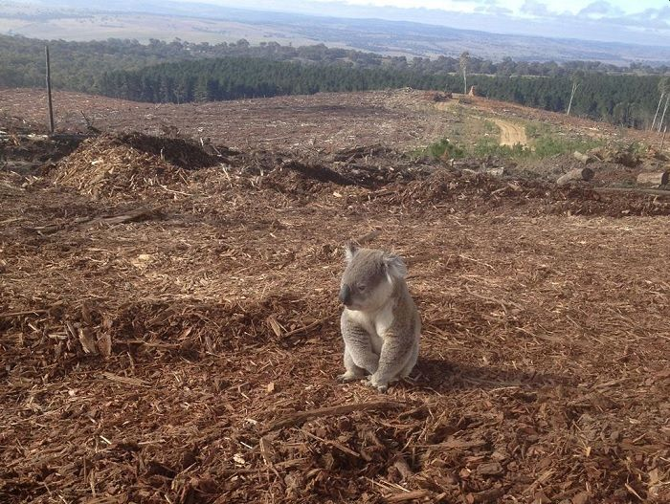
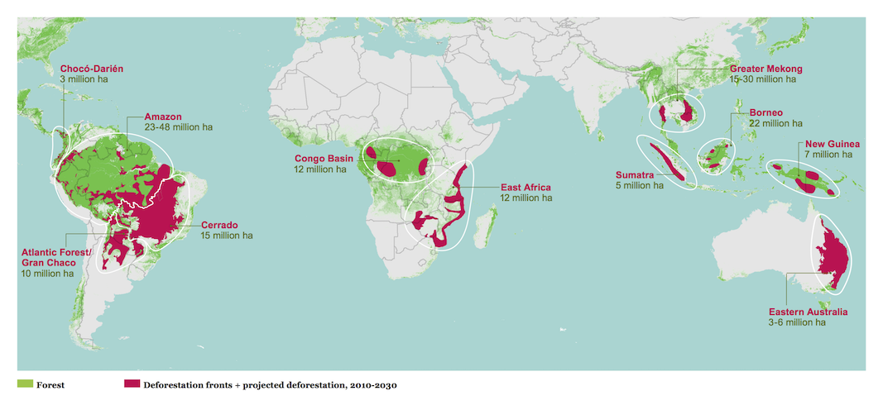
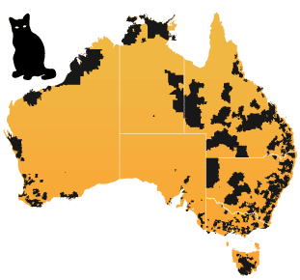
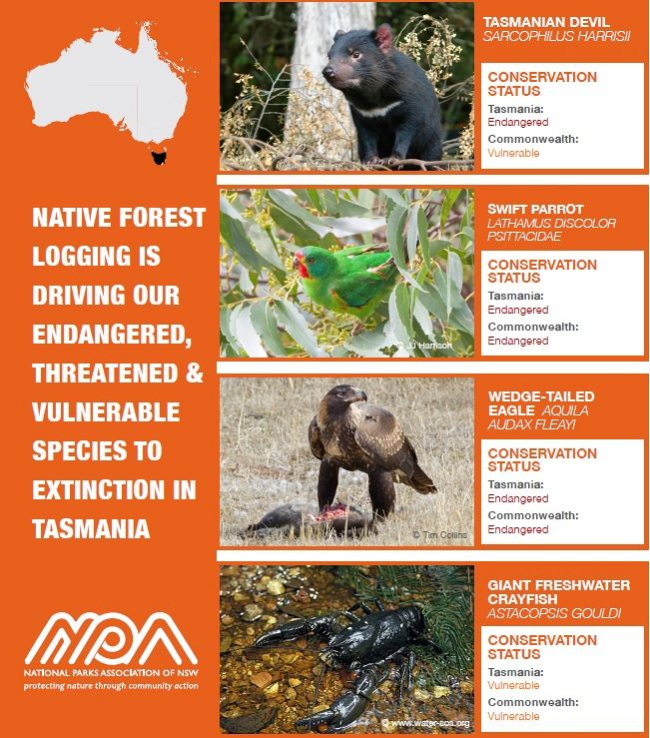

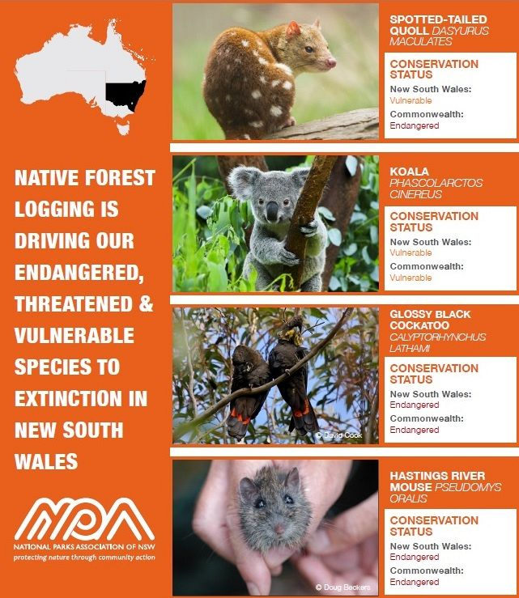

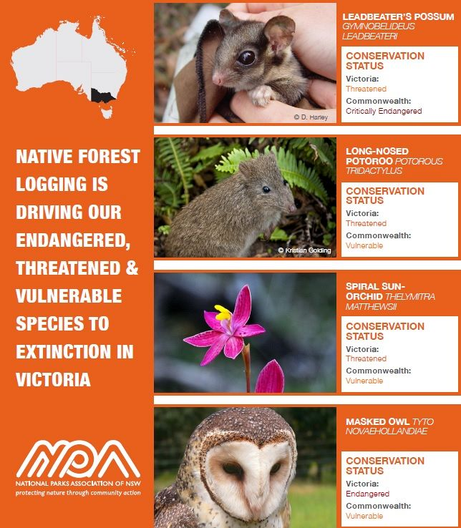

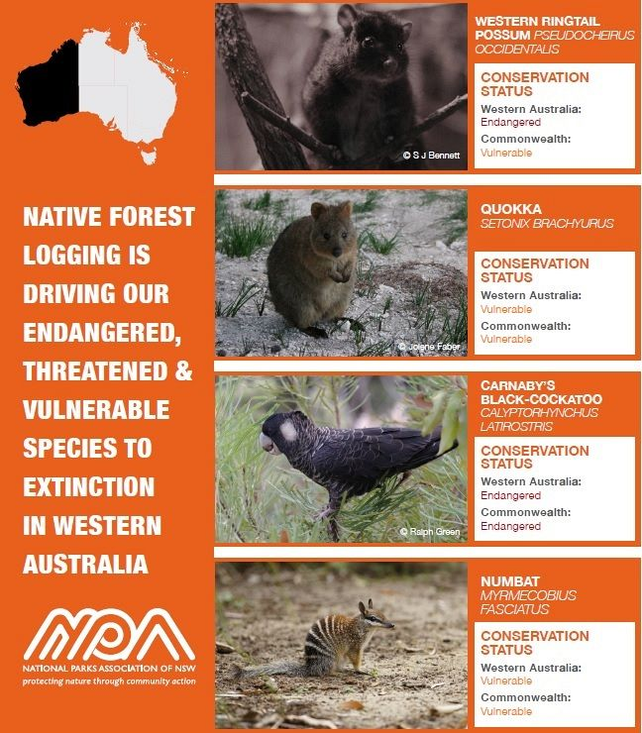

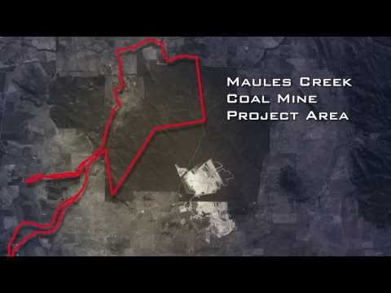

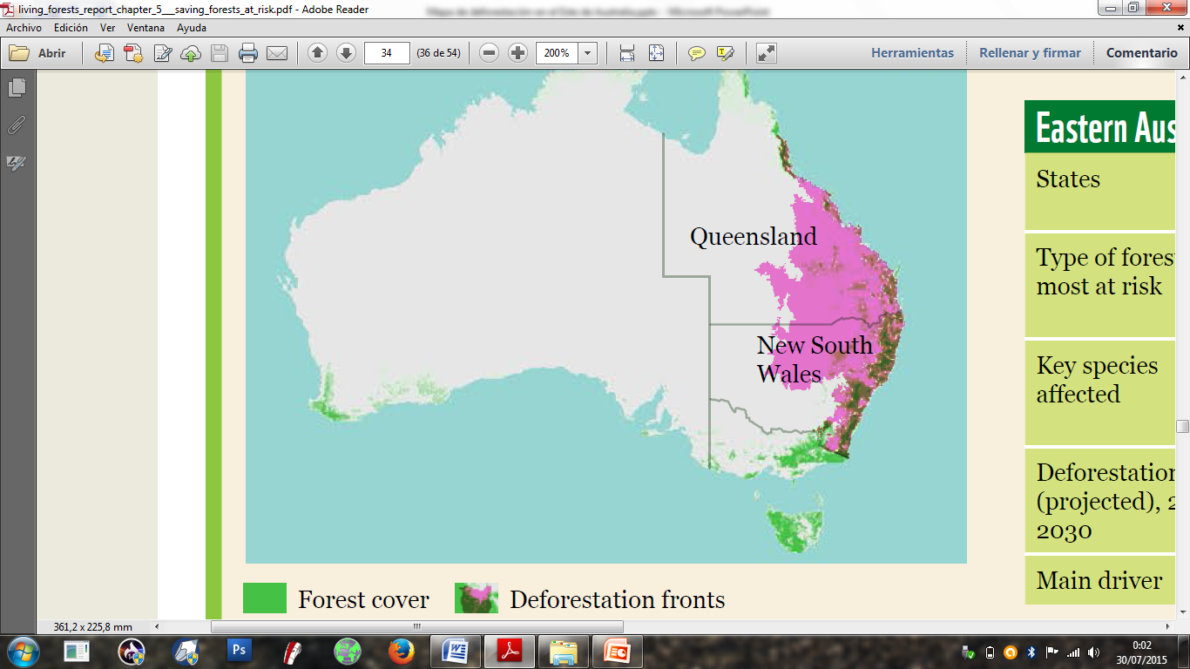

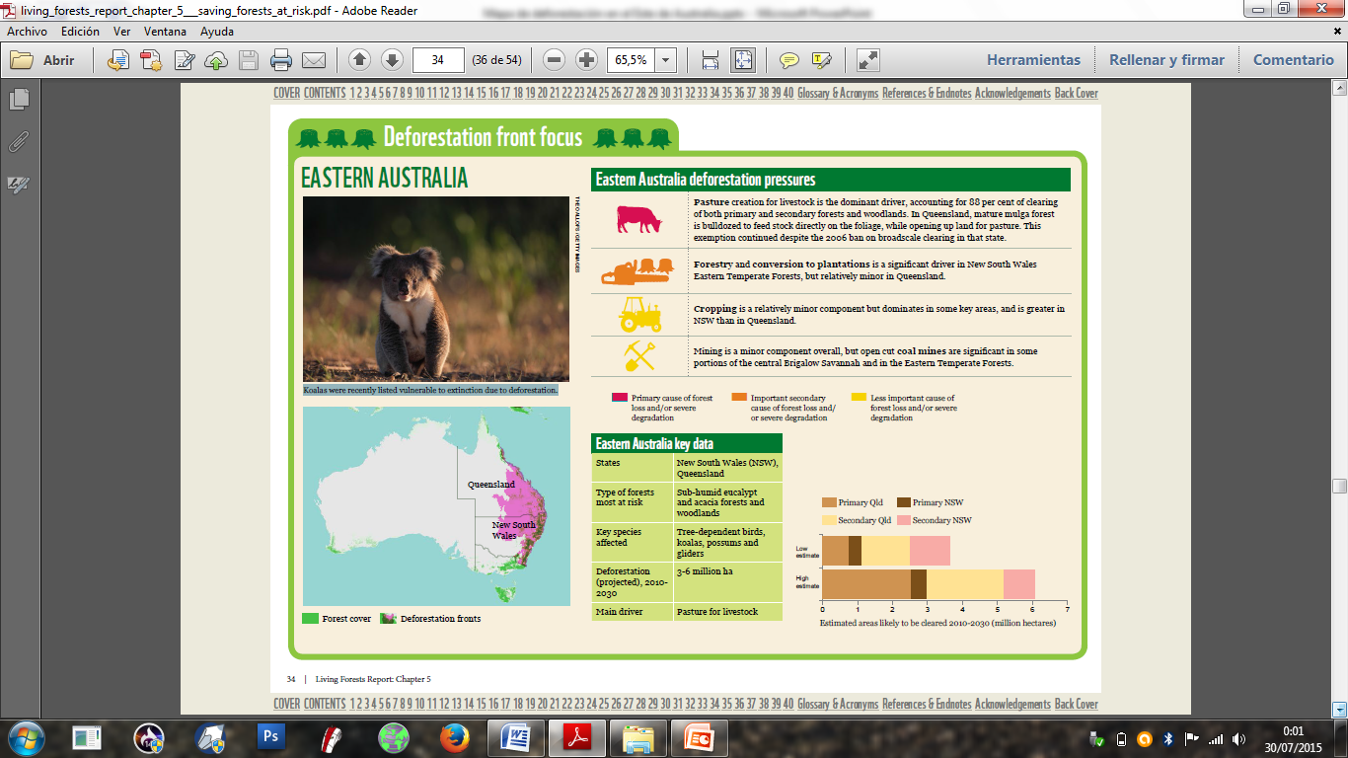

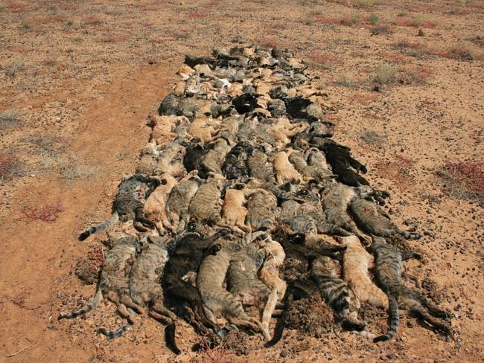

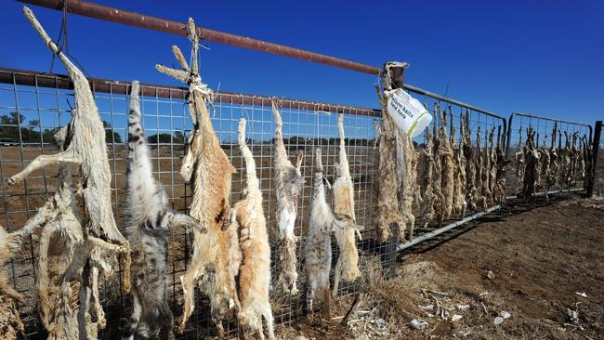

SEGUNDA VALORACION.- De las Pruebas aportadas no cabe la menor duda sobre la autenticidad de las mismas, considerando su procedencia, pues cada testimonio recopilado proviene de un enlace de internet donde se encuentra la información correspondiente que respalda y robustece la evidencia a través de un artículo e imágenes (fotografías). Sobre todos los artículos que se ofrecen como probanza y que además se etiqueta en los mismos los Delitos y las acciones cometidas (caso que no ocupa ni compete conocer ni decidir jurisdiccionalmente en este asunto por nuestra Parte), no hay objeción, descalificación o invalidación del contenido digital por la Parte que represento, en virtud de que son medios digitales que proceden de fuente digna y que además se declararon y publicaron en su momento de manera formal y abierta, de las cuales no cabe duda sobre su autenticidad o veracidad.-

TERCERA VALORACION.- Por lo expuesto, publicado, declarado y reproducido en los medios de comunicación y que ahora son presentados como Prueba digital para este caso por la Secretaria Ejecutiva del CIEB y TBDH Maestra Yan Maitri-Shi, se determinan dichas probanzas por la Parte que represento en cuanto Fiscal del CIEB y TBDH como LEGITIMAS y VALIDAS, mismas que respaldan y confirman la Acusación que presenta la World Association of Buddhism al gobierno de AUSTRALIA y su Ministro de Medio Ambiente por Delitos de PERSECUCION, EXTERMINIO ANIMAL, ECOCIDIO, DEFORESTACION, CONTAMINACION MARITIMA y Los que resulten, cometidos en agravio de los Animales (gatos salvajes y domésticos, y otras especies) y el Medio Ambiente.-
Se deja constancia que ante el Derecho a la Defensa, el gobierno Australiano contestó a las acusaciones del Buddhist Tribunal on Human Rights con una evasiva, pues su Embajada declaró con un escrito acerca de la “importación de ovejas”, lo cual no se relaciona en absoluto con el caso denunciado.
En tal situación, se da inicio a la Quinta Etapa del Procedimiento denominada de “SENTENCIA”, en la cual se establece el término de 5 cinco días a los Miembros del Jurado para decidir si el gobierno de AUSTRALIA y su ministro medioambiental son “Inocentes” o “Responsables” por los Delitos de PERSECUCION, EXTERMINIO ANIMAL, ECOCIDIO, DEFORESTACION, CONTAMINACION MARITIMA y Los que resulten con respecto a las Pruebas aportadas, aceptadas y valoradas en el presente escrito.-

Sekkha Dhamma
Fiscal del CIEB y TBDH

México mes de Octubre del año 2015 dos mil quince.-

