Case 50-2019: Quora & Adam D'Angelo

CHARGES
• Defamation
• Discrimination
• Hate Speech
• Violation of human rights

EVIDENCES
Buddhist Law regulate that freedom of expression has limits, since hate speech, discrimination, insults, persecution and defamation are prohibited. The company called "Quora" seems to ignore the limits of ethics and human rights. Quora company only deleted a photo of Master Maitreya accusing him of "fraud", but the company refused to remove all the defamatory content, which was clearly done by the members of the Deepak Rao paramilitary group during the fullness of their cyber attacks, which can be clearly seen in the fact of the time and names of the alleged comments.
Prosecutor Master Yan Maitri-Shi: Dear Sir / Madam, Please remove in the next 5 days some post in which there are defamatory actions from a member of Quora. Some links of this individual are the following:
https://www.quora.com/What-is-UBNO-United-Buddhist-Nations-Organization-Is-it-a-fake-university-acting-like-a-diploma-mill
https://www.quora.com/Who-is-His-Excellency-Maitreya-Samyaksambuddha
We request that Quora delete this post and also we require some formal apologize. December 5, 2018.

Quora: (December 6, 2018): Dear Dr Yan, Thank you for your message. We have reviewed your complaint and determined that the content you refer to does not warrant takedown on the basis that it violates Quora's policies. The ability of posters to discuss and refer to your organization is a fair use. Moreover, as an intermediary platform, Quora is not able to adjudicate conflicting opinions or versions of facts by posters and is not required to do so under applicable law. If you disagree with the opinions expressed by particular posters, you are encouraged to respond in the comments section or in a new post.

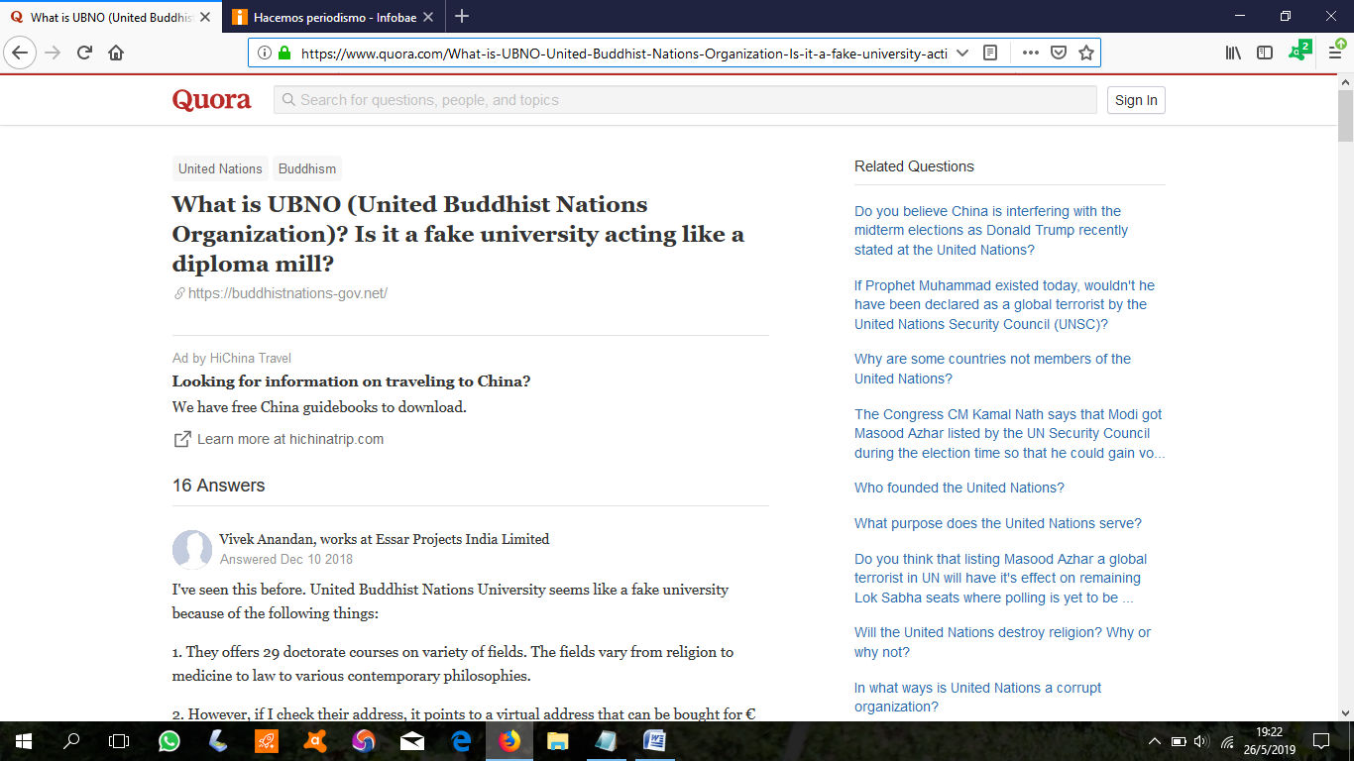
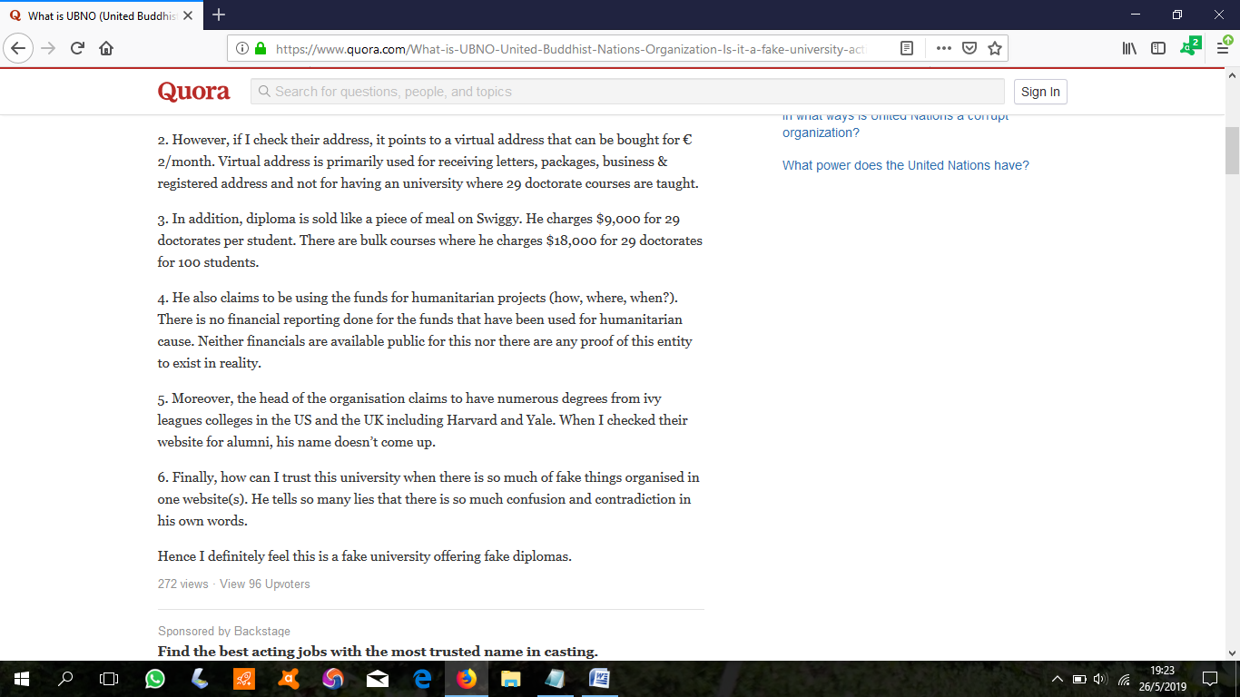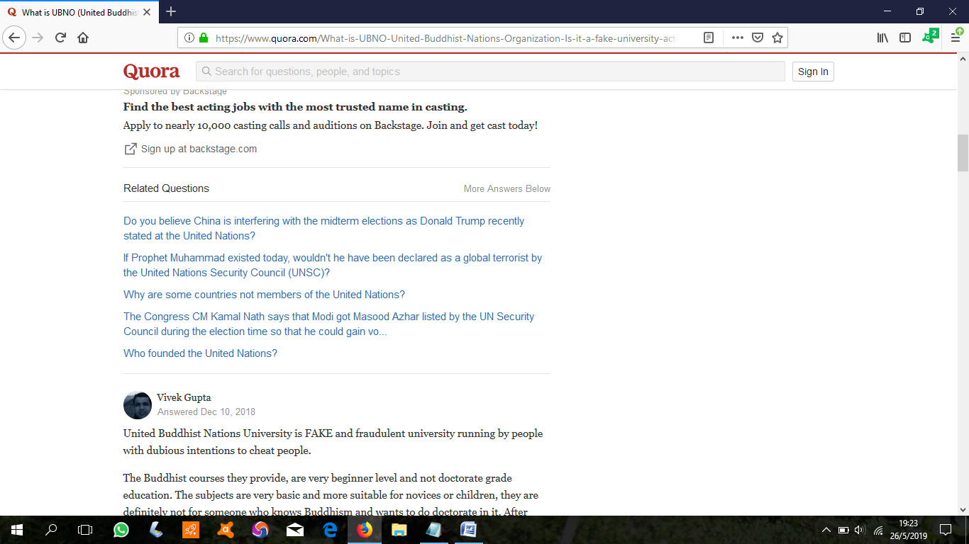
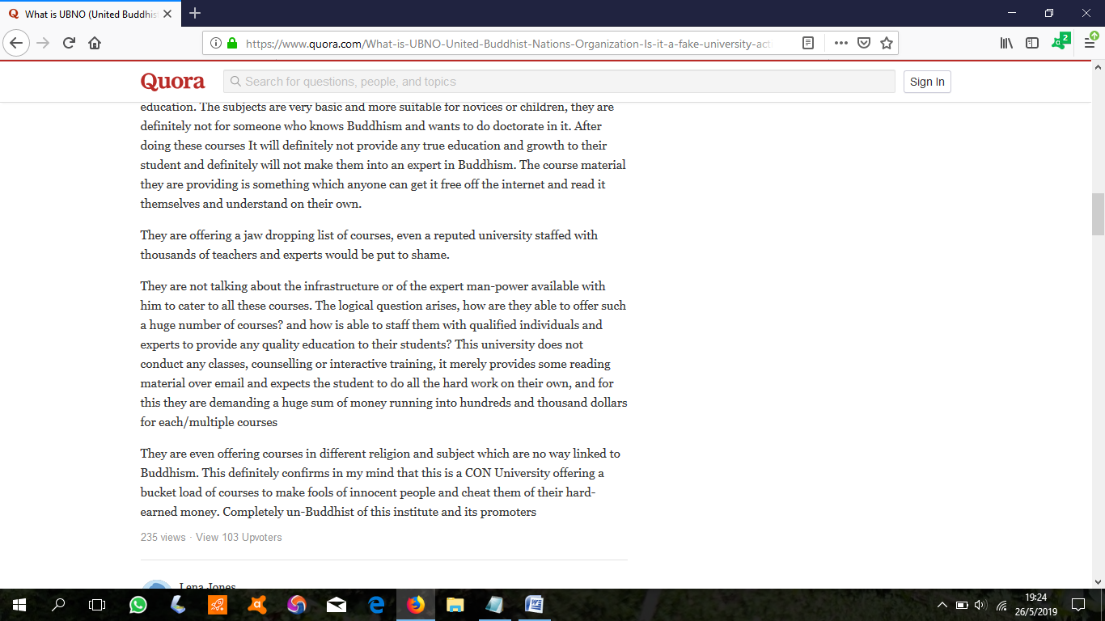
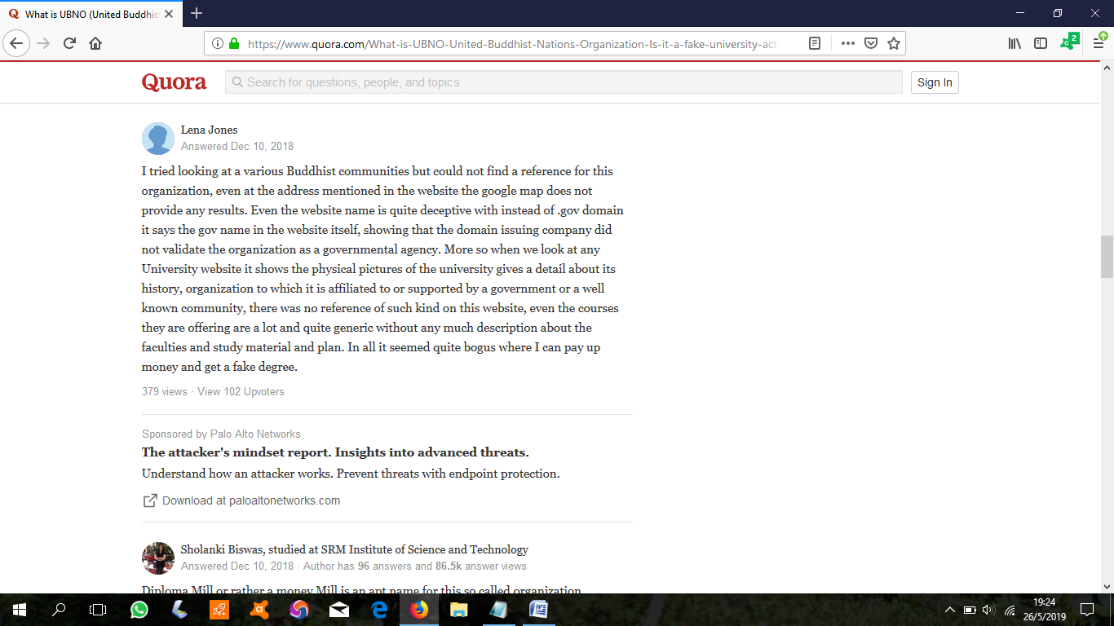
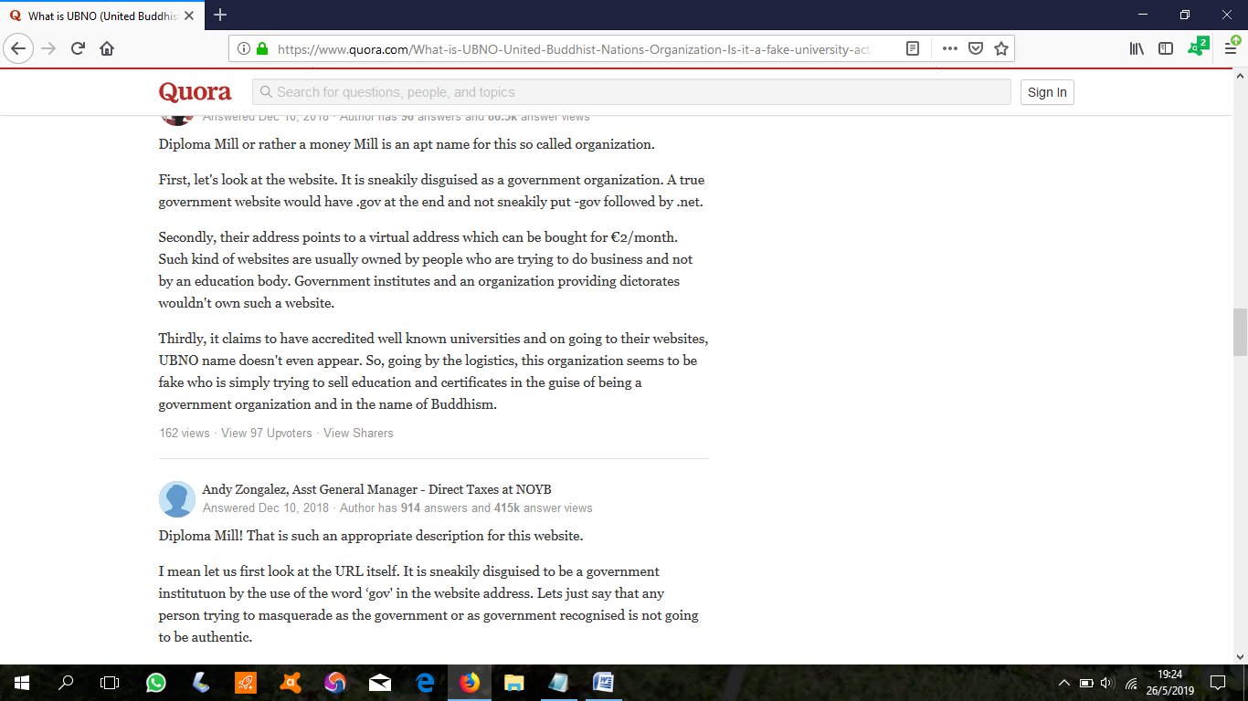
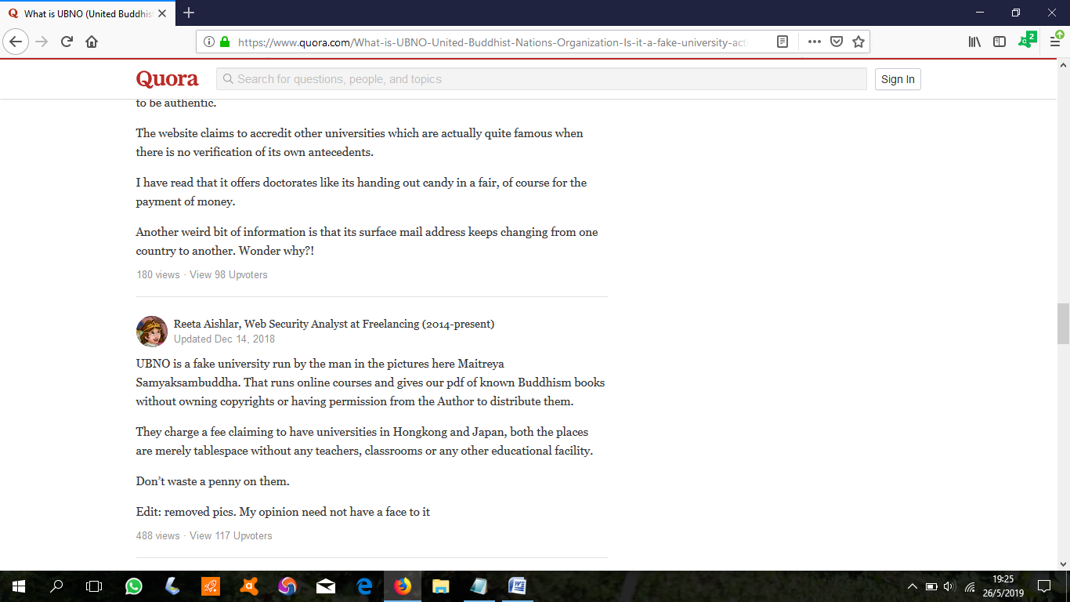
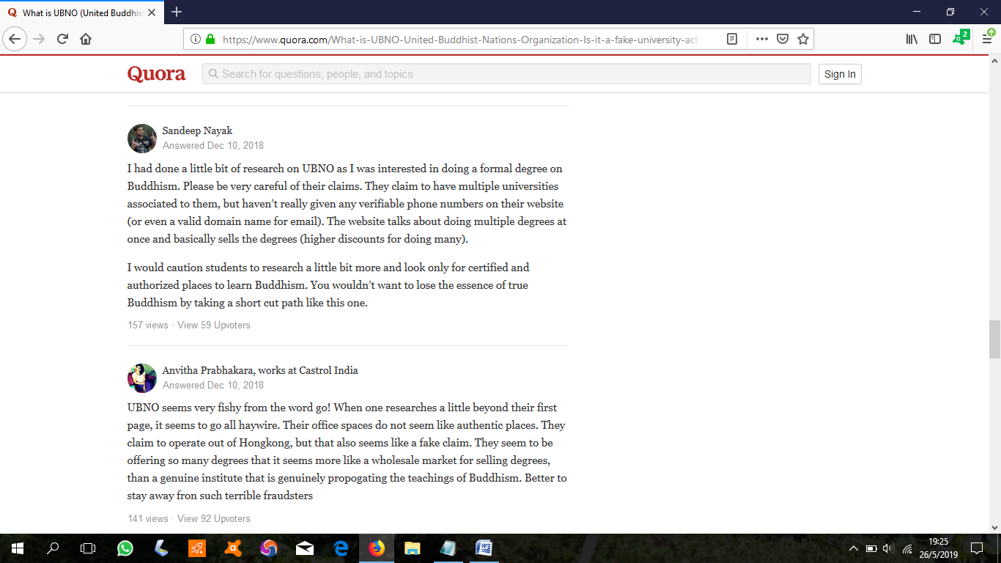
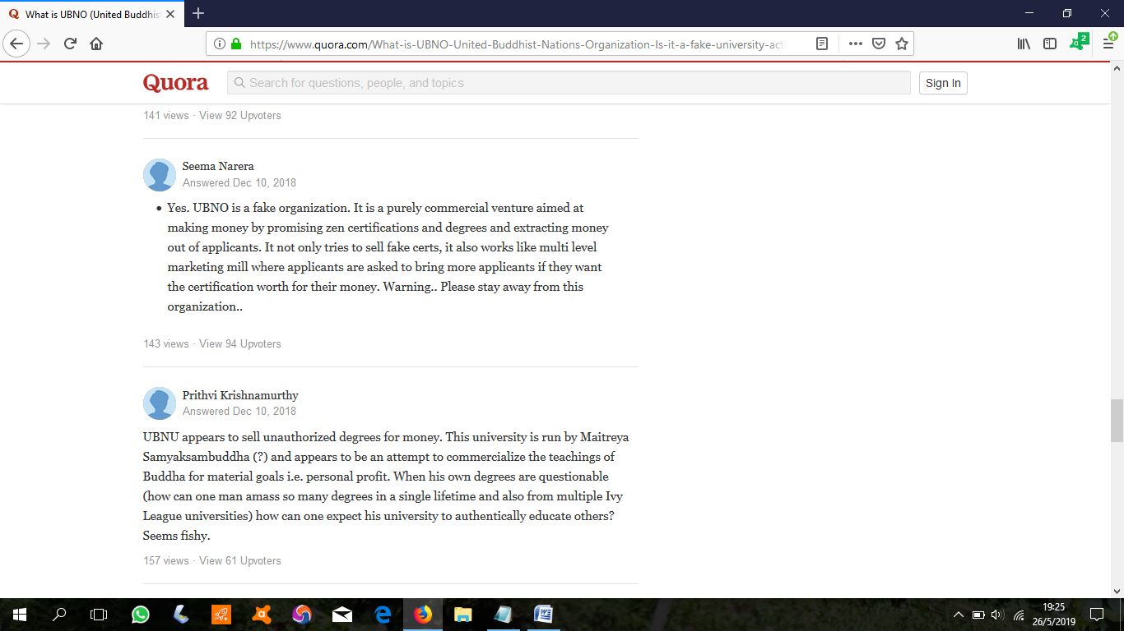
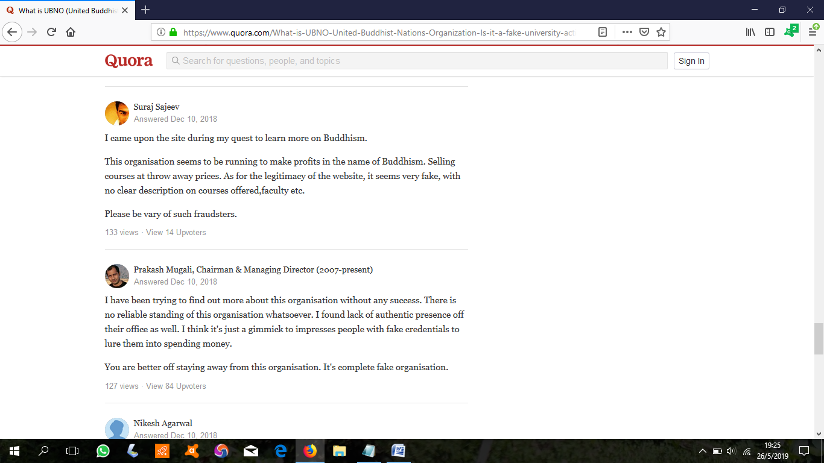
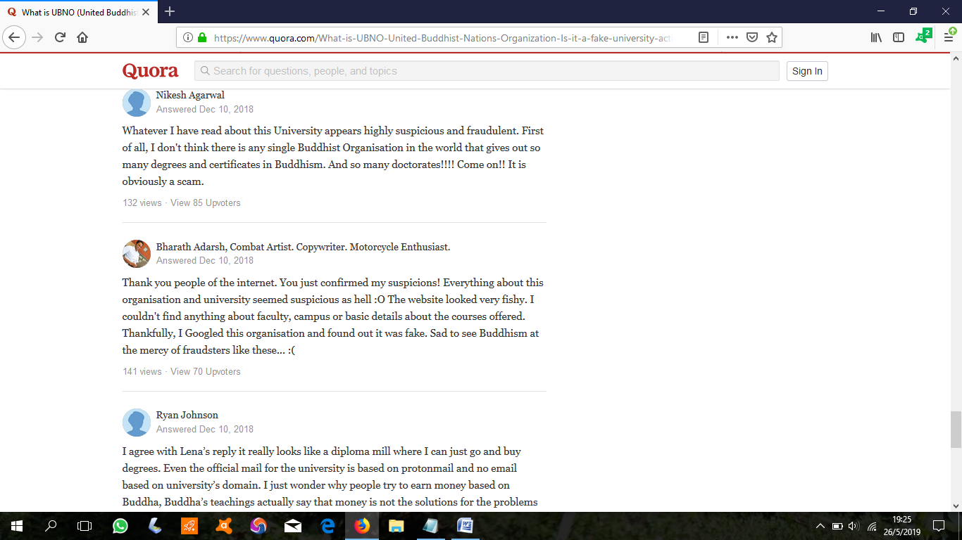
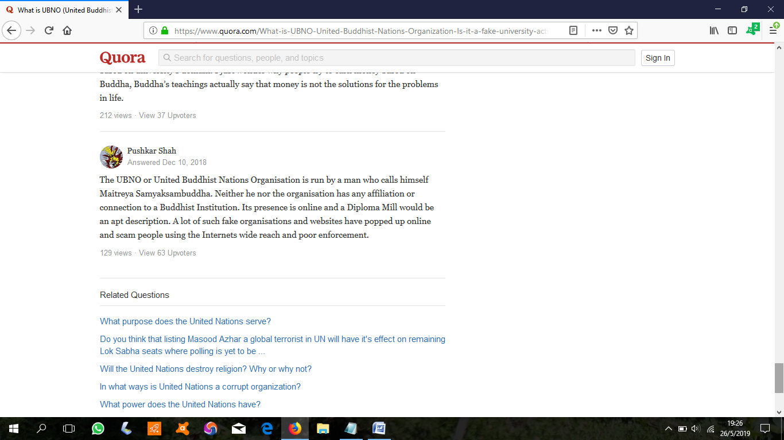
https://www.quora.com/What-is-UBNO-United-Buddhist-Nations-Organization-Is-it-a-fake-university-acting-like-a-diploma-mill

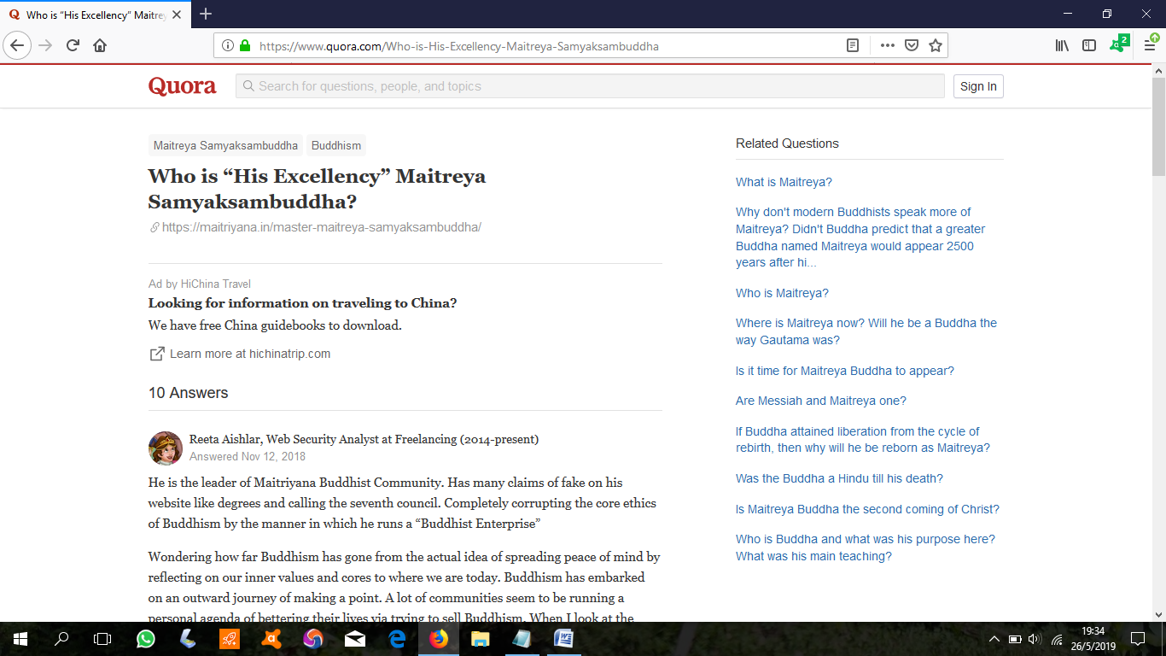
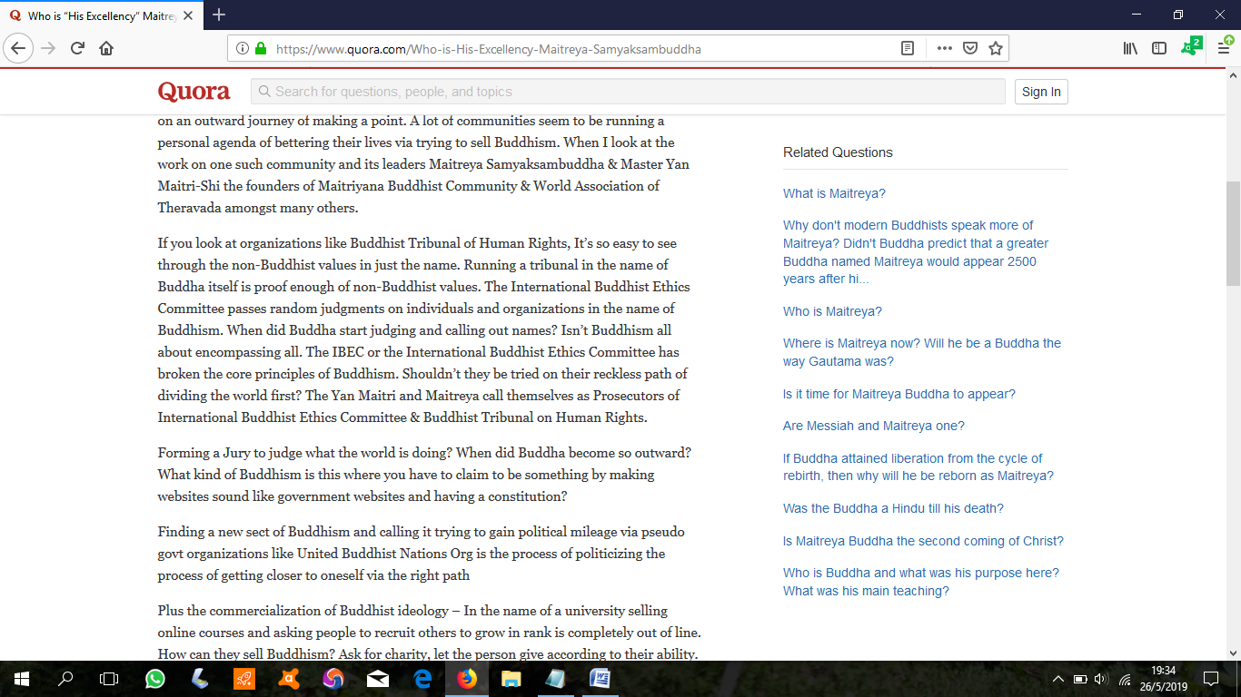
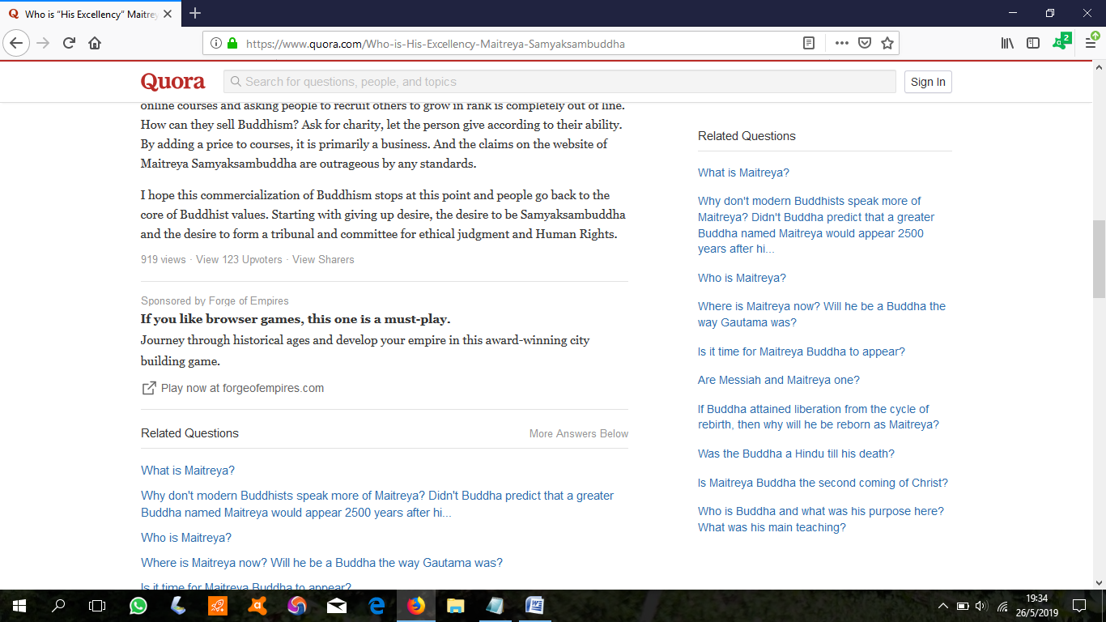
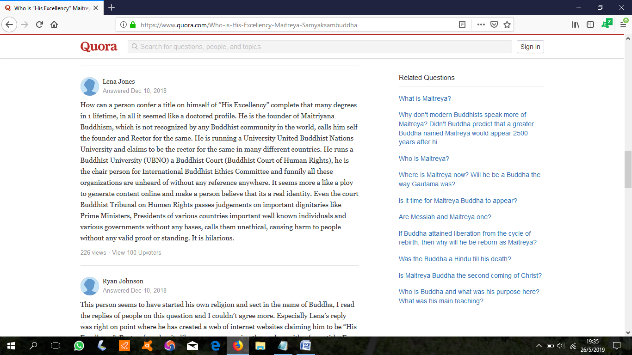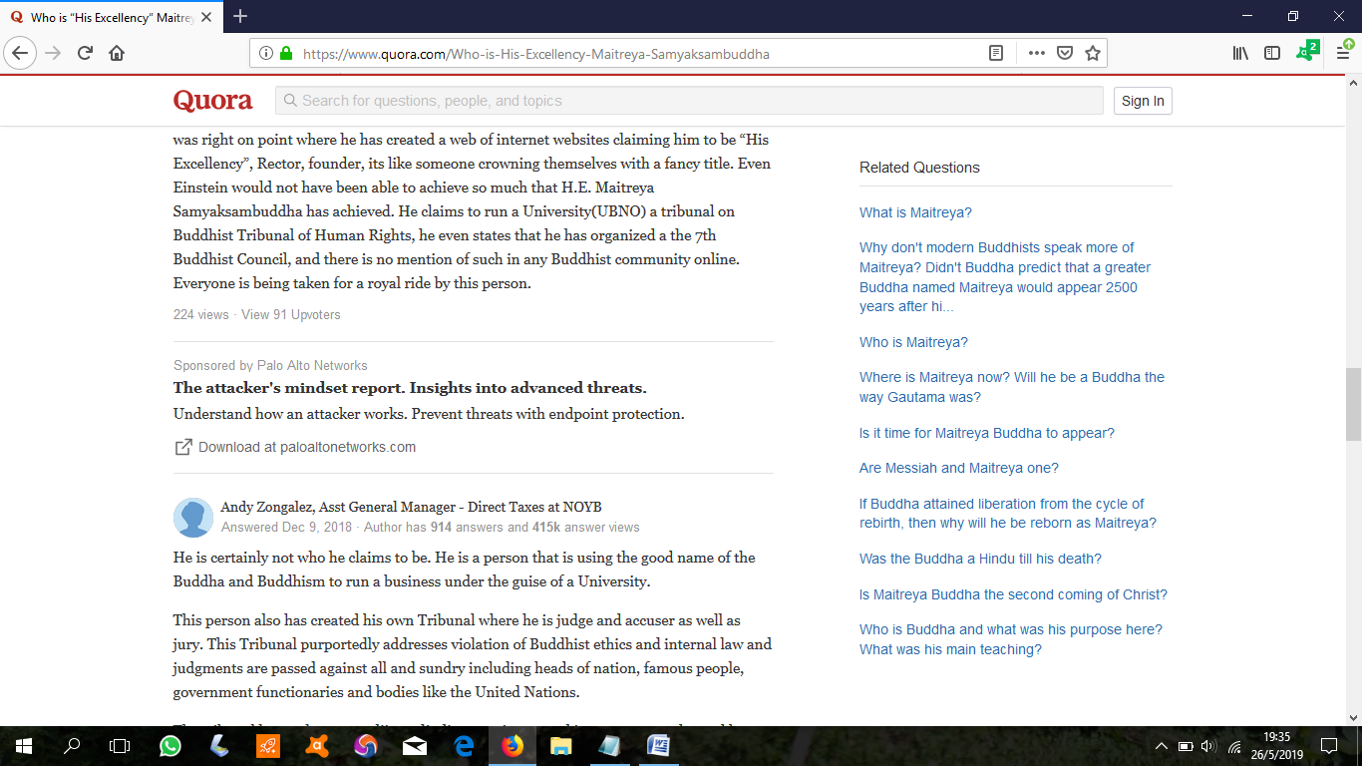
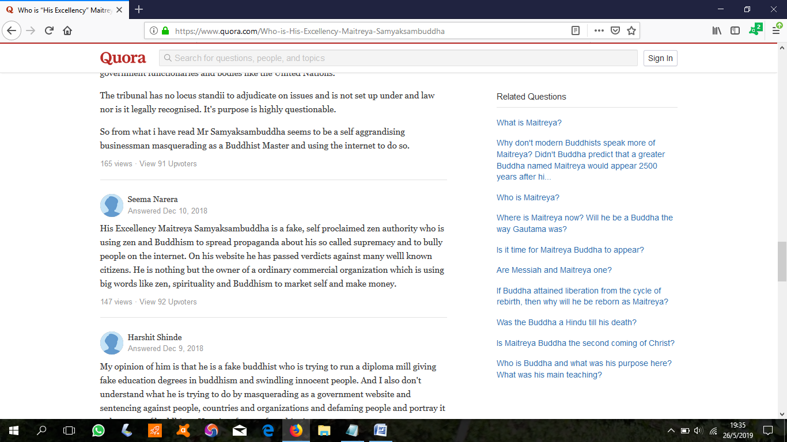
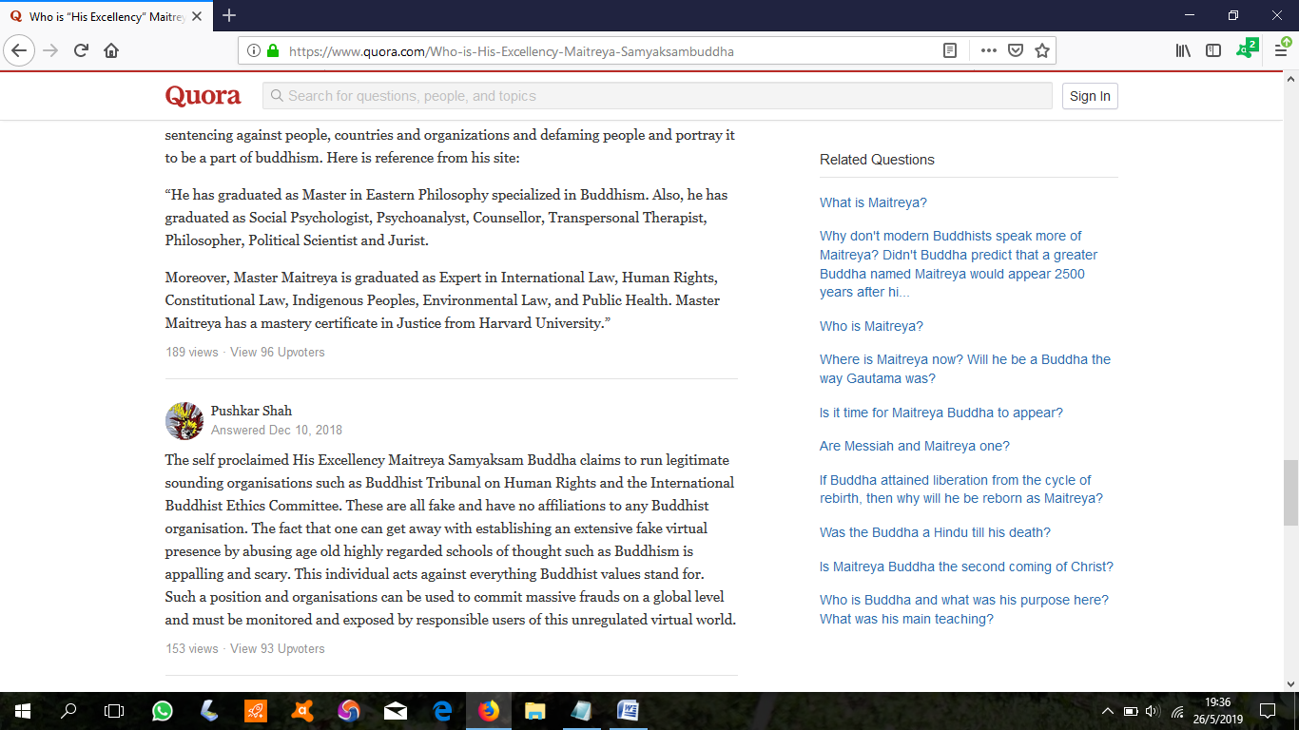
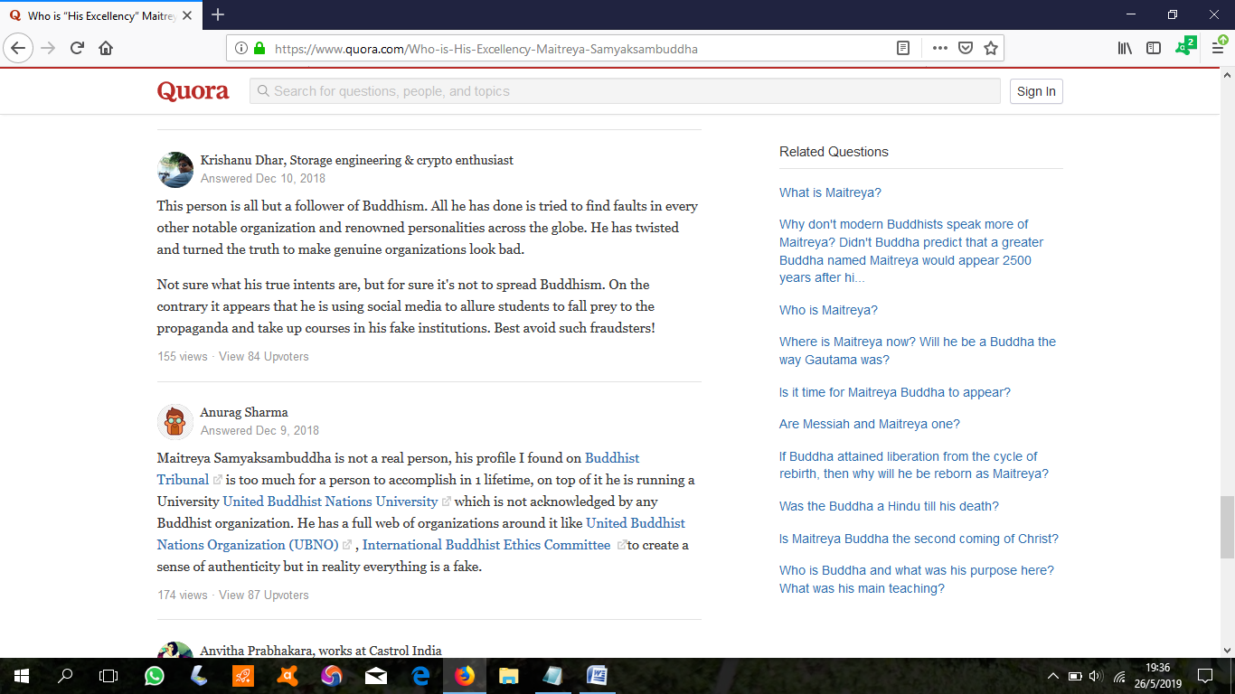
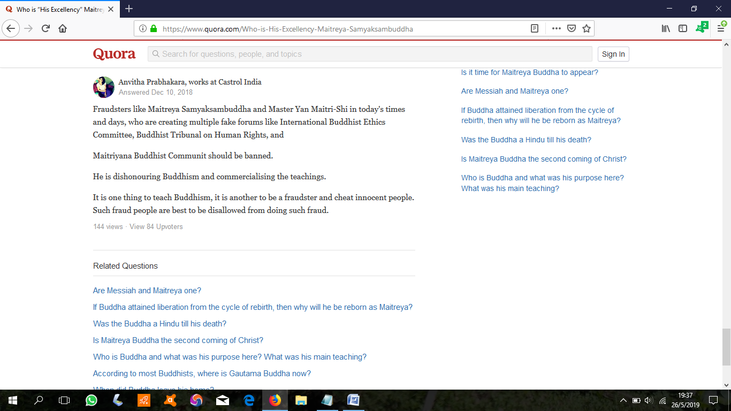
https://www.quora.com/Who-is-His-Excellency-Maitreya-Samyaksambuddha

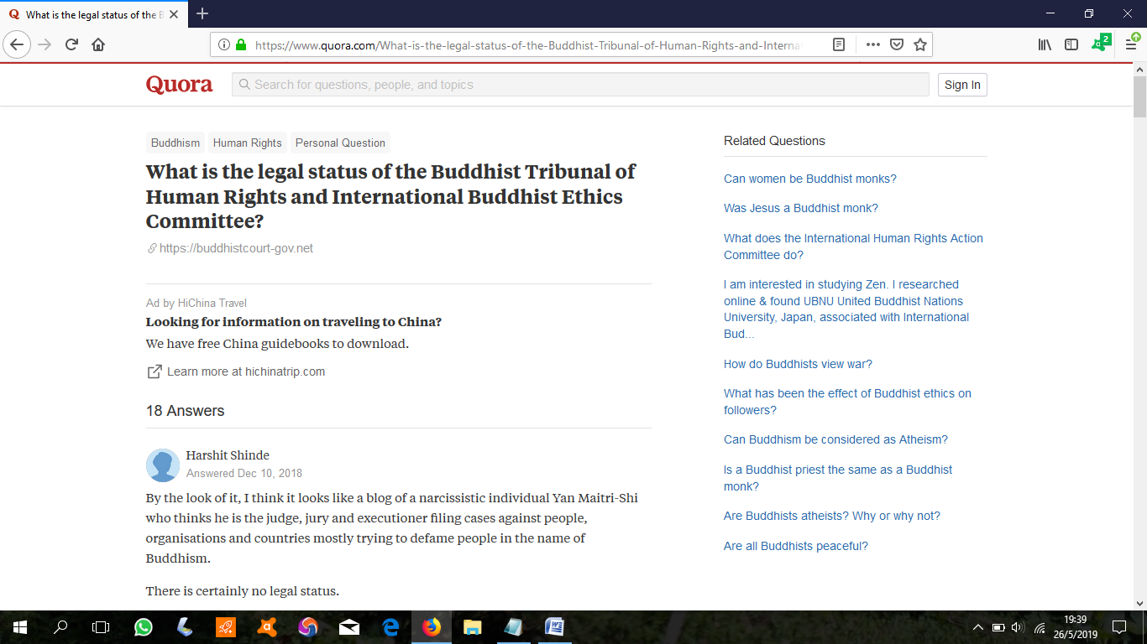
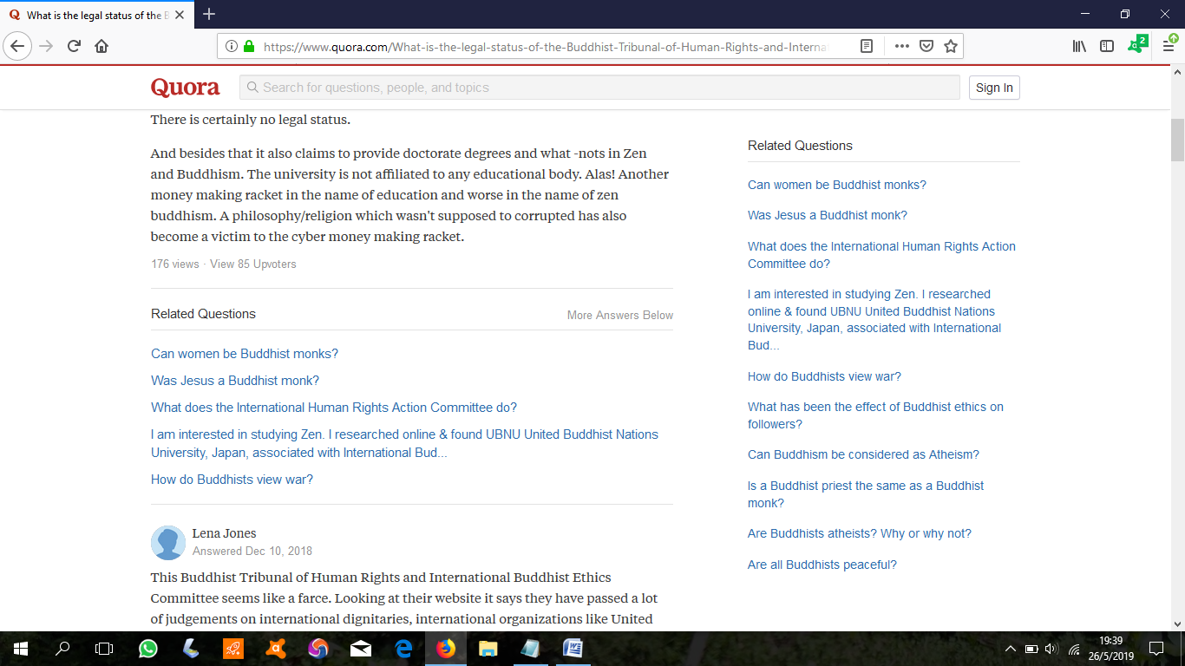
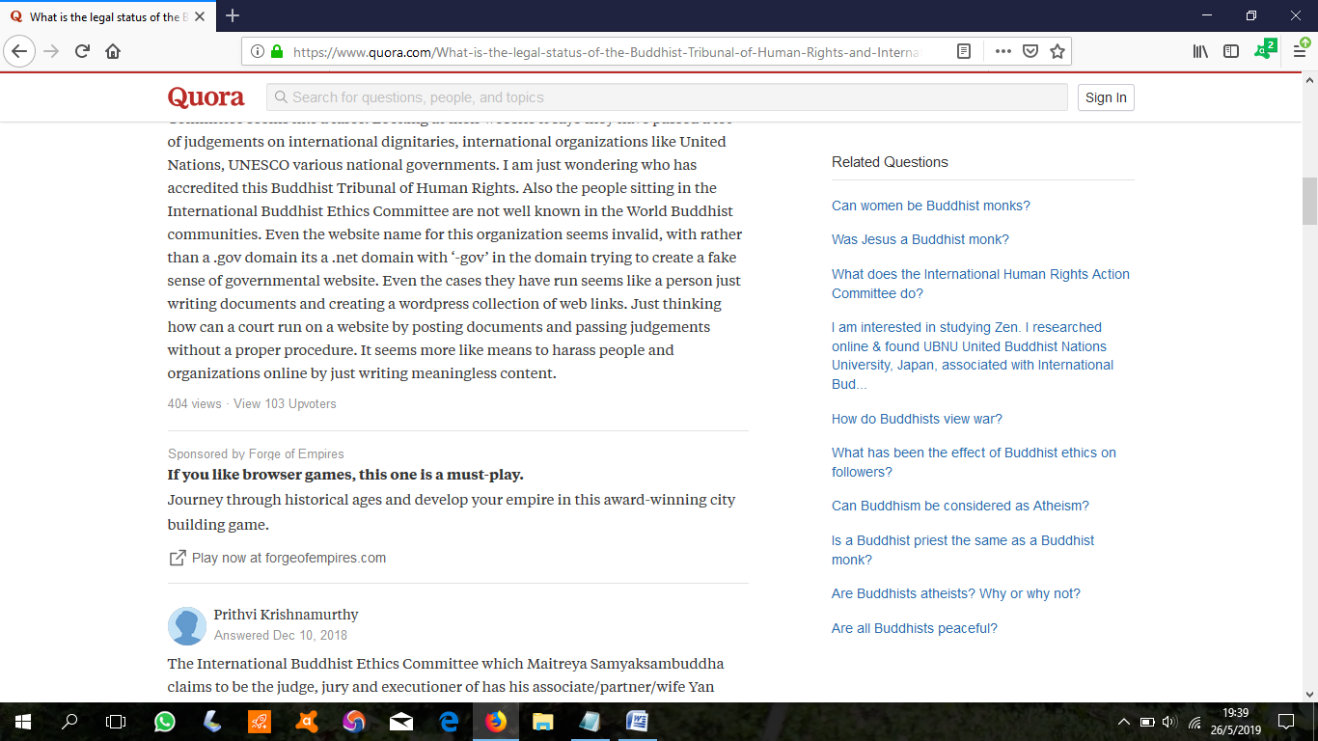
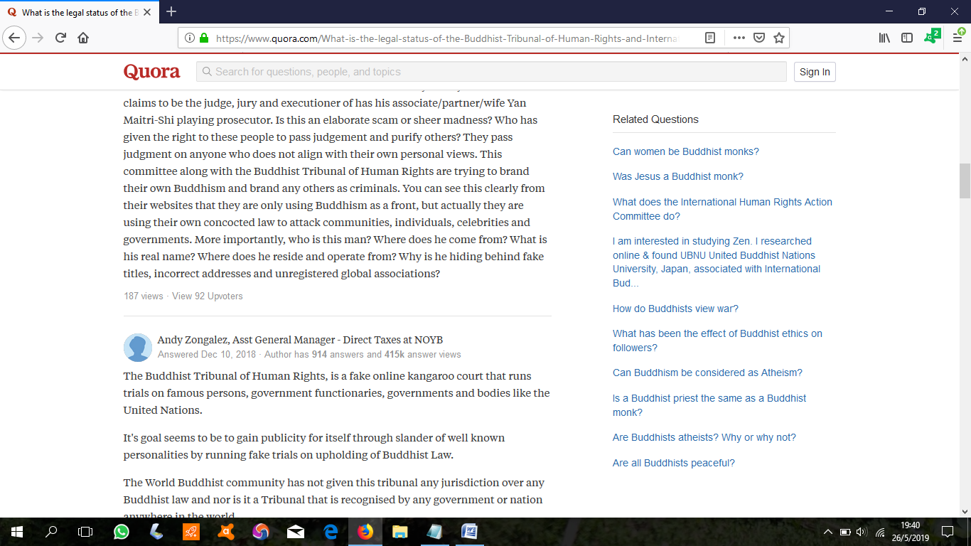
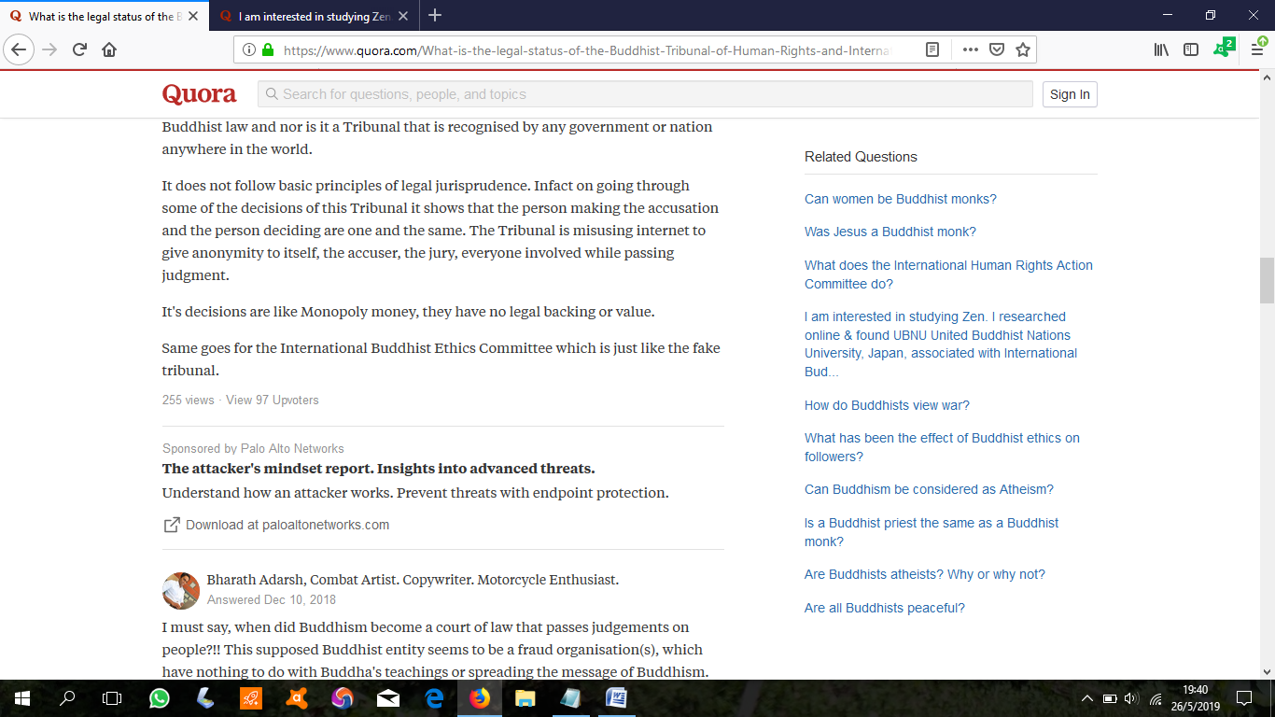
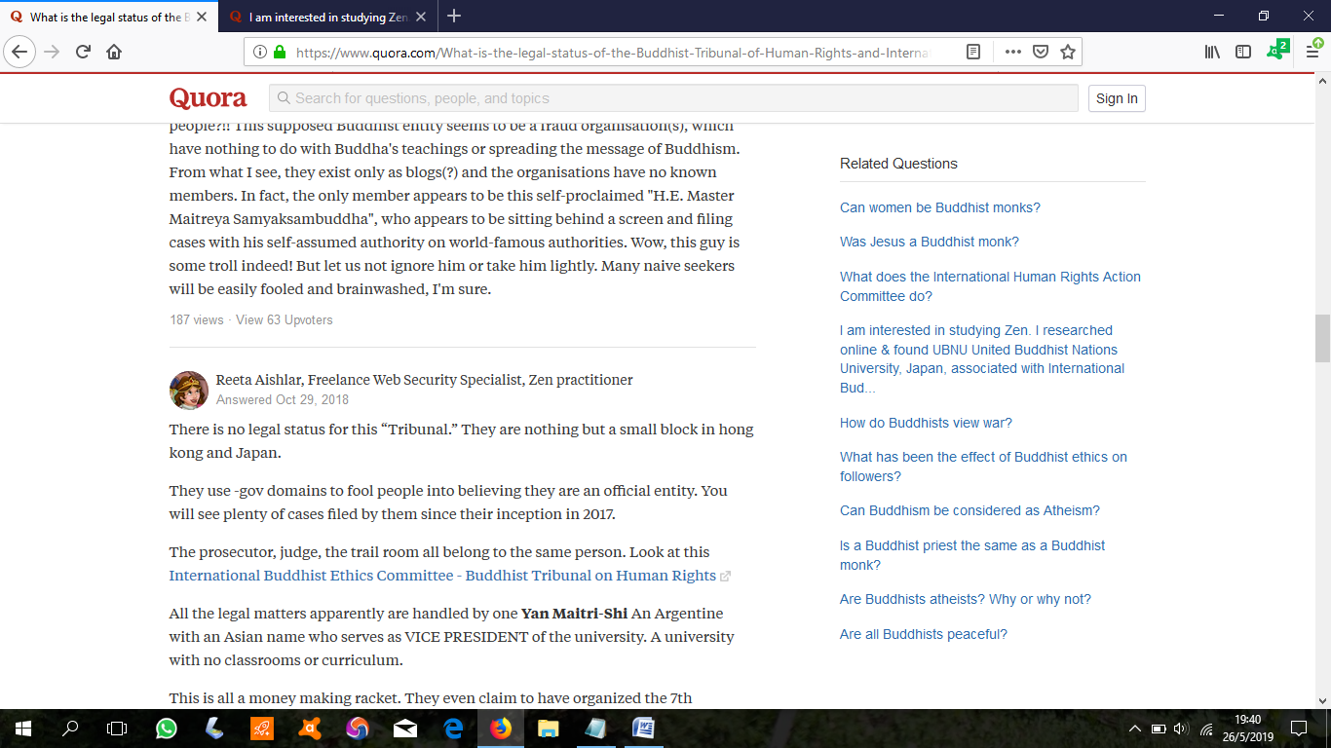
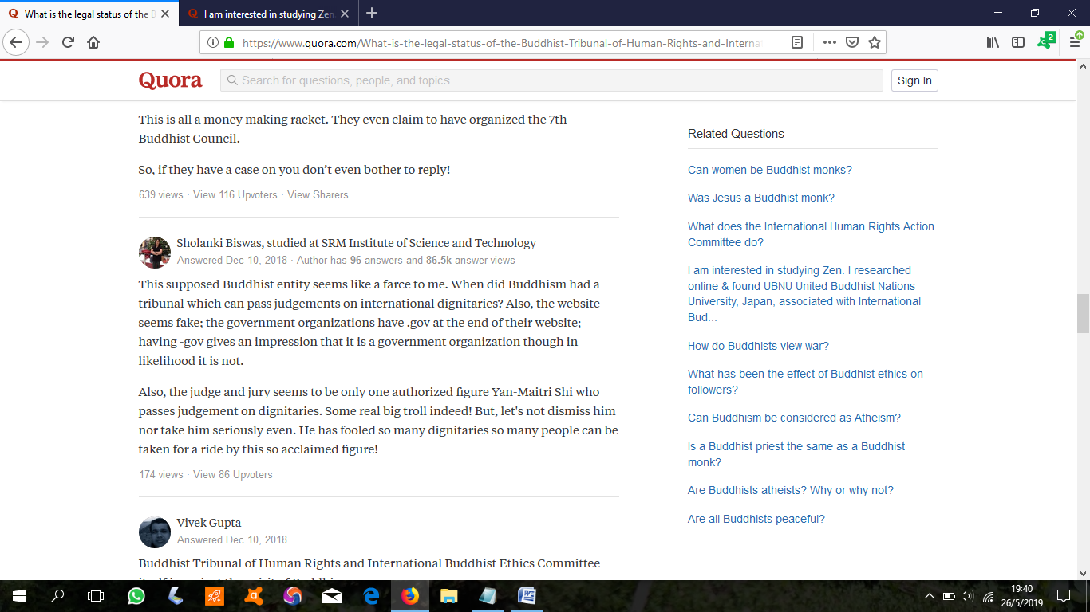
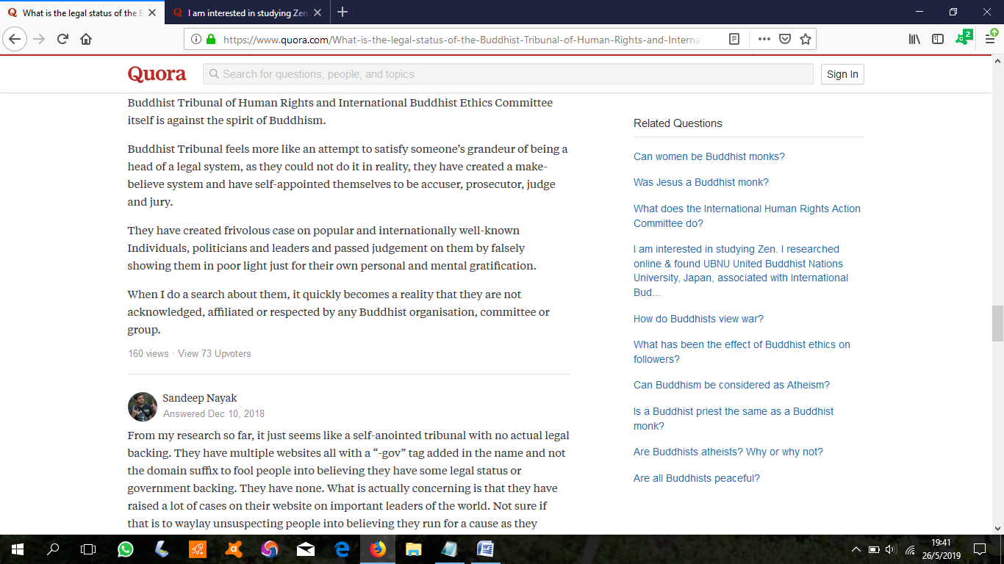
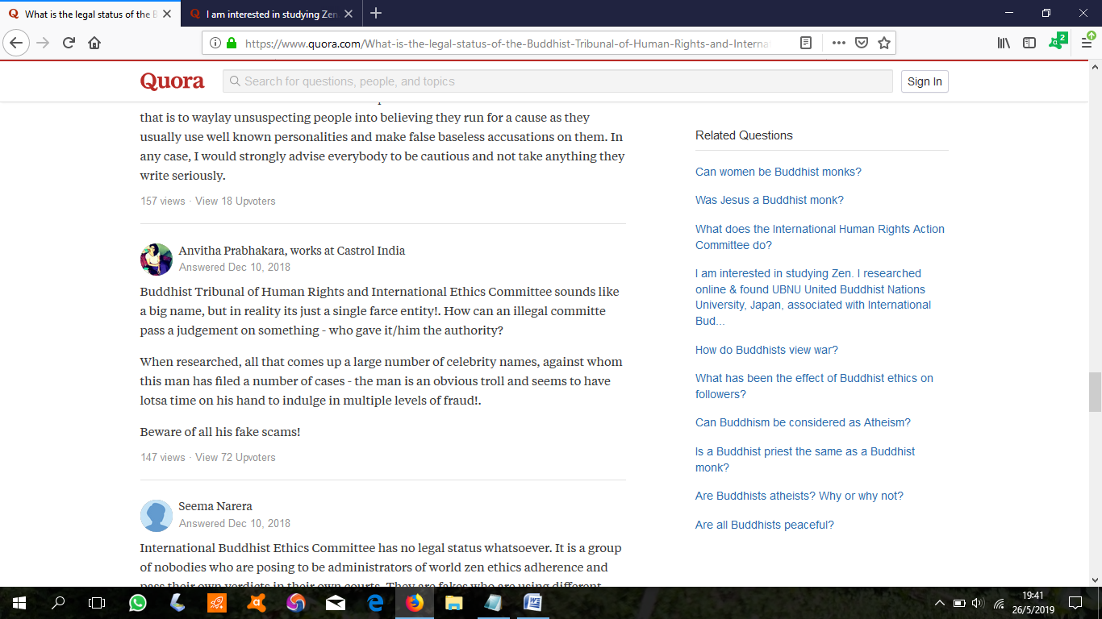
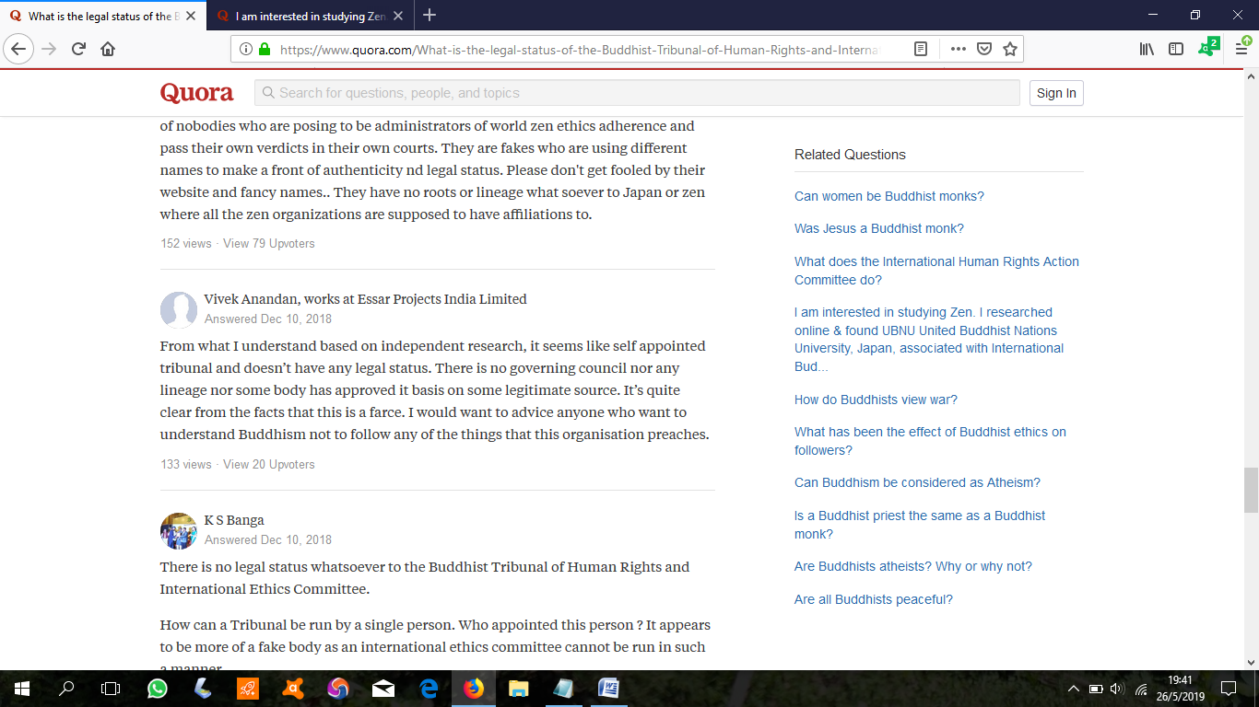
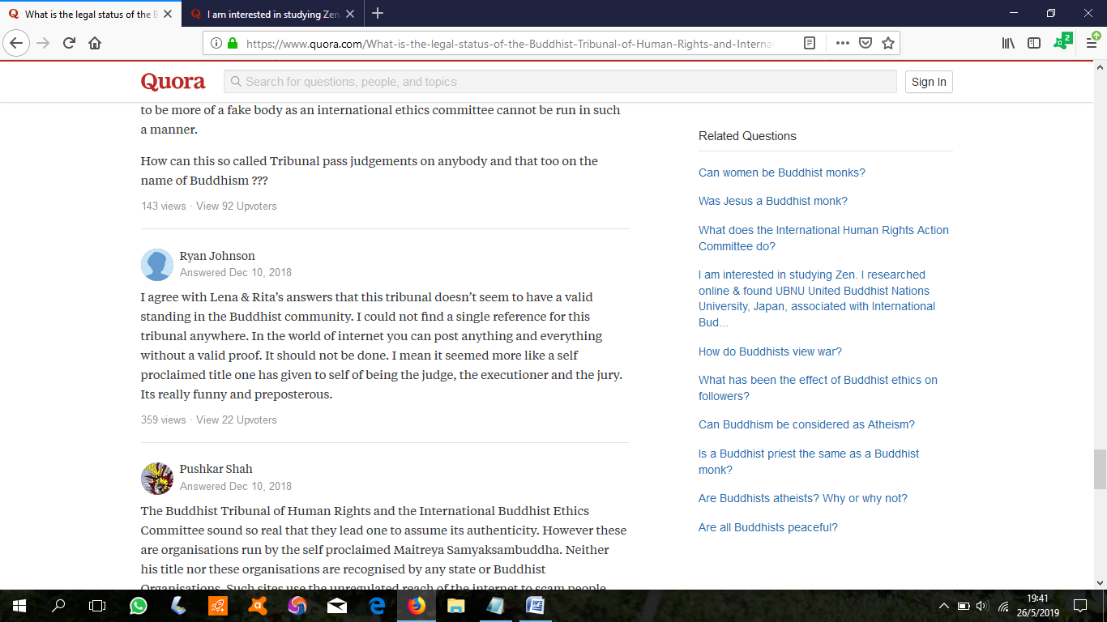
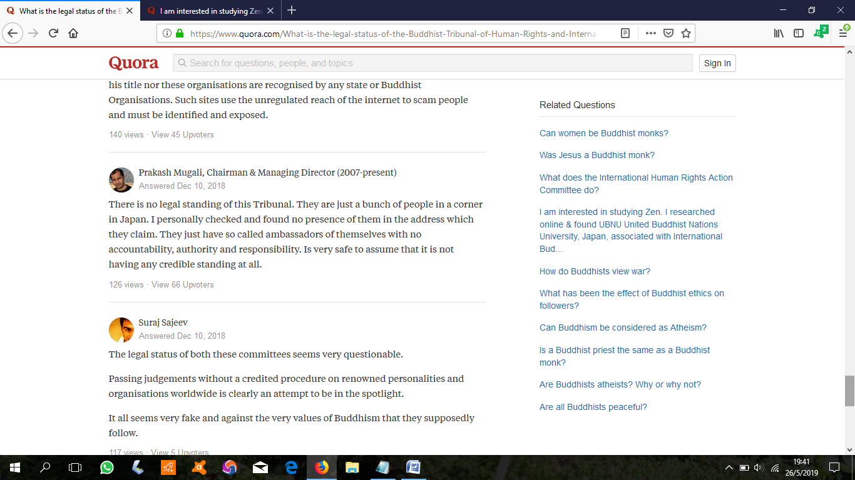
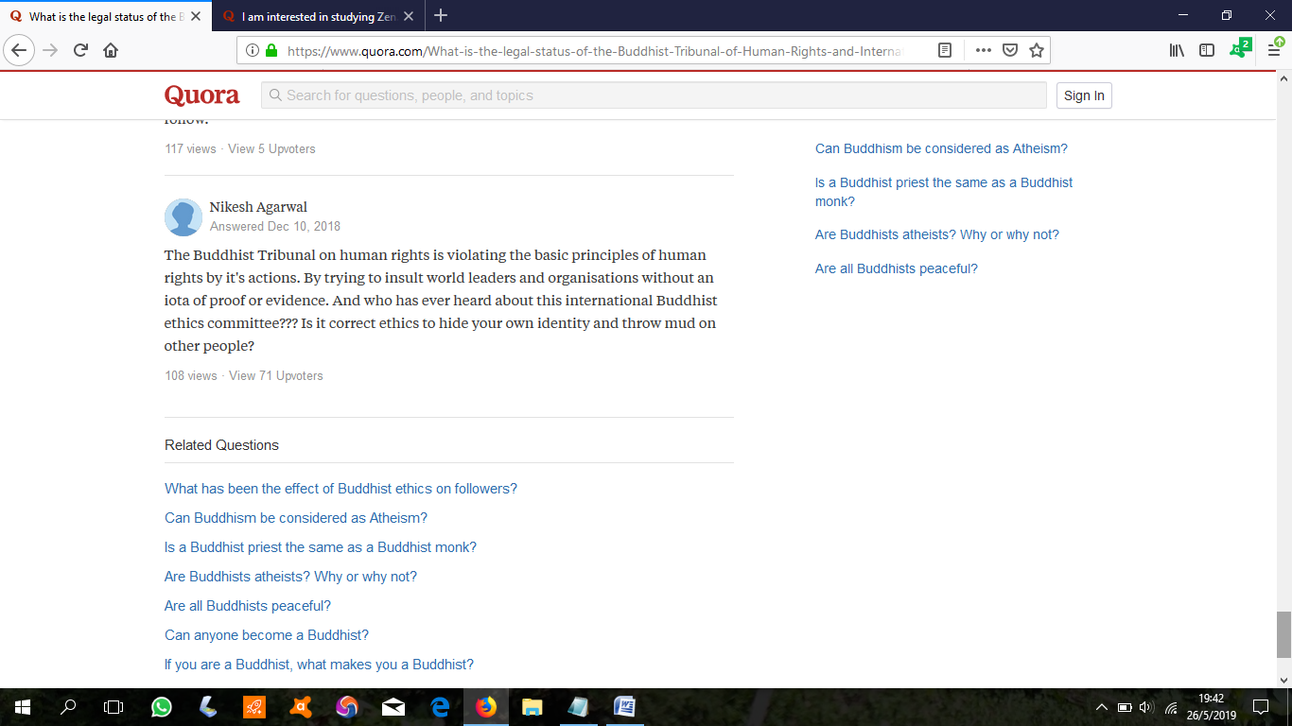

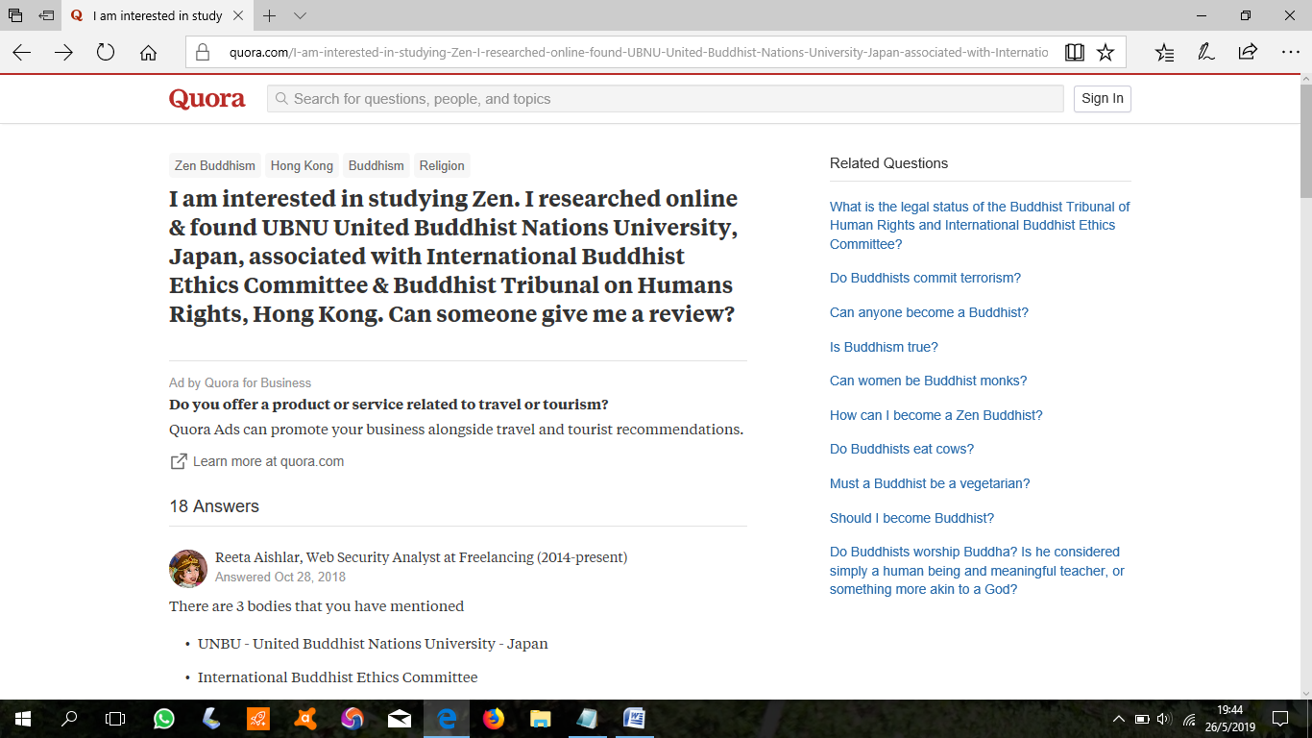
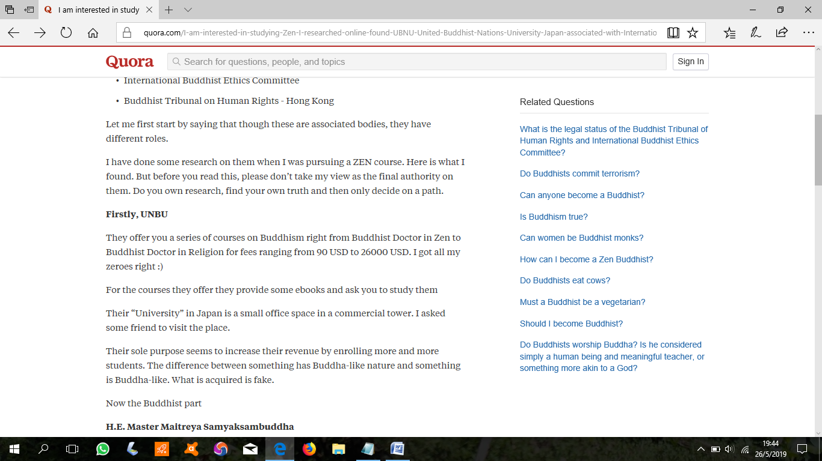
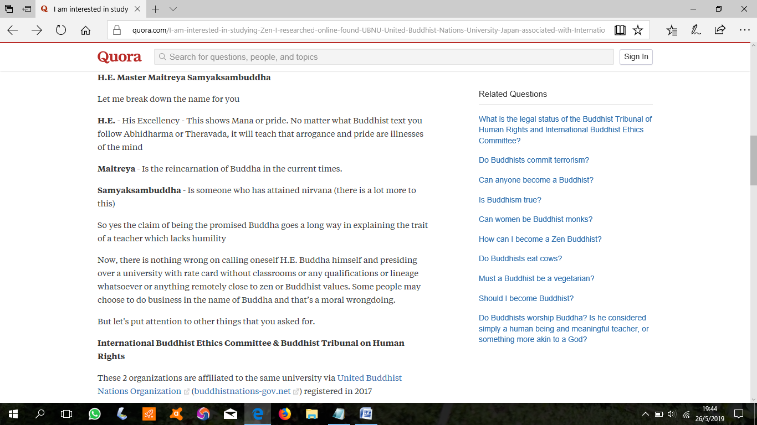
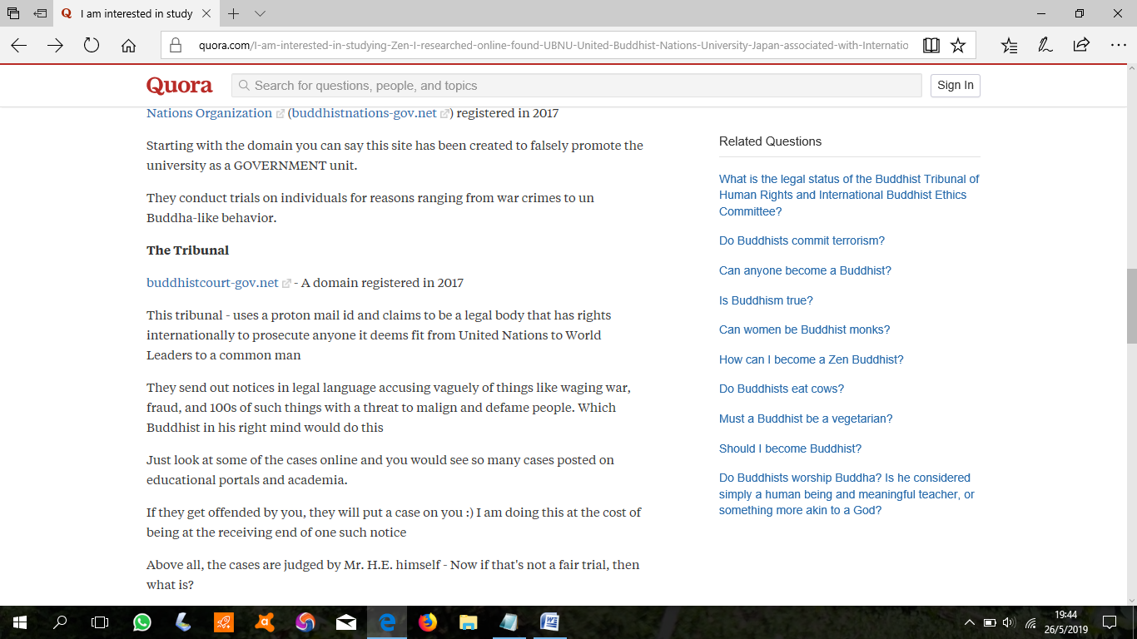
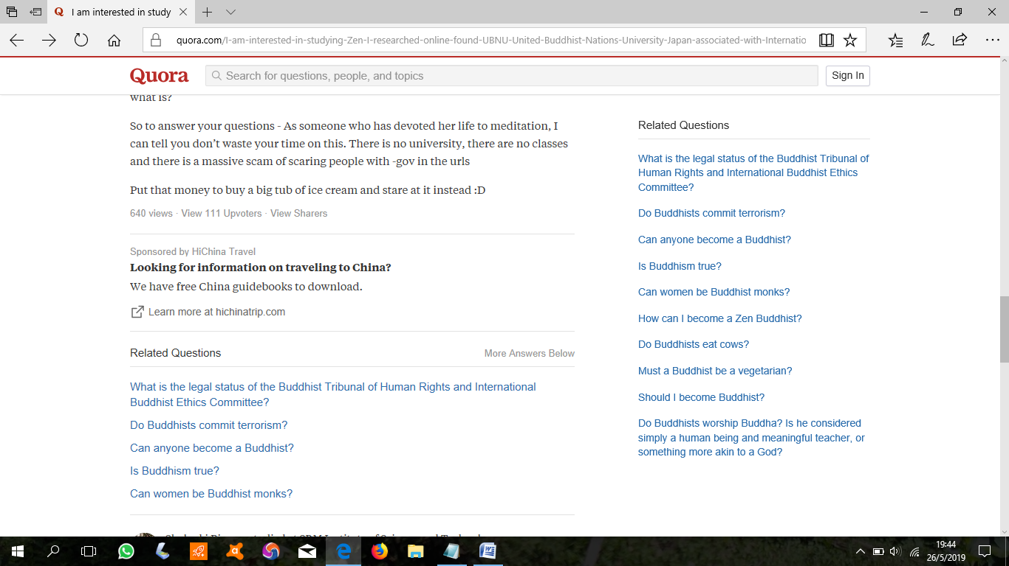
https://www.quora.com/I-am-interested-in-studying-Zen-I-researched-online-found-UBNU-United-Buddhist-Nations-University-Japan-associated-with-International-Buddhist-Ethics-Committee-Buddhist-Tribunal-on-Humans-Rights-Hong-Kong-Can

