Case 35-2017: University of Kelaniya
By Master Yan Maitri-Shi, Prosecutor

HONORABLE JURY OF INTERNATIONAL BUDDHIST ETHICS COMMITTEE (IBEC) & BUDDHIST TRIBUNAL ON HUMAN RIGHTS (BTHR)
After Legitimating and Validating Evidences and Charges by Master Maitreya, President and Spiritual Judge of IBEC-BTHR, it is addressed the case against the accused party “University of Kelaniya”. This investigation was initiated from a complaint started by MBU.
The Charges by which the International Buddhist Ethics Committee is accusing “University of Kelaniya” are enumerated below:
- PLAGIARISM
- VIOLATION OF CULTURAL HERITAGE

Therefore, it is detailed a series of EVIDENCES that support the Charges referred so that the Jury members decide about the possible "Responsibility", "Innocence" or "Insanity" of the accused. Such evidence come from graphic and audiovisual media that have been gathered, sorted and confirmed in their order and context as Means of Proof in order to know, establish, dictate and determine the Responsibility of the Accused for committing the aforementioned Charges.
The procedure established in the Statute of INTERNATIONAL BUDDHIST ETHICS COMMITTEE & BUDDHIST TRIBUNAL ON HUMAN RIGHTS provides both bodies the ostentation to enjoy independence and liberty from state and national regulation and control, besides having the legality and acting as a Buddhist People in order to assert its customs, traditions, practices, procedures, judgments and rights as well as acting in pursuit of the development of Spirituality, of Buddhist Ethics, and of the defense of International Human Rights. This procedure has the particularity, singularity and distinction of having "Special Jurisdiction of the Tribal Law" and "Universal Jurisdiction of the International Law", thus having the Character, Juridical validity, Legal Powers, infrastructure, Training and Capability necessary to be Actor, Administrator and Executor of Justice in this realm and exercise, by judging of the Accused by means of an Ethical Judgment whose Purpose is Truth, Reconciliation and Learning.-

DETAILS OF THE CASE:
International Buddhist Ethics Committee: On October 7, 2017 the UNITED BUDDHIST NATIONS ORGANIZATION (UBNO) received a request from Professor Galmangoda Sumanapala asking for the organization "Nagananda International Institute for Buddhist Studies" to be accredited by the UBNO. However, the latter institution discovered that Professor Sumanapala not only published a book on Buddhist Ayurvedic Counselling with a chapter entitled "Buddhist Psychoanalysis" in Nagananda, but he is also a part of the University of Kelaniya, where two courses with the name "Buddhist Psychoanalysis" are taught. Faced with this situation, the UBNO communicated to warn Professor Sumanapala about the fact that these activities would constitute an act of Plagiarism, so he should had asked for permission from the creator of Buddhist Psychoanalysis: Master Maitreya Samyaksambuddha. However, Professor Sumanapala replied that he is authorized to teach at the "Nagananda International Institute for Buddhist Studies", that he was not in charge of the Buddhist Psychoanalysis courses at the University of Kelaniya and that now he no longer wants to be a member of the UBNO. At the same time, the Maitriyana Buddhist University, which is the area where Buddhist Psychoanalysis was created, communicated with all the authorities and professors of the University of Kelaniya, confirming to them that Buddhist Psychoanalysis is a discipline that is Copyrighted and was created in 2007 by Master Maitreya Samyaksambuddha, and that they had to confirm whether they are teaching Master Maitreya's theory or whether they are teaching another thing. However, no authority of the University of Kelaniya decided to respond to this serious complaint. Only Professor Gnana Ratana responded by saying that they "do not know anyone called Mitreya sambuddha", which is false because in recent years all the institutions headed by Master Maitreya have communicated several times with the University of Kelaniya and with Professor Sumanapala to disseminating activities among which was a free Course in Buddhist Psychoanalysis, so it is false that they were not aware of the existence of the creator of this discipline.
Faced with this situation, the Maitriyana Buddhist University responded that if they are not reproducing the theory of Master Maitreya then there is a Plagiarism of the name of the discipline; confirming the fact that the University of Kelaniya might be authorized to teach a course called "Buddhist Psychoanalysis" only if they confirm that Master Maitreya Samyaksambuddha is the creator of the discipline. They were given 5 days in order to comply with this requirement and not to commit Plagiarism, but they never responded. On the other hand, it is noticeable that the University of Kelaniya is plagiarizing the name of "Buddhist Psychoanalysis" to actually teach a Course on Buddhism and Psychoanalysis, which is something far different from the synthesis created by Master Maitreya Samyaksambuddha. The Maitriyana Buddhist University did not make any kind of economic claim to the University of Kelaniya, but it simply asked for a minimum of respect not only to the discipline of Buddhist Psychoanalysis, to which they are distorting and manipulating by teaching a false vision, but it is also requested an act of respect for the Buddhist Law, which prohibits Theft (Plagiarism) with the penalty of expulsion from the Buddhist Commune (Sangha).

Evidence 1: GRAPHIC EVIDENCE OF PLAGIARISM
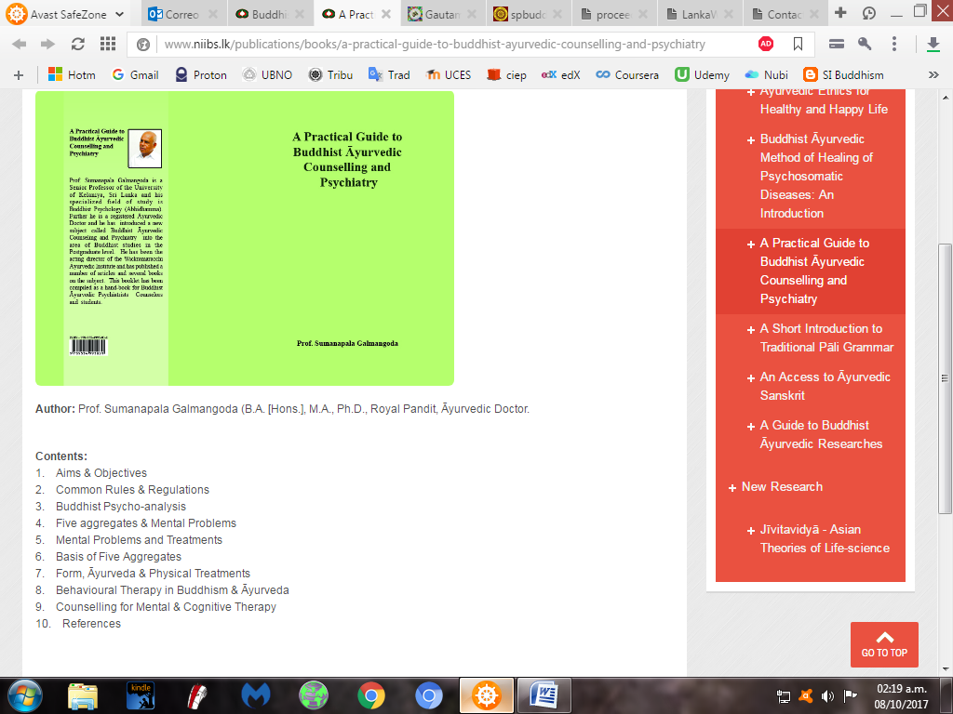
http://www.niibs.lk/publications/books/a-practical-guide-to-buddhist-ayurvedic-counselling-and-psychiatry

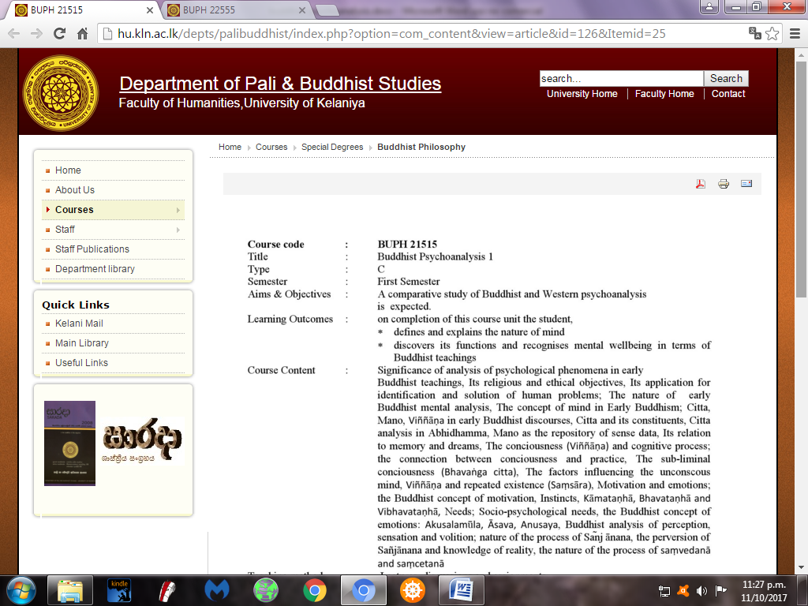
http://hu.kln.ac.lk/depts/palibuddhist/index.php?option=com_content&view=article&id=126&Itemid=25
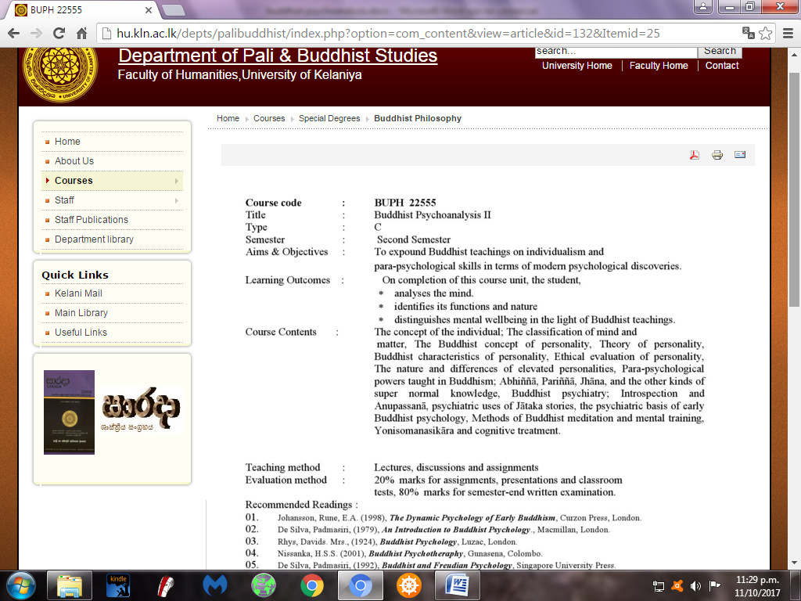
http://hu.kln.ac.lk/depts/palibuddhist/index.php?option=com_content&view=article&id=132&Itemid=25

Evidence 2: VIOLATION OF CULTURAL RIGHTS
UNIVERSAL DECLARATION ON THE RIGHTS OF BUDDHIST PEOPLES AND SPIRITUAL COMMUNITIES: “Article 28: Buddhist Peoples and Spiritual Communities have the right to maintain, control, protect and develop intellectual property of their cultural heritage, traditional knowledge, artistic cultural expressions and scientific discoveries. (… ) Article 42: Buddhist Peoples and Spiritual Communities have the right to practice and revitalize their cultural movement, by maintaining, protecting and developing the manifestations of past, present and future, which include the right to manage its archaeological and historical sites as well as its objects, ceremonies, visual arts and literature. States have the duty to provide effective mechanisms for redress and restitution of cultural, intellectual and spiritual heritage of Buddhist Peoples and Spiritual Communities when they had been deprived of them without informed, prior and free consent and or when their laws, traditions and customs have been violated.”
Universal Declaration on Buddhism as Cultural Heritage of Humanity: “Being aware that the UNESCO Constitution is committed to assist the conservation, progress and dissemination of knowledge, having the duty to preserve and protect the universal cultural heritage of humankind; Noting that the cultural heritage traditions of Buddhist Peoples and Spiritual Communities are threaten to be banalized, deteriorated or destroyed by contemporary societies obsessed with economic development and mass media; (…) Declaring that the deterioration or destruction of the Buddhist Cultural Heritage constitutes a spiritual impoverishment of the heritage of all the peoples and nations worldwide; (…) Recognizing that globalization has brought political and economic advances although it has also created cultural and environmental dangers, such as the deterioration and destruction of tangible and intangible cultural heritage; (…)Recalling that the cases carried out by the International Buddhist Ethics Committee have the purpose of safeguarding the integrity of the intangible cultural heritage of Buddhism, in particular the ethical teachings of spiritual masters; (…) Calling for the adoption of measures to protect cultural expressions of Buddhist Peoples, especially spiritual traditions that may suffer the dangers of destruction, deterioration, contempt or plagiarism; (…)Consolidating the vitality of the Cultural Heritage of spiritual communities and tribal peoples, which have the right to create, disseminate and protect their traditional cultural expressions; (…) Persuaded that the activities and services of Buddhism are a Cultural Heritage that renews the identity and the values of the people, so they should not be manipulated for commercial purposes; (…) Perceiving that globalization processes have developed technologies and media, although at the same time it has impoverished and manipulated spiritual traditions, allowing people outside a culture to profit from the values or knowledge of those traditions; Noting that every individual has the right to participate in the cultural tradition of Buddhism, provided that he or she does not violate the integrity of the tradition or violates the rights of others who participate in said cultural heritage, especially the rights of the creators of such knowledge and practices; Providing certainty that intercultural and interreligious dialogue is fundamental, so that every individual can be linked to any cultural tradition as long as he or she respects this heritage and does not copy it without authorization; (…) Observing compliance and protection of the intellectual property rights of spiritual communities that creatively contribute to the Cultural Heritage of Humanity; (…)Demonstrating that the creation of the spiritual framework of Maitriyana, which gave birth to the United Buddhist Nations Organization, ensures a proper process for the integration and reconciliation of all the cultural traditions of history, posing Buddhism as the Supreme Cultural Heritage of the entire humankind; (…) Article 17 – Buddhism has the right that its Cultural Heritage is safeguarded by means of effective measures such as identification, documentation, research, preservation, protection, promotion, valuation, transmission and revitalization of all its traditional aspects. (…)Article 24 – Buddhism has the right that its Cultural Heritage can be fully defended through the sovereignty and self-determination of spiritual communities, before which States of the international community should cooperate. Article 25 – Buddhism has the right that its Cultural Heritage shall not be damaged or manipulated by direct or indirect measures of individuals, groups or States. (…) Article 27 – Buddhism has the right that the International Buddhist Ethics Committee is in charge of defending its Cultural Heritage, having the duty to carry out trials in cases of violations of the integrity of Buddhist traditions. (…) Article 40 – Buddhism has the right that its Cultural Heritage is safeguarded by the participation of individuals, institutions and communities that create, maintain and transmit its heritage, especially by spiritual masters. Article 41 – Buddhism has the right to recognition of its Cultural Heritage that is composed of the works of Buddhist sages and spiritual masters, even if it involves oral or written teachings, contributing to its rescue, registration, study, diffusion and safeguarding as supreme intangible cultural heritage of the entire humanity. (…) Article 48 – Buddhism has the right to let its Cultural Heritage to be saved by the international community, which should successfully protect this material and immaterial cultural heritage, assuming the responsibility to preserve these cultural expressions of exceptional importance in the face of threats of destruction, manipulation or plagiarism. (…) Article 59 – Buddhism has the right to recognition of its Cultural Heritage for therapeutically benefiting the health of individuals, so that its ancient techniques have potentialities and capabilities that should be taught and used in all contemporary societies, but at the same time by protecting the rights of intellectual property. (…) Article 65 – Buddhism has the right that its Cultural Heritage is considered as jurisdiction of the spiritual commune (Sangha), which has cultural sovereignty over its traditions. (…) Article 82 – Buddhism has the right that its Cultural Heritage, composed of the sacred texts and also of the spiritual relationship between masters and apprentices, is respected, preserved and cared for in schools, universities, communities and the media, having the duty to document, teach and disseminate its teachings in an appropriate way and with the supervision of the Buddhist Peoples.”
UNESCO Declaration concerning the Intentional Destruction of Cultural Heritage: “Recalling the tragic destruction of the Buddhas of Bamiyan that affected the international community as a whole, (…) Referring to Article I(2)(c) of the Constitution of UNESCO that entrusts UNESCO with the task of maintaining, increasing and diffusing knowledge by assuring the conservation and protection of the world’s inheritance of books, works of art and monuments of history and science, and recommending to the nations concerned the necessary international conventions, (…) Mindful that cultural heritage is an important component of the cultural identity of communities, groups and individuals, and of social cohesion, so that its intentional destruction may have adverse consequences on human dignity and human rights, Reiterating one of the fundamental principles of the Preamble of the 1954 Hague Convention for the Protection of Cultural Property in the Event of Armed Conflict providing that damage to cultural property belonging to any people whatsoever means damage to the cultural heritage of all mankind, since each people makes its contribution to the culture of the world, (…) Mindful of the development of rules of customary international law as also affirmed by the relevant case-law, related to the protection of cultural heritage in peacetime as well as in the event of armed conflict; Also recalling Articles 8(2)(b)(ix) and 8(2)(e)(iv) of the Rome Statute of the International Criminal Court, and, as appropriate, Article 3(d) of the Statute of the International Criminal Tribunal for the former Yugoslavia, related to the intentional destruction of cultural heritage, (…) The international community recognizes the importance of the protection of cultural heritage and reaffirms its commitment to fight against its intentional destruction in any form so that such cultural heritage may be transmitted to the succeeding generations. (…) intentional destruction means an act intended to destroy in whole or in part cultural heritage, thus compromising its integrity, in a manner which constitutes a violation of international law or an unjustifiable offence to the principles of humanity and dictates of public conscience (…). States should take all appropriate measures to prevent, avoid, stop and suppress acts of intentional destruction of cultural heritage, wherever such heritage is located. (…)When conducting peacetime activities, States should take all appropriate measures to conduct them in such a manner as to protect cultural heritage (…) States should take all appropriate measures, in accordance with international law, to establish jurisdiction over, and provide effective criminal sanctions against, those persons who commit, or order to be committed, acts of intentional destruction of cultural heritage of great importance for humanity, whether or not it is inscribed on a list maintained by UNESCO or another international organization.”
UNESCO Convention for the Safeguarding of the Intangible Cultural Heritage: “Recognizing that the processes of globalization and social transformation, alongside the conditions they create for renewed dialogue among communities, also give rise, as does the phenomenon of intolerance, to grave threats of deterioration, disappearance and destruction of the intangible cultural heritage, in particular owing to a lack of resources for safeguarding such heritage; (…) Considering the invaluable role of the intangible cultural heritage as a factor in bringing human beings closer together and ensuring exchange and understanding among them, (…) The intangible cultural heritage means the practices, representations, expressions, knowledge, skills – as well as the instruments, objects, artefacts and cultural spaces associated therewith – that communities, groups and, in some cases, individuals recognize as part of their cultural heritage. This intangible cultural heritage, transmitted from generation to generation, is constantly recreated by communities and groups in response to their environment, their interaction with nature and their history, and provides them with a sense of identity and continuity, thus promoting respect for cultural diversity and human creativity. For the purposes of this Convention, consideration will be given solely to such intangible cultural heritage as is compatible with existing international human rights instruments, as well as with the requirements of mutual respect among communities, groups and individuals, and of sustainable development. (…) Safeguarding means measures aimed at ensuring the viability of the intangible cultural heritage, including the identification, documentation, research, preservation, protection, promotion, enhancement, transmission, particularly through formal and non-formal education, as well as the revitalization of the various aspects of such heritage. (…) Each State Party shall endeavour, by all appropriate means, to: ensure recognition of, respect for, and enhancement of the intangible cultural heritage in society, in particular through: (…) non-formal means of transmitting knowledge; (…) Within the framework of its safeguarding activities of the intangible cultural heritage, each State Party shall endeavour to ensure the widest possible participation of communities, groups and, where appropriate, individuals that create, maintain and transmit such heritage, and to involve them actively in its management.”
UNESCO Convention on the Protection and Promotion of the Diversity of Cultural Expressions: “Recognizing the importance of traditional knowledge as a source of intangible and material wealth, and in particular the knowledge systems of indigenous peoples, and its positive contribution to sustainable development, as well as the need for its adequate protection and promotion, (…) Taking into account the importance of the vitality of cultures, including for persons belonging to minorities and indigenous peoples, as manifested in their freedom to create, disseminate and distribute their traditional cultural expressions and to have access thereto, so as to benefit them for their own development, (…) Recognizing the importance of intellectual property rights in sustaining those involved in cultural creativity; Being convinced that cultural activities, goods and services have both an economic and a cultural nature, because they convey identities, values and meanings, and must therefore not be treated as solely having commercial value”
UNESCO Universal Declaration on Cultural Diversity: "Cultural heritage in all its forms must be preserved, enhanced and handed on to future generations as a record of human experience and aspirations, so as to foster creativity in all its diversity and to inspire genuine dialogue among cultures (...) In the face of present-day economic and technological change, opening up vast prospects for creation and innovation, particular attention must be paid to the diversity of the supply of creative work, to due recognition of the rights of authors and artists and to the specificity of cultural goods and services which, as vectors of identity, values and meaning, must not be treated as mere commodities or consumer goods. (...) Respecting and protecting traditional knowledge, in particular that of indigenous peoples; recognizing the contribution of traditional knowledge (...) Ensuring protection of copyright and related rights in the interest of the development of contemporary creativity and fair remuneration for creative work"
UNESCO Recommendation on the Safeguarding of Traditional Culture and Folklore: "Preservation is concerned with protection of folk traditions and those who are the transmitters, having regard to the fact that each people has a right to its own culture and that its adherence to that culture is often eroded by the impact of the industrialized culture purveyed by the mass media. (...) It is essential for the items that make up this cultural heritage to be widely disseminated so that the value of folklore and the need to preserve it can be recognized. However, distortion during dissemination should be avoided so that the integrity of the traditions can be safeguarded. (...) In so far as folklore constitues manifestations of intellectual creativity whether it be individual or collective, it deserves to be protected in a manner inspired by the protection provided for intellectual productions. Such protection of folklore has become indispensable as a means of promoting further development, maintenance and dissemination of those expressions,- both within and outside the country, without prejudice to related legitimate interests."
UNESCO Recommendation concerning the Preservation of Cultural Property Endangered by Public or Private works: "Considering that contemporary civilization and its future evolution rest upon, among other elements, the cultural traditions of the peoples of the world, their creative force and their social and economic development; Considering that cultural property is the product and witness of the different traditions and of the spiritual achievements of the past and thus is an essential element in the personality of the peoples of the world; Considering that it is indispensable to preserve it as much as possible, according to its historical and artistic importance, so that the significance and message of cultural property become a part of the spirit of peoples who thereby may gain consciousness of their own dignity; Considering that preserving cultural property and rendering it accessible constitute, in the spirit of the Declaration of the Principles of International Cultural Cooperation adopted on 4 November 1966 in the course of its fourteenth session, means of encouraging mutual understanding among peoples and thereby serve the cause of peace; Considering also that the well-being of all peoples depends, inter alia, upon the existence of a favourable and stimulating environment and that the preservation of cultural property of all periods of history contributes directly to such an Environment; (...) Considering, however, that the prehistoric, protohistoric and historic monuments and remains, as well as numerous recent structures having artistic, historic or scientific importance are increasingly threatened by public and private works resulting from industrial development and urbanization; (...) Considering equally that adequate preservation and accessibility of cultural property constitute a major contribution to the social and economic development of countries and regions which possess such treasures of mankind by means of promoting national and international tourism; (...) Member States should take steps to ensure that offences, through intent or negligence, against the preservation or salvage of cultural property endangered by public or private works are severely punished by their Penal Code, which should provide for fines or imprisonment or both. (...) Member States should encourage individuals, associations and municipalities to take part in programmes for the preservation or salvage of cultural property endangered by public or private works. (...) Educational institutions, historical and cultural associations, public bodies concerned with the tourist industry and associations for popular education should have programmes to publicize the dangers to cultural property arising from short-sighted public or private works, and to underline the fact that projects to preserve cultural property contribute to international understanding."
Council of Europe Framework Convention on the Value of Cultural Heritage for Society: "Emphasising the value and potential of cultural heritage wisely used as a resource for sustainable development and quality of life in a constantly evolving society; Recognising that every person has a right to engage with the cultural heritage of their choice, while respecting the rights and freedoms of others, (...) The Parties to this Convention agree to (...) recognise individual and collective responsibility towards cultural heritage; (...) cultural heritage is a group of resources inherited from the past which people identify, independently of ownership, as a reflection and expression of their constantly evolving values, beliefs, knowledge and traditions. It includes all aspects of the environment resulting from the interaction between people and places through time; a heritage community consists of people who value specific aspects of cultural heritage which they wish, within the framework of public action, to sustain and transmit to future generations. (...) everyone, alone or collectively, has the responsibility to respect the cultural heritage of others as much as their own heritage, (...) Exercise of the right to cultural heritage may be subject only to those restrictions which are necessary in a democratic society for the protection of the public interest and the rights and freedoms of others. (...) enhance the value of the cultural heritage through its identification, study, interpretation, protection, conservation and presentation; (...) promote cultural heritage protection as a central factor in the mutually supporting objectives of sustainable development, cultural diversity and contemporary creativity; (...) encourage reflection on the ethics and methods of presentation of the cultural heritage, as well as respect for diversity of interpretations; establish processes for conciliation to deal equitably with situations where contradictory values are placed on the same cultural heritage by different communities; develop knowledge of cultural heritage as a resource to facilitate peaceful co-existence by promoting trust and mutual understanding with a view to resolution and prevention of conflicts; (...) To sustain the cultural heritage, the Parties undertake to: a promote respect for the integrity of the cultural heritage by ensuring that decisions about change include an understanding of the cultural values involved; (...) ensure that these policies respect the integrity of the cultural heritage without compromising its inherent values. (...) encourage non-governmental organisations concerned with heritage conservation to act in the public interest. (...) encourage everyone to participate in: – the process of identification, study, interpretation, protection, conservation and presentation of the cultural heritage; – public reflection and debate on the opportunities and challenges which the cultural heritage represents; (...) seeking to resolve obstacles to access to information relating to cultural heritage, particularly for educational purposes, whilst protecting intellectual property rights; recognising that the creation of digital contents related to the heritage should not prejudice the conservation of the existing heritage."
United Nations Declaration on the Rights of Indigenous Peoples: “Indigenous peoples have the right to maintain, control, protect and develop their cultural heritage, traditional knowledge and traditional cultural expressions, as well as the manifestations of their sciences, technologies and cultures, including human and genetic resources, seeds, medicines, knowledge of the properties of fauna and flora, oral traditions, literatures, designs, sports and Traditional games and visual and performing arts. They also have the right to maintain, control, protect and develop their intellectual Property over such cultural heritage, traditional knowledge, and Traditional cultural expressions. (…) Indigenous peoples have the right to promote, develop and maintain their institutional structures and their distinctive customs, spirituality, traditions, procedures, practices and, in the cases where they exist, juridical systems or customs, in accordance with international human rights standards. Indigenous peoples have the right to determine the responsibilities of individuals to their communities. (…) Indigenous peoples have the right to access to and prompt decision through just and fair procedures for the resolution of conflicts and disputes with States or other parties, as well as to effective remedies for all infringements of their individual and collective rights. Such a decision shall give due consideration to the customs, traditions, rules and legal systems of the indigenous peoples concerned and international human rights.”

http://portal.unesco.org/en/ev.php-URL_ID=17718&URL_DO=DO_TOPIC&URL_SECTION=201.html
http://portal.unesco.org/en/ev.php-URL_ID=17716&URL_DO=DO_TOPIC&URL_SECTION=201.html
http://portal.unesco.org/en/ev.php-URL_ID=31038&URL_DO=DO_TOPIC&URL_SECTION=201.html

