Case number 08/2015:
AUSTRALIA

HONOURABLE JURY OF THE INTERNATIONAL BUDDHIST ETHICS COMMITTEE (IBEC) & BUDDHIST TRIBUNAL ON HUMAN RIGHTS (BTHR)
P R E S E N T . –

In the presence of the President and Spiritual Guide of IBEC-BTHR, Buddhist Master Maitreya, and the Executive Secretary of IBEC-BTHR Master Yan Maitri- Shi, it is addressed the Case reported by the World Association of Buddhism (WBA) against AUSTRALIA for the Crimes of PERSECUTION, ANIMAL EXTERMINATION, ECOCIDE, DEFORESTATION, MARINE POLLUTION and those which result from them, being a clear and painful violation and disrespect for the animal life, vegetal life and the waters of that country.-

I, Sekka Dhamma, as Prosecutor of the IBEC & BTHR, acknowledge the hard and organized work that was conducted for the comprehensive compilation of Evidence in this case, likewise, I appreciate the contribution of them for the analysis concerning the Party I represent. That said, with all due respect I appear to expound:
By being received the list of digital media that were collected, ordered and, at the same time, confirmed in their order and context as Evidence by the Executive Secretary of IBEC and BTHR Master Yan Maitri-Shi, I give way to the Fourth Stage of the Procedure called "EVALUATION OF EVIDENCE" which is established in the Constitutive Act of IBEC and BTHR in order to know, establish, rule and determine the responsibility for the commission of crimes of PERSECUTION, ANIMAL GENOCIDE AND EXTERMINATION, ECOCIDE, DEFORESTATION, MARINE POLLUTION and those which result as responsibility of the AUSTRALIA government and the Environment Minister Greg Hunt, thereby proceeding on the Violation of the Rights of Animals (cats and other affected animal species) which aims to eradicate through predatory, cruel and atrocious tactics. This accusation was made by the WORLD ASSOCIATION OF BUDDHISM in the field of Buddhist Ethics, an act that follows below:

EVALUATION OF EVIDENCES
FIRST EVALUATION.- By being the core of this Procedural stage, it is necessary to point out the Means of Proof offered by the Executive Secretary of IBEC and BTHR Master Yan Maitri-Shi, and formally present them to the Jury for its information, which is composed of 12 evidences that prove the motivating Accusation of the current process, entitled with a wide range of Crimes committed against Flora, Fauna (wild and domestic cats and other animals that are consequently affected from the savage persecution and elimination of feline species) and Australian waters. The latter, denounced from the field of Buddhist Ethics. These evidences come from digital audiovisual media in the public domain (mass media), which are listed below:

Evidence 1: PERSECUTION AND GENOCIDE OF CATS
Greg Hunt, ministro de Medio Ambiente de Australia dijo: "By 2020, I want to see two million feral cats culled, five new islands and 10 new mainland areas as safe havens, free of feral cats, and control measures applied across 10 million hectares," (https://news.vice.com/article/feline-massacre-australia-unveils-plan-to-kill-two-million-feral-cats)
French animal rights champion, former actress, Brigitte Bardot said in a letter to Australia’s Environment Minister Greg Hunt: "This animal genocide is inhumane and ridiculous, (…) Killing cats to protect other animals is outrageous, you will disperse harmful products, dangerous for all species, without distinction, and death by poisoning is a terrifying pain. In addition to being cruel, killing these cats is totally useless because the rest of them will keep breeding,(…) Your country is sullied by the blood of millions of innocent animals, so please don't add cats to this morbid record" (https://www.rt.com/news/310547-australia-cats-bardot-genocide/ )
Jonathan Pearlman, from The Telegraph UK, said: “Declaring a war on cats, the federal government said it planned to use poison baits and has created a phone app called Feral Cat Scan for the public to alert authorities about areas where large numbers of the predators have been spotted.” (http://www.telegraph.co.uk/news/worldnews/australiaandthepacific/australia/11743499/Australia-declares-war-on-feral-cats-with-plan-to-cull-two-million-by-2020.html)
Jonathan Pearlman, from The Telegraph UK, said: “The government is pushing for tighter regulation of cat ownership and measures to control the population such as desexing and microchipping. (…) Some experts said the government should consider requiring domestic cats to be kept indoors.” (http://www.telegraph.co.uk/news/worldnews/australiaandthepacific/australia/11743499/Australia-declares-war-on-feral-cats-with-plan-to-cull-two-million-by-2020.html)
Damien Licari, an ecologist with Lismore city council, said: “There's no doubt that cats and domestic cats have an impact on small mammals and birds in urban areas, (…) I choose not to own a cat and in times when I have owned cats, they've been entirely indoor cats. I would applaud any change in laws that would lock cats inside.” (http://www.telegraph.co.uk/news/worldnews/australiaandthepacific/australia/11743499/Austraia-declares-war-on-feral-cats-with-plan-to-cull-two-million-by-2020.html)

Evidence 2: EXTERMINATION
John R. Platt, from Scientific American: “Most recently 3,000 feral cats were shot during a 16-day period in Queensland to keep them away from a 29-square-kilometer (…)” (http://blogs.scientificamerican.com/extinction-countdown/feral-cats-killed-protect-bilbies/)
Jared Owens, from The Australian, wrote: “Environment Minister Greg Hunt has called for research into a virus to eradicate feral cats (…) Mr Hunt said the government endorsed a dedicated eradication program, the use of island arks that exclude invasive species, and a research into a safe and targeted form of biological control (…) Domestic cat owners would likely be required to immunise their pets against the disease.” (http://www.theaustralian.com.au/national-affairs/greg-hunt-calls-for-eradication-of-feral-cats-that-kill-75m-animals-a-night/story-fn59niix-1226939644027)

Evidence 3: EXTERMINATION OF OTHER SPECIES
John R. Platt, from Scientific American said: “Dingoes, which compete with cats and other predators for food, have been poisoned to protect agricultural sheep, but Griffith University researcher Jean-Marc Hero told The Australian last September that this approach gave cats and foxes a chance to fill the ecological gap the dingoes left behind.” (http://blogs.scientificamerican.com/extinction-countdown/feral-cats-killed-protect-bilbies/)
ABC News said: “Earlier this year officials said that close to 700 koalas had been killed off in south-eastern Australia because overpopulation led to the animals starving, while feral camels and wild horses have been culled in the outback to stop them destroying land.” (http://www.abc.net.au/news/2015-07-22/brigitte-bardot-condemns-greg-hunt-for-feral-cut-cull-plan/6640846)
Brigitte Bardot, from Brigitte Bardot Foundation, said: “The public image of Australia is disastrous: Kangaroo massacres, wild horses slaughters… Your country is far from being exemplary (…) Indeed, you are about to scatter harmful chemicals in the wild, potentially dangerous for all species without any distinction. (…) You expose these animals to a death under atrocious suffering. (…). Your country is sullied by the blood of millions of innocent animals, so please, don’t add cats to this morbid record!” (www.fondationbrigittebardot.fr) and (www.abc.net.au/news/2015-07-22/brigitte-bardot-condemns-greg-hunt-for-feral-cut-cull-plan/6640846)
The Conversation said: “If rabbits are culled from an area, but cats aren’t controlled at the same time, then cats might switch prey and eat more small native mammals.(…) Past experience tells us how these programs can go awry. For example, when feral cats were eradicated from Macquarie Island in 2000, rabbit numbers exploded because the cats had kept the rabbits in check. Rabbits caused severe damage to the island’s native vegetation before being eradicated (…) in 2014.” (http://theconversation.com/feral-feast-cats-kill-hundreds-of-australian-animals-35555)
Mike Seccombe, from Saturday Paper, wrote: “Hunt also approved the West Australian government’s controversial, and now abandoned, plan to catch and kill sharks to protect swimmers” (https://www.thesaturdaypaper.com.au/news/politics/2014/12/06/greg-hunts-hostile-attack-the-environment/14177844001333)

Evidence 4: PETITIONS TO STOP THE SLAUGHTER AND SUGGESTIONS FOR RECONCILING SOLUTIONS IN ORDER TO CONTROL THE POPULATION OF FERAL CATS

Mini Kitty Commune (MKC), Australia asked: “Prime Minister Tony Abbott (…) Please stop planned killing of 2 million Australian cats. We don’t want a war on kittens! (…) The Australian Government plans to kill over 2 million cats, with a $3.6m fund established to wipe colony cats off the face of the earth. (…) This high risk initiative includes a website designed to dob in colony cats and a number of cat eradication programs including baiting, shooting, dogs, traps and nearly every method of killing known. (…) We have concerns that this massive war on cats is high risk and significantly dangerous to the community. We ask that the government stop this program to allow public review, put in place solid checks and balances to ensure that this program is not a free for all for cat hating people to dob in cats and destroy colonies of well managed animals. This includes; The huge risk to owned and unowned cats, with baiting programs that could easily go wrong; The risk of cruelty to animals, with trapping, savage dog attacks, shooting and other methods that harm animals; The illogical approach of a “dob in a colony” site, showcasing trapping methods and risking home grown grudges from cat hating people; A risk to all animals through the many methods of death that do not discriminate between cat, dog, possum, bird or any animal.(…) This program should not have snuck quietly into legislation, but been subject to public review and scrutiny. Please stop this program to allow full public review and assurance that millions of animals are not being unnecessarily killed for their only crime, of being a cat. (…) Yours (undersigned)” (http://mkc.org.au/learn/petitioncatwar)

Brigitte Bardot, from Fondation Brigitte Bardot wrote: “Dear Minister, The announcement made by your government regarding the culling of two million cats is appalling the whole international community. May I remind you that cats are, such as dogs, pets. (…) Killing two million cats of a population of 20 million is a scandal, a shame! (…) This animal genocide is inhumane and ridiculous; the 6 million dollars you plan to spend in destroying these animals would be much better spent in setting up a large-scale sterilization campaign. These campaigns have been proven very effective everywhere they have been experienced. My foundation works all over the world with the Australian veterinarians of Vets Beyond Borders to neuter successfully stray animals. (…) In addition to being cruel, killing these cats is absolutely useless since the rest of them will keep breeding. My Foundation works on this kind of issues for decades and I can assure you that no alternative is efficient but neutering. Sterilized cats will still defend their territory but will no breed anymore. (…) These are the reasons why I implore you, Minister, to dedicate 6 million dollars budget not to cull 2 million cats but to set up a vast sterilization campaign instead. (…) It is high time to stop these barbaric and pointless practices as they put the spotlight on your country the worst possible way. (…) Humane cruelty is limitless but changing one’s mind is a proof of intelligence and humanity. (…) I’m counting on you, don’t disappoint me. Brigitte Bardot.” (www.abc.net.au/news/2015-07-22/brigitte-bardot-condemns-greg-hunt-for-feral-cut-cull-plan/6640846)
Animalspetition.org: “Dear Australian Environment Minister Greg Hunt, (…) You recently announced a plan to kill 2 million feral cats in the country who it says are harming native species, despite the fact that animal rights groups say this won’t do much to help. You claim the cats will be killed humanely, but is there really a way to murder innocent animals who are just trying to survive? (…) I agree with Brigitte Bardot that Bardot the money set to murder innocent animals would be better used to sterilize them and decrease the population in that nonviolent way rather than your plan to shoot and poison the animals. (…) Considering feral cats stem from domesticated cats who became wild, sterilization seems much more fair. These animals didn’t ask to be abandoned from their homes and forced to survive in the wild. I urge you to not unnecessarily murder 2 million feral cats and instead consider more humane options. (…) Sincerely,” (http://animalpetitions.org/114862/dont-murder-feral-cats/)
Damián Di Leonardo, from Argentina: “To the Minister of Environment Mr.Greg Hunt Australia and the Australian ambassador to Argentina Mr.Noel Campbell (…) I order to annul the decision to exterminate the cats because they threaten the world animal protection law applying the use of poison "Eradicat" and land cheating or attempting to bring expensive natural enemies that only their own pockets. The only way I propose is that with this money mass sterilization program for stray cats and a possible migration of these other areas that do not alter the coexistence with other animals do.” (https://www.change.org/p/greg-hunt-noel-campbell-anular-la-decisi%C3%B3n-de-exterminar-a-gatos-callejeros-por-supuesto-da%C3%B1o-ecol%C3%B3gico?recruiter=57117040&utm_source=share_petition&utm_medium=twitter&utm_campaign=share_twitter_responsive)
Arian Wallach, University fellow at Charles Darwing University and Daniel Ramp, Senior Lecturer at University of Technology, Sydney, wrote: “let’s embrace cats as part of Australia’s environment. We could even rename them Australian wildcats. (…) what may seem counterintuitive is that leaving cats alone can also benefit Australia’s threatened native species (…) Many cats do live among us, but most now exist in a completely wild state, including in the middle of the driest of deserts and the lushest of rainforests. Sterilisation can help reduce the number of house cats without a home, but it will not benefit wildlife away from cities. We need to move beyond thinking about cats as either wards or enemies. (…) Killing cats, even two million of them, can inadvertently increase cat numbers by enabling more cats to immigrate into vacant territories. Conversely, cat eradication can cause population booms of other species (such as rabbits and rats) and result in further harm.(…) Attempting to remove cats from Australian ecosystems will not be a clean and painless surgery (…)The number of cats and their influence on other wildlife are a function of ecological context. Major forces that influence the ability of prey to coexist with cats include vegetation cover and larger predators. Grazing and fire can reduce vegetation cover and make it harder for prey animals to escape. Significantly, larger predators, such as dingoes, are a major threat to cats. (…) Foxes have long been held as Australia’s primary environmental villain. They are also easier to kill, because they more readily scavenge. Meat baits laced with 1080 poison are used extensively in conservation programs. (…) This inhumane poison kills foxes and dingoes in untold numbers, and enables cats to breed up and move with impunity across the landscape. (…) For example, a major poison-baiting campaign did help recover endangered woylies for a time, but eventually the loss of foxes and dingoes caused cats to take over and the newly recovered population collapsed. (…) Cats have become an integral part of Australia’s wildlife and beauty. Many native species successfully coexist with cats, especially when we leave predators alone. (…) Australian wildcats probably provide the same ecological functions as they do in their native ranges, such as suppressing population irruptions of their prey. Killing cats achieves only one outcome with consistency: it produces dead cats. (…) Embracing cats is a paradigm shift. It means embracing the entirety of Australia’s modern ecosystems - native and feral - and letting go of the past. (…) It is time to accept these immigrants as Australian citizens.” (https://theconversation.com/lets-give-feral-cats-their-citizenship-45165)

Evidence 5: MASS DEATHS DUE TO POISONING AND RISK OF AFFECTING OTHER ECOSYSTEMS
VICE NEWS said: “The elimination of wild cats will involve the use of detector dogs, fencing, and shooting, as well as the use of a new poison bait called "Curiosity", which has been developed by the government and a private biotech company over several years. A toxic compound in the bait stops the flow of oxygen within the poisoned cat, and is described in the government's plan as the new humane feral cat bait. It will be placed inside pieces of meat that are molded to resemble sausages.” (https://news.vice.com/article/feline-massacre-australia-unveils-plan-to-kill-two-million-feral-cats)
People for the Ethical Treatment of Animals (PETA) said: “Having witnessed the painful deaths of countless feral cats, we cannot in good conscience advocate trapping, altering and releasing as a humane way to deal with overpopulation and homelessness, (…) Not only is shooting and poisoning cats cruel, culls have been shown to be unsuccessful in the long term,”(https://www.rt.com/news/310547-australia-cats-bardot-genocide/)
RT Question More: “a spokeswoman for PETA Australia told (…) that the use of poison in suburban areas puts domestic animals, such as cats and dogs, as well as carnivorous wildlife at risk.”(https://www.rt.com/news/310547-australia-cats-bardot-genocide/ )
John R. Platt, from Take Part said: “The 1080 poison, also known as sodium fluoroacetate (…) The Australian charity The World League for Protection of Animals calls it [poison] cruel and indiscriminate and says it can damage ecosystems in which it is applied” (http://www.takepart.com/article/2015/02/04/australias-new-plan-kill-feral-cats-and-save-endangered-marsupials)
Dr. Tony Buckmaster, of the Invasive Animals Cooperative Research Center at the University of Canberra, said: “In my view, it becomes a choice—deploy the bait and potentially risk the death of a few native animals, or don’t deploy the bait and guarantee the death of many, (…) it is simply not possible to guarantee that no nontarget animal will ever take a bait and die,” (http://www.takepart.com/article/2015/02/04/australias-new-plan-kill-feral-cats-and-save-endangered-marsupials)

Evidence 6: GOVERNMENTAL DECEIT
Greg Hunt, Environment Minister, said: “There are up to 20 million feral cats taking up to four native Australian animals a night. That is over 20 billion Australian native species being destroyed a year,” (http://www.abc.net.au/news/2014-11-13/greg-hunt-feral-cat-native-animals-fact-check/5858282)
ABC News said: “Fact Check asked Mr Hunt for the basis of his claim and his office said the figures were sourced from The Action Plan for Australian Mammals published in June 2014. (…) However, Fact Check contacted the authors, Professor John Woinarski from Charles Darwin University and consultant biologist Andrew Burbidge, who both say the plan provides no such statistic. (…) The Environment Department says feral cats are thought to threaten 81 vulnerable and endangered native animals - 35 bird species; 36 mammal species; 7 reptile species; and 3 amphibian species. (…) The number of native Australian animals killed by feral cats each night is also difficult to calculate, due to differences in the size of prey. The stomachs of dissected feral cats can contain one rabbit, or up to 50 frogs. (…) Mr Hunt's claim that feral cats are destroying over 20 billion native Australian animals each year is unverifiable.” (http://www.abc.net.au/news/2014-11-13/greg-hunt-feral-cat-native-animals-fact-check/5858282)
Professor Woinarski, from Charles Darwin University said: “The Action Plan for Australian Mammals does not give any estimate or data on the number of feral cats in Australia or on the number of individual animals killed by those cats,” (http://www.abc.net.au/news/2014-11-13/greg-hunt-feral-cat-native-animals-fact-check/5858282)
Dr. Burbidge, who chairs the West Australian Government's Threatened Species Scientific Committee, said: “The action plan highlights that feral cats are the current greatest threat to Australia's mammals. But... it does not attempt to provide an estimate of the number out there,” (http://www.abc.net.au/news/2014-11-13/greg-hunt-feral-cat-native-animals-fact-check/5858282)
Professor Dickman, from Sydney University said: “If it's difficult to put a number on the population, then it's difficult to put a number on animals they kill.” (http://www.abc.net.au/news/2014-11-13/greg-hunt-feral-cat-native-animals-fact-check/5858282)
Tim Doherty, PhD Candidate at Edith Cowan University said: “The assumption that cats eat five native animals each night may hold true in northern Australia where European rabbits are largely absent, but it won’t always stand up in the southern half of the continent where rabbits form a staple part of cats' diets in many areas. These are only estimates of course and they’re useful for engaging the wider community in the feral cat discussion. (…) A number of news reports also state that the recent Action Plan for Australian Mammals estimated that there are 15 million feral cats in Australia. I’ve read the main sections of this 1,000 page book, and I don’t believe this to be the case. It appears that these numbers are becoming conflated as they filter through various media reports. Nevertheless, these massive numbers are great for capturing the attention of the general public and raising awareness about feral cat impacts. But from a scientific point of view, it’s important to ask how reliable these estimates are. (…) I think it’s important that we think about this more closely, especially given Greg Hunt’s decade-long feral cat eradication plan. How can we eradicate feral cats if we don’t know how many there are? ”. (http://theconversation.com/to-eradicate-feral-cats-we-need-to-know-how-many-are-out-there-33014)
Lisa Chalk, from Animals Australia said: “It's worth noting that the primary and most significant threat to the continued existence of Australia's native species is the destruction of their habitat and food sources.” (http://www.abc.net.au/news/2015-07-22/brigitte-bardot-condemns-greg-hunt-for-feral-cut-cull-plan/6640846)
ABC News said: “Animals Australia said it was sceptical the Government's proposed measures would make a significant difference to the wild cat population.” (http://www.abc.net.au/news/2015-07-22/brigitte-bardot-condemns-greg-hunt-for-feral-cut-cull-plan/6640846)

Evidence 7: PERVERSE AND INHUMANE DEATHS
Ameena Schelling, from The Dodo For the Love of Animals, wrote: “Unfortunately, the cats face unpleasant deaths. Australia will use a variety of approaches to cull the cats — as well as non-native foxes — including poison traps and trained tracker dogs.” (https://www.thedodo.com/australia-kill-feral-cats-1253963938.html)
Brianne Hogan, from Ecorazzi, wrote: “The government funding of the five-year plan will largely go toward killing Australia’s feral cats, whether by baiting, shooting or poisoning, with promises that these killings will be carried out in a “humane and effective” manner. (…) Tyler Flockhart, a wildlife ecologist from University of Guelp (…) noted euthanasia of those cats that aren’t adopted out of shelters isn’t popular with the public (nor does it seem humane). (…) However, it seems that Australia doesn’t agree, or just doesn’t care. Nevertheless, it will be a devastating five years for the feral cats in Australia.” (http://www.ecorazzi.com/2015/07/22/australia-plans-to-kill-2-million-stray-cats-by-2020/)
Shane Bateman, a veterinarian and chair of the board of the Guelph Humane Society, said: “A good scientific look at history would tell us that that model just simply doesn’t work,” (http://www.ecorazzi.com/2015/07/22/australia-plans-to-kill-2-million-stray-cats-by-2020/)

Evidence 8: ECOCIDE; DEFORESTATION; CONTAMINATION IN WATERS AND OCEANS
Master Yan Maitri-Shi: [On images 4; 5; 6 y 7 of the photographic evidence, it can be observed some of the species in danger of extinction, which are being mainly damaged by deforestation.]
Master Yan Maitri-Shi: [On image 1 it can be observed a lonely koala which is in the middle of the deforested area]
Master Yan Maitri-Shi: [On image 8, marked in red, it can be observed the great area affected by deforestation.]
Oliver Milman, from The Guardian, UK wrote: “Eastern Australia is one of the world’s 11 deforestation hotspots that together will account for 80% of global forest loss by 2030, a new report has warned. (…) Between 3m hectares and 6m hectares of rainforest and temperate forest, mainly stretching across New South Wales and Queensland, could be lost between 2010 and 2030 on current trends, according to the World Wildlife Fund’s Living Forests report. (…) About 70% of the eastern forests of Australia have already been cleared or disturbed, with just 18% of the area under any sort of protection, the WWF report states. Australia’s forestry loss has primarily been caused by land clearing for livestock, with unsustainable logging and mining also blamed for tree felling. (…) WWF said the watering down of environmental protections by the previous LNP government in Queensland led to a sharp rise in land clearing, with 275,000 ha torn down in the past financial year – a tripling of vegetation loss rates since 2010.” (http://www.theguardian.com/environment/2015/apr/27/east-australia-one-of-11-areas-account-for-80-of-world-forest-loss-by-2030)
Dermot O’Gorman, chief executive of WWF Australia said: “Maintaining forest protections is vital at state level. We’ve lost the large majority of the eastern Australian forest, which means the remaining forests are even more important to maintain. (…) If business as usual continues, we will see more Australian species disappear, as well as the continuing decline of our water, topsoil and local and regional climate.” (http://www.theguardian.com/environment/2015/apr/27/east-australia-one-of-11-areas-account-for-80-of-world-forest-loss-by-2030)
Frances Pike, from Independent Australia: “Forestry has changed. Industrialised logging is the new norm. Silviculture now is highly mechanized harvesting technology capable of intense rapid clearing. There was no announcement to the Australian public that selective logging by manual extraction was being replaced by machines that flatten forest understoreys. (…) A disastrous set of clear fell “experiments”, alongside the aerial application of herbicide and/or accompanying on ground “disincentives” to native animals (in the form of poisoned baits), is called “sustainable”. Systematically, industrialised logging modifies forest ecosystems. Deliberately or inadvertently, a process of “conversion” of forests into factories takes place. Australian deforestation is occurring at rate and of a scale never seen before. (…) Two thirds of Australia's loggable native forest is under Commonwealth-state Regional Forest Agreements (RFAs) — a mid to late 90’s attempt to control deforestation. The ecological basis was to be an offset system, the establishment of Comprehensive, Adequate and Representative (CAR) reserves. The process for establishing these was inadequate, unscientific, its legal status ambiguous. Yet the stated ecological intent is used by government and Industry to claim sustainability. Reports of catastrophic damage are countered by a hollow statement — RFAs were to make Australian forestry sustainable. Ergo Australian logging is sustainable. RFA rhetoric, paid for by their taxes, was fed to the public by industry and government. Now, science and empirical evidence expose the sustainable native forest logging myth as a "deadly" lie. Australia is a leader in global deforestation and leads the extinction crisis. (…) no law protects native forests from anything.(…) Wildlife is pushed to extinction, soil, water and carbon storage functions destroyed. Industrialised logging kills forest life, directly and indirectly and through cumulative impacts. (…)The North East of NSW, one of the world’s 35 “biodiversity hotspots”, with at least 1,500 endemic plant species (0.5% of the world’s known plants) is still being logged, despite 70% of primary vegetative cover already having been lost. Though a critical refuge for global species survival, from the Queensland border to Gosford, these biodiverse forests are, by stealth, being converted from ecosystems to single aged stands favouring one species. There are seven endangered ecological communities on the national list here; 43 animal species and 164 plant species critically endangered, endangered and/or vulnerable to extinction. These forests house 11% of Australia's nationally listed threatened animals and 13% of the threatened plants. Of 109 species threatened by logging, it is logging that is now the number one threat to the survival of 41. (…) The infamous and despised cable logging, that decimated huge swathes of Tasmanian native forests, would destroy the refuge for wildlife in the process of being "expunged" (by logging) from the coast and lower hinterland strip (…) In the South-Eastern bioregion, where 27,727 ha (45% of the gross area) can be logged, live 210 threatened species. Nineteen of these are not only bio-regionally, but nationally endangered, with some classified as "critically endangered" – one step from extinction – yet still the forests wherein they literally cling to survival are being clear felled. (…) extinction is on the cards also for three large forest owls, the glossy and the red tailed black cockatoos, the long nosed potoroo, the large brown tree frog, the spotted tail quoll, the greater glider and the list goes on. (…) The Tasmanian swift parrot population is 'on a trajectory to extinction'. Damage to habitat of one species places pressure on another in an intensely inter-related chain of impact. Logging destroys not only mammal, bird, reptile and aquatic species habitat — it depletes invertebrates, sources of the terrestrial and aquatic food chain and, as pollinators, critical vectors for the survival of flowering plants. Invertebrates comprise at least 95% of global biodiversity. (…) The prime minister "tore up" the Tasmanian Forest Agreement to protect 500,000 ha of world heritage nominated old growth (primary) forest upon coming to election (…) The koala is now also declared nationally vulnerable to extinction. Australian forests and all they represent in terms of the biological richness of life on earth face accelerated mass extinction (…) a global extinction crisis that is man-made,(…) It is ecocide.” (https://independentaustralia.net/environment/environment-display/australian-logging-and-the-end-of-species,7788)
Lachlan Barker, from Independent Australia wrote: “In the south-east corner of NSW, the interests of forestry and wildlife are again clashing — with this time innocent wombats being put in the firing line by NSW Primary Industries Minister Katrina Hodgkinson.(…) The Glenbog State Forest is being logged for wood chip and, in the process, the local wombats are suffering — badly. (…)The forestry contractors, working under the auspices of the Forestry Corporation of NSW, have shown a callous disregard for the fortunes of these iconic Australian animals (…) Wombat burrows have been buried and the animals that use them buried alive. (…) What makes this all too heart breaking to contemplate is that local wildlife carers met with the Environment Protection Authority before work began and made provision for the wombat’s safety. (…) However, these provisions have been largely ignored. (…) So Glenbog forest is being logged, seemingly with little or no care being paid to the noble wombat. (…) Therefore, the blame for these hideous wombat deaths lies with the Baird State Government and Minister Katrina Hodgkinson, for not providing adequate staff to monitor the project for compliance. (…) Sadly, by then, all that may be left of the wombats of Glenbog forest could be a lot of skeletons.” (https://independentaustralia.net/environment/environment-display/baird-government-sacrifices-wombats-in-quest-for-woodchips,6772)
Martin Maron & Bill Laurance, from The Ecologist, wrote: “eastern Australia is one of 11 regions highlighted in a new chapter of the WWF Living Forests report 'Saving forests at risk', which identifies the world's greatest deforestation fronts - where forests are most at risk - between now and 2030. (…) The report uses projections of recent rates of forest loss to estimate how much we are on track to lose over the next 15 years. The estimates for eastern Australia range from 3 million to 6 million hectares. (…) In particular, it points the finger of blame at recent and foreshadowed changes to environmental legislation. These changes have already removed protections for well over a million hectares of Queensland's native vegetation.” (http://www.theecologist.org/blogs_and_comments/commentators/2850745/why_is_australia_topping_wwfs_world_deforestation_league.html)
WWF, Living Forests Report, Chapter 5; Saving Forests at Risk: “Of the 1,250 plant and 390 animal specieslisted as threatened by the Australian government (excluding extinct and marine species), 964 plant species (77 per cent) and 286 animal species (73 per cent) have deforestation and resulting fragmentation or degradation of their habitats listed as threats. (…) Koalas were recently listed vulnerable to extinction due to deforestation.” [En la Imagen 10 de la evidencia Fotográfica, se observan algunas de estas estadísticas.]

Evidence 9: COMPLICITY OF ENVIRONMENT MINISTER IN THE ECOLOGICAL DAMAGE
Lachlan Barker, from Independent Australia published: “Big Coal, represented by Whitehaven and Idimetsu Kosan, with the backing of The Minister for Making a Lot of Money out of Coal, Greg Hunt, are desperate to destroy a unique piece of ecology in the quest for coal profit. (…) Whitehaven’s Maules Creek coal mine is located within the Leard Forest and the Leard Forest is what the coal company seeks to destroy. (…) Local ecologist Phil Spark says that in the end the companies wish to bulldoze 3,400 hectares in and around Leard Forest to allow mining activities. (…) This is bad enough ‒ sheer destruction for profit ‒ but what’s worse, the “offset” for these mines is totally and utterly bogus. (…) What’s more, when I checked into the ‘independent verification’, I discovered it was being done by one of Greg Hunt’s minions. (…) To do the bulldozing for Maules Creek, Whitehaven are required to find another 554 hectares of White Box Gum Grassy Woodland, in good order, and preserve that. (…) But, these days, with the amount of damage we have done to this continent, finding a matching bit of ecosystem is becoming increasingly difficult. (…) And in the case of Leard Forest — impossible. (https://independentaustralia.net/environment/environment-display/the-maules-creek-coal-mine-ecological-disaster,6413)
Joshua Robertson, from The Guardian UK, said: “The federal environment minister, Greg Hunt, has been accused of ignoring his department’s advice on two vulnerable species when approving what would be Australia’s largest coal project, Queensland’s Carmichael mine. (…) The group [Mackay Conservation Group] argued Hunt has failed to take into account departmental advice on the Carmichael mine’s impact on the ornamental snake and the yakka skink. (…) The group’s spokeswoman Ellen Roberts said Hunt had carried out an “unacceptable” breach of his own rules around environmental protection. (…) The federal environment department lists habitat loss as a key threat to both the yakka skink and the ornamental snake.” (http://www.theguardian.com/environment/2015/jun/16/greg-hunt-ignoring-advice-on-danger-to-wildlife-from-carmichael-coalmine#img-1)
Mike Seccombe, from Saturday Paper, wrote: “Then there were Hunt’s rushed approvals of massive new coalmines and port facilities in Queensland, apparently driven by the desire to push more coal into the world market.” (https://www.thesaturdaypaper.com.au/news/politics/2014/12/06/greg-hunts-hostile-attack-the-environment/14177844001333)

Evidence 10: NEGATION OF GLOBAL WARMING, ATTACKS TOWARDS ENVIRONMENTAL ORGANISATIONS AND TOWARDS ENVIRONMENT
Mike Seccombe, from Saturday Paper, wrote: “These days he [Environment Minister Greg Hunt] advocates the government’s so-called Direct Action policy, which would pay carbon-polluting industries to reduce their emissions. (…) the suspicion is made stronger by the record of this government in targeting those who advocate for environmental issues in general, and climate change in particular.(…) it seems fair to say [Tony Abbot’s Government]unceasing attacks on the environment and environmentalists mark this as the most hostile federal government in many decades. (…) [Abbot Government] and its backers in the fossil fuel industry just don’t like anyone talking about climate change. (…) Another instrumentality the government is trying to kill is the National Water Commission, which was established to give expert advice on the allocation of scarce water resources in this, the driest inhabited continent. (…) there was Joe Hockey’s declaration that the sight of wind turbines erected near Lake George ruined his drive from Sydney to Canberra. He found them utterly offensive. (…) All the indications are that Hockey truly doesn’t get the reality of climate change. Not at all. When asked by Barrie Cassidy on the ABC’s Insiders program last month whether he thought climate change constituted a risk to economic growth, he answered bluntly, No. No, I don’t. Absolutely not. (…) The government asked the United Nations to delist 74,000 hectares of Tasmanian World Heritage forests. It was refused. (…) The government has defunded Environmental Defenders Offices around the country. (…) Even given Abbott’s reluctance to engage with the scientific evidence of global warming – (…) he once called it “crap”, although he has latterly said he accepts the reality – he saw no need to have a minister for science (…) the biggest issue of all, and arguably (…) the abolition of the Gillard government’s carbon tax and its replacement with Greg Hunt’s Direct Action policy. (…) the new scheme differs from the old one in that, instead of taxing big polluters for polluting, it will pay them to pollute less. (…) the government’s environmental agenda is actually pretty expensive. (…) Costly in terms of services not provided. And, above all, to the planet.” (https://www.thesaturdaypaper.com.au/news/politics/2014/12/06/greg-hunts-hostile-attack-the-environment/14177844001333)
Tim Flannery, former head of the Climate Commission said: “Almost the first act of Greg Hunt was to phone me and say we were being abolished (…) Not only did they abolish it – we knew that was coming – they took down the website, on which millions of dollars had been sent, and [which] was being used by people like teachers, farmers and others all around Australia (…) So we got together with some bright young people to look at crowd funding. And within a week we had come back as a not-for-profit organisation, the Climate Council. We now have a budget of about $1.75 million a year, thanks to individual Australians. And we find we can be more effective outside government than inside” (https://www.thesaturdaypaper.com.au/news/politics/2014/12/06/greg-hunts-hostile-attack-the-environment/14177844001333)

Evidence 11: CONSPIRACY TO CONCEAL HARM TO SPECIES FROM DEFORESTATION
Master Yan Maitri-Shi: “Throughout the whole investigation we have discovered an eye-catching correlation between the areas where cats mostly inhabit and the deforestation areas. The Australian Government attributes the responsibility for the increasing diminution of endangered species to the cats. In the photographic evidences (which are shown below) in Images 2 and 3, it can be clearly seen that the area where the damage for deforestation (eastern Australia) mainly occur, is coincidentally the same territory where there are the largest number of wild cats. This conclusively proves that the Environment Minister is falsely accusing the feral cats of being the cause of the disappearing species, when they actually are victims of the deforestation supported by the government.”
Master Yan Maitri-Shi: [In the Image 9 it can be observed the eastern area of Australia affected by deforestation, as well as they can also be observed graphs and statistics of threatened species.]

Evidence 12: PHOTOS, SLIDES AND GRAPHICS
The following 12 slides, wherein some images are shown, constitute a full proof and support the presented Evidences above:

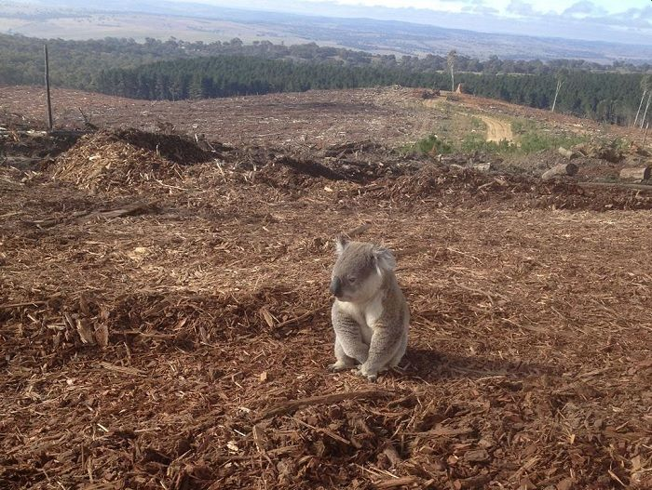
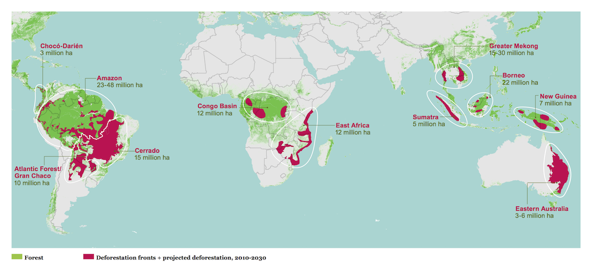
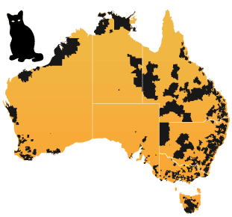
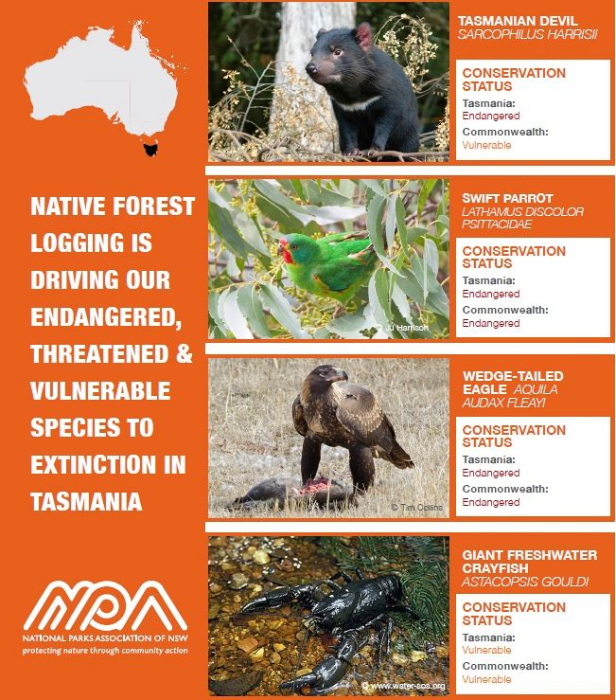

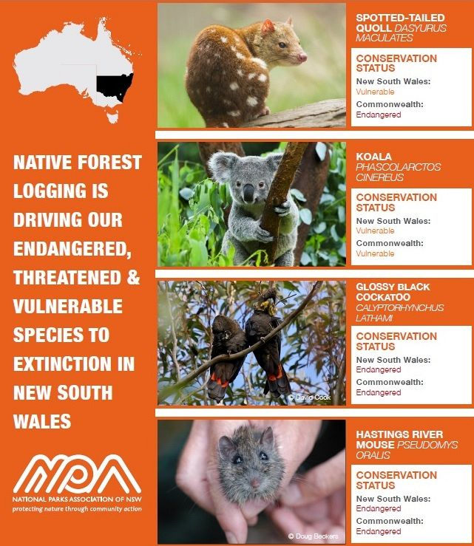

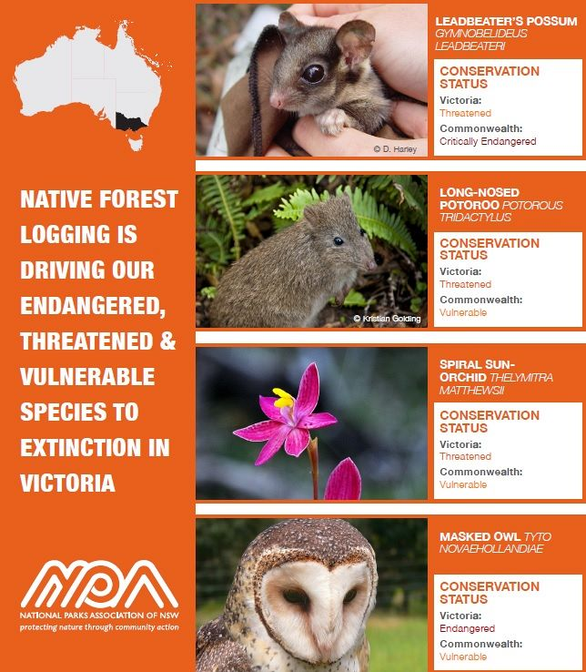

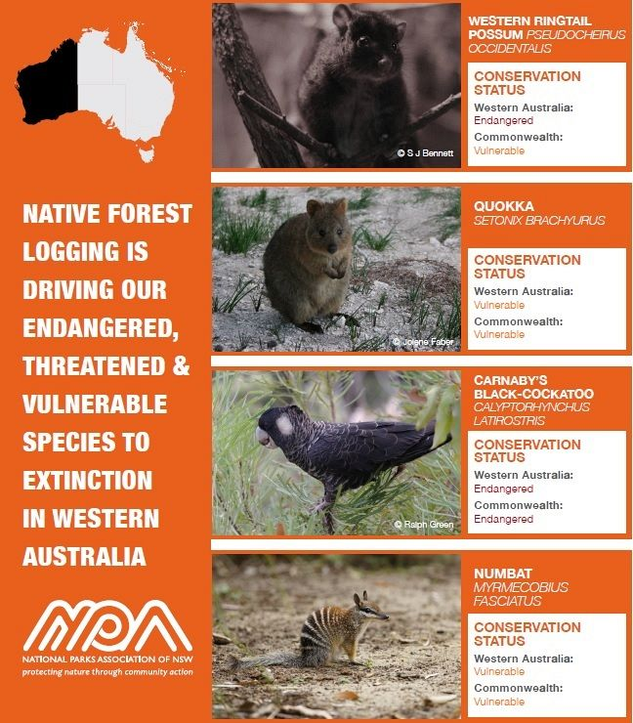

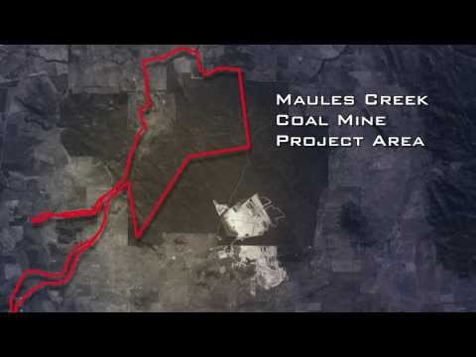

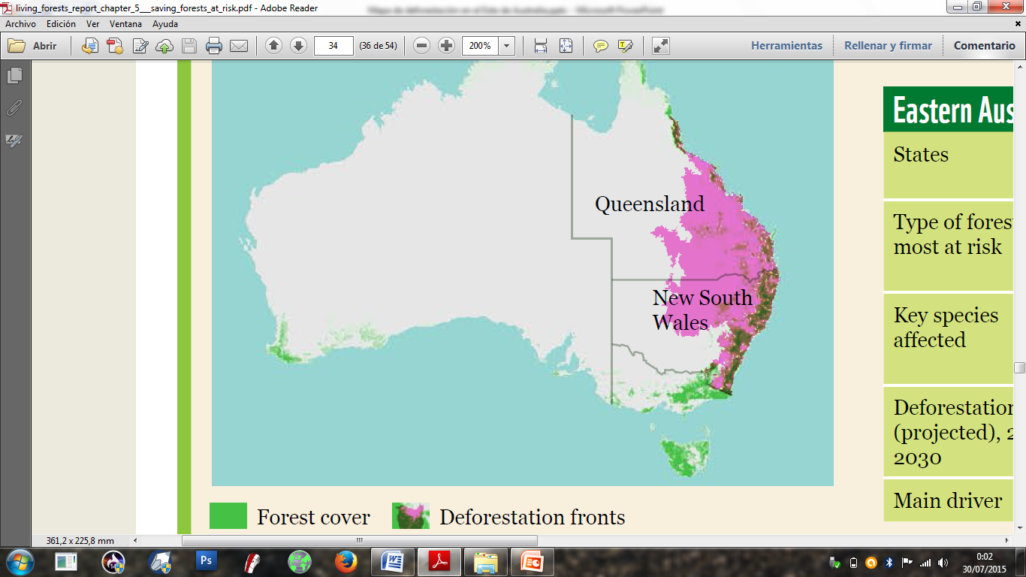

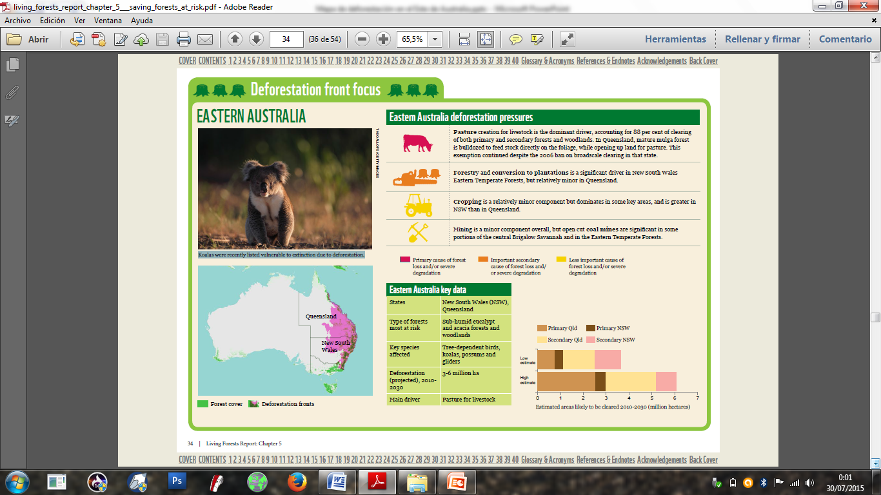

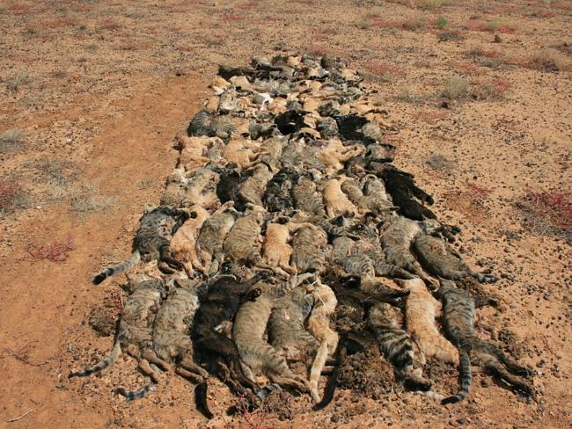
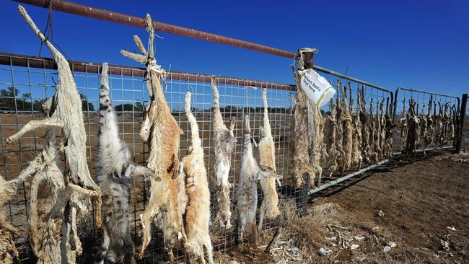

SECOND EVALUATION.- Of the evidence provided there is no doubt about the authenticity of them, considering their provenance, as each compiled testimony comes from an internet link where is the relevant information that supports and strengthens the evidence through an article and pictures (photographs). About all the articles that are offered as proof and which are also labeled on them the Crimes and the committed actions (case that is not our competence to jurisdictionally know or decide on this matter by our Party), there is no objection, disqualification or invalidation of the digital content by the Part I represent, given that they are digital media that come from reliable sources and also were declared and published at that time formally and openly, from which there is no doubt about their authenticity.-

THIRD EVALUATION.- By virtue of what was expound, published, declared and reproduced in the media and which are now presented as digital Evidence for this Case by the Executive Secretary of IBEC and BTHR Master Yan Maitri-Shi, these proofs are determined by the Party I represent as prosecutor of the IBEC and BTHR as LEGITIMATE AND VALID, which support and confirm the Accusation presented by the World Association of Buddhism against AUSTRALIA's government and its Environment Minister for the crimes of PERSECUTION, ANIMAL EXTERMINATION, ECOCIDE, DEFORESTATION, MARINE POLLUTION and those crimes that result from them, committed against Animals (wild and domestic cats and other species) and against the Environment.-
It is placed on record that regarding the Right to Defense, the Australian government responded to the accusations of Buddhist Tribunal on Human Rights with an evasion, since its Embassy declared with a written about the "importation of sheep", a fact which is not related to the case denounced at all.
In such a situation, it is begun the Fifth Stage of the Procedure called "Judgment", in which the term of 5 five days is set to the Jury Members in order to decide whether the Government of AUSTRALIA and its environmental minister are "Innocent" or "Responsible" for the crimes of PERSECUTION, ANIMAL EXTERMINATION, ECOCIDE, DEFORESTATION, MARINE POLLUTION and those that result from them, regarding the Evidences that were provided, accepted and evaluated in the present writing.-

Sekkha Dhamma
Prosecutor of IBEC & BTHR

Mexico, October 2015 two thousand fifteen.-

