support@supportcenter.mercadolibre.com

Case 45-2018: Mercado Pago & Marcos Galperin
By Master Yan Maitri-Shi, Prosecutor

HONORABLE JURY OF INTERNATIONAL BUDDHIST ETHICS COMMITTEE (IBEC) & BUDDHIST TRIBUNAL ON HUMAN RIGHTS (BTHR)
After Legitimating and Validating Evidences and Charges by Master Maitreya, President and Spiritual Judge of IBEC-BTHR, it is addressed the case against the accused party “Mercado Pago & Marcos Galperin”. This investigation was initiated from a complaint of the temple World Association of Buddhism.
The Charges by which the International Buddhist Ethics Committee is accusing “Mercado Pago & Marcos Galperin” are enumerated below:

Scam

Corruption

Therefore, it is detailed a series of EVIDENCES that support the Charges referred so that the Jury members decide about the possible "Responsibility", "Innocence" or "Insanity" of the accused. Such evidence come from graphic and audiovisual media that have been gathered, sorted and confirmed in their order and context as Means of Proof in order to know, establish, dictate and determine the Responsibility of the Accused for committing the aforementioned Charges.
The procedure established in the Statute of INTERNATIONAL BUDDHIST ETHICS COMMITTEE & BUDDHIST TRIBUNAL ON HUMAN RIGHTS provides both bodies the ostentation to enjoy independence and liberty from state and national regulation and control, besides having the legality and acting as a Buddhist People in order to assert its customs, traditions, practices, procedures, judgments and rights as well as acting in pursuit of the development of Spirituality, of Buddhist Ethics, and of the defense of International Human Rights. This procedure has the particularity, singularity and distinction of having "Special Jurisdiction of the Tribal Law" and "Universal Jurisdiction of the International Law", thus having the Character, Juridical validity, Legal Powers, infrastructure, Training and Capability necessary to be Actor, Administrator and Executor of Justice in this realm and exercise, by judging of the Accused by means of an Ethical Judgment whose Purpose is Truth, Reconciliation and Learning.-

PRESENTATION OF THE CASE

International Buddhist Ethics Committee: The company called "Mercado Pago" (a part of "Mercado Libre") of the businessman Marcos Galperin incorrectly charged two purchases, improperly appropriating funds belonging to the International Temple "World Association of Buddhism". One purchase was for $ 624 pesos (on May 25th) and another for $ 120 pesos (on June 1st). This money was very important for the budget of food and health of the Buddhist Temple. Although multiple claims were made to the company, it never returned the funds. "Mercado Pago" promised 3 times the return, first saying that in 48 hours the problem would be solved, and then saying that they were 7 days, which was systematically breached. In the face of this situation the Buddhist Temple told the company that Mr. Marcos Galperin would be criminally denounced for scams, before which the company "Mercado Pago" apologized and confirmed that thousands of users were having this same inconvenience and also said that the company had no date to solve the problem.

Consequently, the International Buddhist Ethics Committee investigated and found that this kind of criminal behavior of "Mercado Pago" & Marcos Galperin is due to a framework of systematic impunity enjoyed by the company in the face of Argentine justice, since from the friendship relationship that Mr. Galperin has with President Macri, he has obtained the annulment of $ 500 million pesos of a debt owed to the Argentine State. This outrageous act constitutes an act of Corruption and crony capitalism that resembles the worst scams carried out by the previous government of argentine former president Kirchner.

However, the International Buddhist Ethics Committee investigated multiple evidences and concluded that the main reason that the company "Mercado Pago" & Marcos Galperin misappropriated funds from thousands of clients -even though these funds would be returned several months afterwards- is because this company is acting outside the law and also because these funds could be used for the creation of a new company of Marcos Galperin called "Mercado Fondo", which would consist of momentarily retain customer funds and place them in banks to obtain monetary income that would then be distributed to customers. Although Marcos Galperin is a billionaire, he undoubtedly needs a monetary capital to finance his new company, and this would be the reason for his criminal action in order not to return the funds he has illegally charged to the International Temple "World Association of Buddhism" and to thousands of other clients.

Photographic evidence of the purchases illegitimately charged
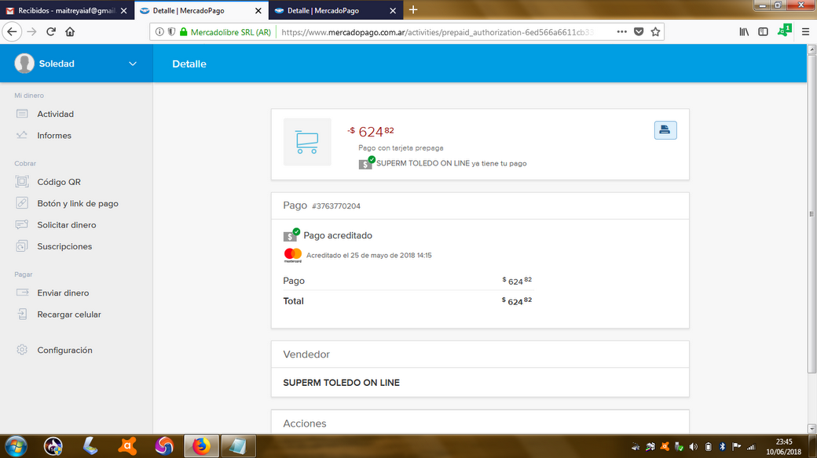
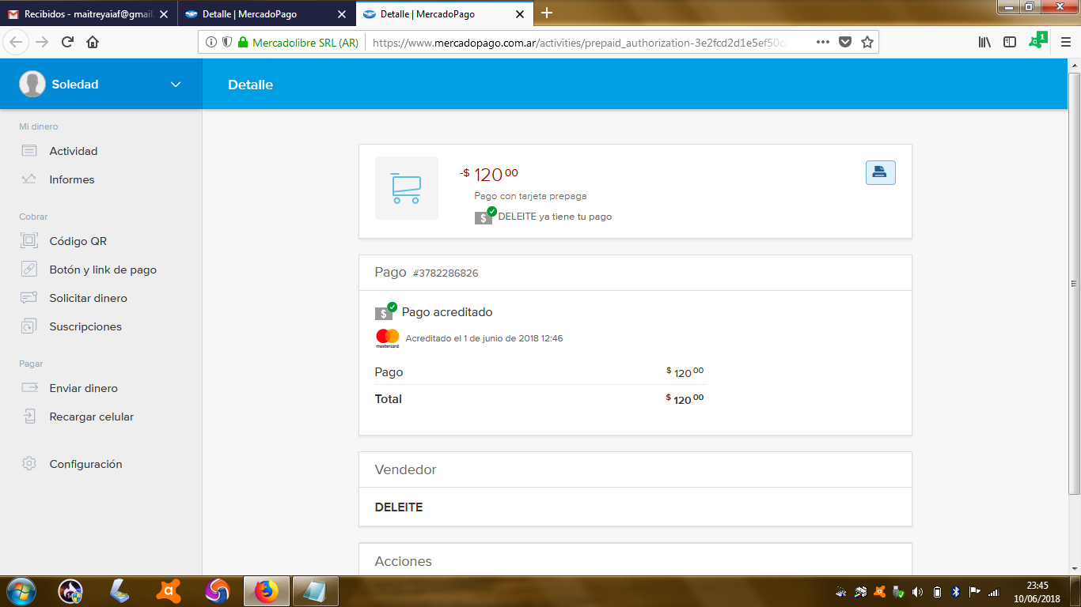

Evidence: Testimony of the Company
Mercado Pago: “06/02/2018 - No. Case: 13326597. (...) You do not have to worry, it's about the reservation of the card, when the payment is rejected in a maximum of 7 working days you should have the money back in your "Mercado Pago" account. So soon you will have both reimbursements with no problems. (...) I am sorry for the information that you received previously but it is functionality of Master [Mastercard], do not worry that we are already working so that you have your money soon, sorry for the inconvenience caused. (...) Do not worry that it will be solved and it will not happen again, we are working on it. (…)Sorry for this inconvenience, but I assure you that everything possible is being done so that you can have it as soon as possible again. (...) Exactly, if after this date you still do not see it [money], it is a mistake that we should report, but surely you will see it without problems. (...) Your money is 100% safe, the alternative in case of not returning the money in the correct time is to report the situation so that the specialized sector solves this problem.”
Mercado Pago: [Case: 13292638] 02/06/2018 "We know that you are having problems with your payment with the Prepaid Card and that is why we are working to solve them as soon as possible. We apologize for the error. We will communicate with you when we have news. Regards, Customer Service. Mercado Pago - Mercado Libre Company”
Mercado Pago: “ June 5th. (…)First of all, I apologize for the delay we are presenting in resolving this situation. Our team is working as soon as possible to verify what happened with the payments you made. Unfortunately, it is taking us longer than estimated due to the complexity of the inconvenience.”
Mercado Pago: “ June 7th. (...) I really understand your concern this time and I want you to know that we are trying to solve it as quickly as possible. We estimate that it will be solved shortly, although it may take longer, depending on the complexity of the inconvenience, since sometimes it is not easy to resolve certain errors. I assure you that we will communicate back to you to notify you as soon as we have been able to resolve the error.”
Mercado Pago: “ June 16th. (…) I really understand the discomfort you show due to the delay of the resolution of the inconvenience that you are posing to us; even for us to communicate that we still do not have a resolution to your problem. We want to help you but nevertheless at the moment we do not have a solution yet. I tell you that in case of errors in the site or in the user's account, several teams work together to solve your problem as soon as possible. This is not an easy or quick process due to all that it entails. I understand that you waited a considered time, but as soon as we have a resolution, we will contact you, since it is very complex error that is affecting many of our users en masse. We really appreciate your patience and we really want to apologize for the inconvenience caused.”

Evidence: Claims of thousands of users against the company
International Buddhist Ethics Committee: In the link below you can see several thousand complaints of users against Mercado Pago Company, which resolves only 44% of them. https://tuquejasuma.com/mercado-pago

Evidence: Possible whereabouts of the illegally withheld funds
Infonegocios.info: (June 1st) “With Mercado Fondo, Mercado Libre will invest the remaining balances in Lebacs. The company advances on the road to becoming a fintech. Although yesterday the presentation of the payment with QR code was the star of the event, the advance of Mercado Fondo did not go unnoticed. (...) "Soon we will be launching Mercado Fondo. It is a product that will allow all people who have a virtual wallet with Mercado Pago to generate an income. All the balance remaining in the digital wallet will generate an income similar to that of the Lebacs,” says Marcos Galperin, CEO of Mercado Libre.”
Revista Fibra: “MercadoFondo is the new bet of Mercado Libre, the Argentine company directed by Marcos Galperín. It is a digital financial instrument that allows the user of Mercado Libre and Mercado Pago digital wallet to generate financial income. "The entire balance of the digital wallet will generate an income; it is something similar to what happens with financial instruments such as Lebac," said the CEO of Mercado Libre. In this way, Mercado Libre will take advantage of the deregulation in the payments and financial market proposed by the Central Bank in the last year. ”

Evidence: Corruption and Impunity
Hugo Alconada Mon – La Nacion (Newspaper): “November 12, 2017. The AFIP points against Mercado Libre for $ 500 million. It claims for the incentives of software law; (...) The taxing body headed by Alberto Abad concluded that Mercado Libre must return hundreds of millions of pesos per year to the State because it would not have access to the tax and labor benefits that enjoys today through the Software Industry Promotion Regime. The AFIP communicated its decision to the Executive on September 28, through a note that the deputy director general of Impositive Operations of National Large Taxpayers, Juan Carlos Santos, referred to the Ministry of Production, and whose copy LA NACION obtained. "It is concluded that Mercado Libre SRL would not be benefited by the tax exemptions established in the analyzed order, both by the observations made regarding its main activity and by the breach of essential requirements defined in the normative plexus," the AFIP informed to Production (...) Mercado Libre has a strong ally: the very Ministry of Production. Consulted by LA NACION, they reaffirmed its position to keep the company within the regime, which they announced that "it will be informed to the AFIP in the coming days". (…)Mercado Libre began in August 1999, under the guidance of Marcos Galperín, its founder and CEO, who lived between Argentina, the United States and Uruguay, and turned his personal undertaking into a giant of US $ 12,400 million. (...) In the case of Mercado Libre, and from the note of the AFIP -which led to the opening of the administrative file 313361/2017-, the Minister of Production, Francisco Cabrera, has 90 days to decide if he keeps it with the benefits of the Software Industry Promotion Regime. But even if Cabrera keeps the company within the regime -as they anticipated from the ministry to LA NACION-, the AFIP already anticipated that it will demand the debts to Mercado Libre. Thus, in its note it reminded the ministry that "this fiscal agency preserves the powers assigned to it by law" and that it communicated its position "so that it can be issued on the matter," but that it does so "as a previous step to initiating the relevant proceedings to initiate the determinative procedure ex officio ". The claim of the AFIP would be multimillionaire. According to the latest report submitted in the United States by Mercado Libre, this special regime allowed it to save US $ 24.1 million due to a 60% reduction in income tax, plus another US $ 7.5 million in labor costs during the 12 months prior to September 30, 2017. That is, US $ 31.6 million. Just over AR$ 500 million in just one year. That amount is what the AFIP could claim, to which the tax and labor benefits of recent years should be added, since Mercado Libre agreed entered the regime in 2007. But the AFIP estimated that the company fails to meet two of the three requirements established by law: allocate funds to research and software development activities, applying recognized quality standard and export software. Both from the AFIP and Mercado Libre agree on two points: the company does not allocate funds to research or develop software, but it did implement the ISO 9001 and ISO IEC 90003 standards. Therefore, the background discussion is whether it exports Software. According to the AFIP, it does not. It only sends Software abroad to related companies for technical support and customer service, when the regime seeks to strengthen the local industry to export and sell their products to outside third parties.”
LPO: “November 12, 2017. Abad advances against Mercado Libre and adds tension with La Rosada [Argentine presidential palace]. The Afip affirms that it does not correspond the tax benefits of the software law. The head of the AFIP, Alberto Abad, sued Mercado Libre to return about 500 million pesos of unpaid taxes, for an erroneous application of the allowances of the software law and aggravated the tension with the Casa Rosada that sees in the company of Marcos Galperín the type of entrepreneur more in line with the PRO [political party] model. (…)Mercado Libre is one of Mauricio Macri's favorite companies. Along with Globant and Despegar is one of the so-called Argentine 'Unicorns', companies that manage to climb their quotation at a rate that doubles that of traditional industries. Without real competition, the CEO of Mercado Libre, Marcos Galperín, is a promoter of the flexibilization of the markets, the working conditions and the union affiliation system. The curious thing is that a few weeks ago he panicked when Amazon, the giant of the electronic commerce created by Jeff Bezos, announced his intentions to enter the Argentine market. Galperín understood that his privileged position was at risk and did not hesitate to ask the State to intervene. The company has Cabrera as a key ally and from Production have suggested that they will maintain the position of keeping the company within the regime of tax benefits. Cabrera and Macri himself have a relationship with this company since it was one of the first to join the Technological District of Parque Patricios, a creation of the current Minister of Production during his administration in Buenos Aires, that to start by force included companies that did not were strictly technological into the tax benefits granted by the City to settle in that neighborhood in the south of the City.”
Big Bang News: “November 13, 2017. "War" in the Government because of MercadoLibre: is it an example or a debtor of $ 500 million? (...) The internal issues in the government for a supposed "benefit" that Mercado Libre would have obtained after benefiting from the Regime for the Promotion of the Software Industry, keeps the AFIP and the Ministry of Production at odds. In the middle of that dispute of powers and interpretations of regulations, Mauricio Macri supported Marcos Galperín, founder and CEO of the e-commerce platform. (...) In the middle of this conflict, Mauricio Macri gave a boost to the Argentine unicorn, whose market value, to date, is US $ 11,885 million. (...) Galperín seems to have Macri's wink and support. One more question: what will Abad do? For now he battles, almost in solitude, for many, in controversial cases such as OCA and the debt of Cristóbal López. Will the "bloodhound" continue in his position if he fails to collect the $ 500 million from Marcado Libre? ”
Eldestapeweb: “November 14, 2017. UNBELIEVABLE: Macri tries to help the owner of Mercado Libre who was reported for evasion. The President met with the owner of the company. The executive had threatened not to invest in the country when the AFIP intimidated the company. The President met with directors of Mercado Libre to convey the details of an expansion plan for Argentina. This happened a day after the company's owner, Marcos Galperin, threatened to stop investing in the country. That had been the reaction of the businessman when the AFIP ordered him to pay $ 500 million owed to the tax office. Mauricio Macri received the Argentine executive at Casa Rosada on Monday. The Minister of Production, Francisco Cabrera, also participated in the meeting (...). On Sunday Galperín had threatened by Twitter to move Mercado Libre to another country. "Did you see that Amazon is doing a city / country contest to see where its mother company is located? It may be a good idea for us to do the same, right?" He had launched, although he deleted it when the impact of his strong pressure on the Government escalated.”
Juan Manuel Barca: “November 24, 2017. Mercado Libre versus AFIP: Marcos Galperín promises to maintain mother company in Argentina if it continues to grow. The businessman of the moment lowered the tone to the conflict that maintains the AFIP with the platform of electronic commerce because of a supposed debt of $ 500 million, and he ratified his support to the labor reform of the Government. Mercado Libre will continue to generate employment in the country. Of course, as long as it keeps growing and the rules don't change. With that warning, Marcos Galperín, the CEO of the largest ecommerce site in Latin America, yesterday lowered the tone to the possibility of relocating his mother company abroad, but without closing the door permanently to an option that he himself slipped last week after the AFIP claimed him $ 500 million in tax benefits. "Let's see, we are growing a lot, and we are very good here, but we are going to see what the context is, "Galperín said when was asked by iProfesional if he analyzed moving the headquarters of his offices. (...) In a defiant tweet, the executive revealed that he was analyzing moving the headquarters to another country (...) However, the owner of the platform finally deleted his posting, a gesture in tune with the signal sent almost immediately by the President at that time from an act in La Matanza, where he praised the Argentine company and compared it with Amazon, its main global competition. It was not by chance. Behind closed doors, in the Government, Galperín is considered an example of the innovation model promoted by Cambiemos: he manages a firm with a value exceeding US $ 10,000 million and more than 5,000 employees in Latin America, 2,000 of them in Argentina. On the other hand, the employer became one of the main defenders of the labor reform.”
Perfil Newspaper: “November 24, 2017. The executive extends another hand to the owner of Mercado Libre. The AFIP had requested the company to stop receiving millionaire tax benefits. The Ministry of Production ruled in favor of Marcos Galperin. The Ministry of Production, directed by Francisco Cabrera, threw overboard a report by the Federal Administration of Public Revenues (AFIP in its Spanish acronym) and once again guaranteed a tax benefit of at least $ 500 million per year to Mercado Libre. This is evidenced in the document to which PERFIL accessed. In this way, businessman Marcos Galperin again divided the waters in the government of Mauricio Macri. Since 2007, and with the permission of the Kirchnerist Economy and Production ministries, Galperin accumulates fiscal benefits for hundreds of millions of pesos. As La Nación revealed, the company saved $ 500 million between September 2016 and the same month this year (US $ 31.6 million at that time) thanks to a special regime designed for software producers and exporters. (…)In addition, they do not pay withholding taxes when exporting. Macri and Galperin praise each other. The CEO has a tax front and appeared in Paradise Papers. For the President, it is a "unicorn". The AFIP has been eyeing Mercado Libre since 2016, when it allocated about a hundred inspectors to investigate the company. While the inspection was being carried out, Alberto Abad's body received the first signal. It was August of last year and Macri showed himself accompanying the CEO of Mercado Libre in announcing his "expansion plan". The picture of both fell like a bucket of cold water, as told then by this media outlet. However, on September 28 of this year, the AFIP presented the report against the company. It determined that the company fails two of the requirements provided by law: producing software for third parties and export. Instead, Cabrera's ministry said that "Mercado Libre SRL has fulfilled all the required filings by law." (...) In less than 24 hours, the President sent signals again: he praised the company in a speech. Now, Production contradicted the tax authorities and determined that "97% of the (company's) billing is directly related to the activities promoted by the software promotion regime. It is not what was determined by the megainspection of the AFIP, whose result was that the production of platforms that meet the requirements of the law only corresponds in this case to 0.18% of the annual turnover. There is a chasm between both percentages. And a difference of $ 500 million per year for the State. Galperin returns the courtesies. On Monday, while the country had its sights set on the pension reform promoted by Macri - and that he managed to approve -, the businessman posted on Twitter: "For the first time in my democratic life, Peronism has a party with equal vocation for power than they. Today is a key day for Argentine democracy".
VCF: “The Government ordered Banco Nación to give a millionaire credit to Mercado Libre. This happened after the AFIP denounced the company belonging to Marcos Galperín for tax evasion of 500 million. As a result, an internal crisis arose in the banking entity due to the government's decision; because Javier González Fraga, president of Banco Nación, refuses to comply with the order of Casa Rosada. (…)In this context, from Casa Rosada they want the National Bank to approve a credit of $ 4,000 million, making it one of the largest in the history of that financial entity. Fraga refuses to obey the request for a reason that - the official - considers obvious: the company faces a claim from AFIP, which turns the firm into a fragile credit. It is necessary to add that the holder of the bank entity, could face judicial problems since it is an unseen number and that, in addition, it would show favoritism since it is one of the favorite companies of Macri. All this adds up to a millionaire debt with the control body, which if it decided to execute the fiscal credits, the capacity of repayment of the credit of the company would weaken and would complicate the capital of the Bank. ”
Marcelo Rielo: “As Perfil revealed, Galperín is not only related to Macri because of his friendship, but also because of the modality of operating in tax havens. The CEO of Mercado Libre is listed as one of the final beneficiaries of an offshore company in the British Virgin Islands. That company invested millions of dollars in one of the ten most important grain production companies in the country, called El Tejar, as it emerged from the Paradise Papers filtration. The link between the Argentine businessman and the offshore world came to light in November last year from the documents obtained by the German newspaper Süddeutsche Zeitung and shared by the International Consortium of Investigative Journalists (ICIJ). (…)Galperín also has another link with operations linked to avoid taxing. Between August 2002 and March 2016, he settled in Uruguay. For what? Although his successful company is based in Buenos Aires, the businessman almost did not pay personal taxes, as profits, before the AFIP. This is the owner of the company that Macri baptized as one of "the four unicorns": ventures that start from scratch and take off quickly to exceed its value by more than 1,000 million dollars. IF YOU HAVE TO PAY, CHOOSE WELL HOW NOT TO DO IT. Mercado Libre enrolled in the Software Industry Promotion Regime, which provides benefits for the Software industry and computer services, such as paying less social security contributions for its employees. At the end of last year, and after an inspection of the tax office, the AFIP that Alberto Abad was still driving determined that Mercado Libre would not produce software and, therefore, does not fit the requirements of the law. (...) Pointed out for having operated through offshore accounts and in controversial situation for the alleged millionaire tax evasion of $ 500 million, what better than go to ask for the favor of a friend. That's why Galperín went to ask for a loan, no less than special, to Banco Nación from the Macri administration. The president of Banco Nación, Javier González Fraga, was left in a very complicated situation because he refuses to obey the order of the Casa Rosada: to grant Mercado Libre a credit of $ 4,000 million, one of the largest in the history of the main public bank of the country. Fraga refuses to obey the Rosada's request for several reasons: first, Galperín's company faces the AFIP's claim, which turns the firm into a glassy credit; second, González Fraga could be accused of favoritism, by helping with an extraordinary amount to a company of a friend of the President.”

https://www.infonegocios.info/nota-principal/con-mercado-fondo-mercado-libre-invertira-los-saldos-remanentes-en-lebacs
http://revistafibra.info/mercadofondo-la-apuesta-de-mercado-libre-para-competir-con-las-lebacs/
https://www.lanacion.com.ar/2081554-la-afip-apunta-contra-mercado-libre-por-500-millones
http://www.lapoliticaonline.com/nota/109518/
https://www.bigbangnews.com/dinero/Guerra-en-el-Gobierno-por-MercadoLibre-es-un-ejemplo-o-un-deudor-de--500-millones-20171113-0023.html
https://www.eldestapeweb.com/insolito-macri-intenta-ayudar-al-dueno-mercado-libre-que-fue-denunciado-evasion-n35922
http://www.iprofesional.com/notas/259203-afip-software-empleados-iva-industria-pymes-uia-pyme-pc-streaming-emprendedor-empleado-actividad-ecommerce-reforma-laboral-otros-Mercado-Libre-versus-AFIP-Marcos-Galperin-promete-mantener-casa-matriz-en-la-Argentina-si-sigue-creciendo
http://www.perfil.com/noticias/economia/el-ejecutivo-le-tiende-otra-mano-al-dueno-de-mercado-libre.phtml
http://vaconfirmamendoza.com.ar/?articulos_seccion_716/id_4110/el-gobierno-ordena-al-banco-nacian-darle-un-millonario-cradito-a-mercado-libre-
http://www.politicargentina.com/notas/201804/25419-macri-consiguio-que-un-ceo-amigo-invierta-usd-275-millones-pero-en-mexico.html

